Vehicle Defect Procedure

Contents

Document Control 2
1 Statement of Aims and Objectives 4
2 Principles 4
3 Definitions 5
4 Responsibilities 5
5 Education and training 6
6 Monitoring compliance 6
7 Audit and Review (evaluating effectiveness) 6
8 Associated Trust Documentation 7
9 References 7
10 Financial Checkpoint 7
11 Equality Analysis 7
Appendix A: Vehicle Defect Process 13
Appendix B: Document Supporting Procedure 14

- Statement of Aims and Objectives
  - South East Coast Ambulance Service NHS Foundation Trust (the Trust) is committed to maintaining the safety, availability and roadworthiness of the vehicles it uses to deliver its core services. To ensure Trust vehicles are kept road legal and compliant they need to be repaired when defects occur.
  - This Trust document explains the vehicle defect procedure that needs to be followed by all Secamb staff who uses a Trust Fleet vehicle
  - For the purpose of this Policy, Trust vehicles include: Ambulances, Response cars, and Hazardous Area Response Team vehicles as well as non-operational vans and cars that carry out Trust duties
  - [This policy is applicable to] all clinicians in the Trust and sets out the scope of clinical practice to which clinicians must adhere.
- Principles
  - This procedure is supported by the flowchart in Appendix A: Vehicle Defecting Process.

  - When a defect occurs on a vehicle the SECAmb vehicle driver will need to determine if the defect is serious enough to warrant the vehicle being taken off the road (VOR), this is also known as a critical vehicle failure (CVF), or if the defect is minor and can continue operationally until the end of its shift where it will then be made VOR for repair.
  - In both cases the vehicle driver will need to log the event on the Trust Electronic Vehicle Defect Reporting platform
  - If the vehicle is VOR and has a patient on board then the crew will need to liaise with the Emergency Operating Centre to arrange the patient transfer.

  - After the patient has been moved on to another vehicle or if there is no patient on board Operational Support will arrange the recovery of the vehicle if required to its nearest workshop or place of repair.

  - If the vehicle does not require recovery, then the crew are to drive the vehicle back to the nearest workshop from their location for repair and advise the onsite Make Ready Operative. If the operative is unavailable advise the on-call Operational Team Leader.

  - When back on base the crew should place the red VOR A4 laminated sign in the windscreen of the vehicle

  - Following the ‘Progressing a VOR and Running Defect on the Key2 Management System’ (see Appendix B) OS will log the event onto the Fleet Data System

  - When the vehicle arrives at its repair workshop / location and within 30 minutes, the maintenance technician will follow the ‘Progressing a VOR and Running Defect on the Key2 System’ (Appendix C) and make an initial assessment to see if the vehicle can be repaired within 30 minutes.

  - If the vehicle can be repaired within 30 minutes the maintenance technician is to repair the vehicle completing all the relevant paper work then advise the Operational Support Officer/On Call OTL when the vehicle is ready for operational use again.

  - If the vehicle can’t be repaired in 30 minutes then the OSO/On Call OTL will need to arrange for a replacement vehicle for the crew to continue their shift.

  - Once the vehicle is repaired and the maintenance technician has completed all necessary documentation they then advise OSO/On Call OTL that the vehicle is ready for operational use
- Definitions – covered in principles section
- Responsibilities
  - The Associate Director of Support Services has overall responsibility for this procedure, including monitoring and audit. Set out clear lines of accountability for the Policy elements, from the Chief Executive Officer to employees, outlining what each has responsibility for.
  - All SECAmb Vehicle Drivers are responsible for reporting the vehicle defect via the Electric Vehicle Defect Reporting App every time a defect occurs no matter how minor. If in doubt, discuss this with the responsible Management Group and check with your Director.
  - EOC are responsible for arranging patient transfer if a patient is on board when a defect occurs.
  - Operational Support is responsible for arranging vehicle recovery where a vehicle cannot be driven back to a place of repair. Logging the event on the Fleet Data system
  - Operational Support Officer (formally Make Ready Manager) is responsible for arranging a replacement vehicle where possible.
  - Workshop Vehicle Technicians and Workshop Managers are responsible for ensuring the vehicle is repaired and that all electronic/paper work is completed and the OSO are informed when the vehicle has been repaired and is again available for operational use.
  - All employees are responsible for adhering to this policy.
- Education and training
  - Describe here the level of education and training required by employees to fulfil the requirements of this policy. If there are no education or training implications to enable employees to fulfil the policy’s requirements, simply delete this section.
- Monitoring compliance
  - This section will vary depending on the subject and content of the policy, and may not be needed at all.
  - Where required, this section should set out:
  - Which post-holder(s), team or Management Group is responsible for monitoring compliance with this policy (i.e. checking that it is being followed by the relevant employees – it may for example be a specific manager’s responsibility, or any line manager’s responsibility, or perhaps it is up to the individual employee to ensure their own compliance);
  - how this will happen (how often compliance will be monitored); and
  - what action will be taken if non-compliance is identified.
- Audit and Review (evaluating effectiveness)
  - Monitoring compliance to this procedure on a day to day basis will be undertaken by workshop and the Operational Support Team.
  - Workshop staff to check on Fleet Data system to ensure that any outstanding defects are rectified and completed.
  - Operational Support staff to ensure all defects are reported and closed off on E-VDR/The Fleet Database
  - Workshop and Operational Support staff will aim to resolve issues of non-compliance with the relevant individual or group. Persistent non-compliance will be reported to the Workshop Manager /Operational Support Manager for remediation. In both cases it may be necessary for a remedial action for non-compliance to be part of a personal development plan; or an action plan to remediate the risks of recurrence.
  - This procedure will be reviewed by the Associate Director of Support Services every three years or sooner if new legislation, codes of practice or national standards are introduced. This section should set out how the principles of the document will be audited (including how often and what action will be taken if non-compliance is identified) and who will review the document to ensure it is effective at meeting its aims and objectives. Use the wording below in addition to any other specific instruction about the audit and review of the policy.
- Associated Trust Documentation
  - Electric Vehicle Defect Report
  - Fleet Management System
  - Progressing a VOR and Running Defect on the Key2 System
- References
  - Road Traffic Act 1988
  - Driver and Vehicle Standards Agency (DVSA)
- Financial Checkpoint
  - To ensure that any financial implications of changes in policy or procedure are considered in advance of document approval, document authors are required to seek approval from the Finance Team before submitting their document for final approval.
  - This document has been confirmed by Finance to have no unbudgeted financial implications.
- Equality Analysis
  - [The Trust believes in fairness and equality, and values diversity in its role as both a provider of services and as an employer. The Trust aims to provide accessible services that respect the needs of each individual and exclude no-one. It is committed to comply with the Human Rights Act and to meeting the Equality Act 2010, which identifies the following nine protected characteristics: Age, Disability, Race, Religion and Belief, Gender Reassignment, Sexual Orientation, Sex, Marriage and Civil Partnership and Pregnancy and Maternity.
  - Compliance with the Public Sector Equality Duty: If a contractor carries out functions of a public nature then for the duration of the contract, the contractor or supplier would itself be considered a public authority and have the duty to comply with the equalities duties when carrying out those functions.]
  - Every policy must be accompanied by a completed and authorised Equality Analysis (EA). The guidance and template for completing this are below.
  - Once the EA is complete, this guidance should be deleted from your policy and the completed EA retained within the document.
  - Equality Analysis (EA) is a tool aimed at improving the quality of our services by ensuring that individuals and teams think carefully about the likely impact of their work on different communities or groups. It involves anticipating the consequences of the Trust’s policies, functions and services on different communities and making sure that any negative consequences are eliminated or minimised, whilst opportunities for promoting equality are maximised.
  - Systematic and robust completion of EAs will assist us to comply with the Equality Act 2010 which places a duty on the Trust to have due regard to the need to:
    - Eliminate discrimination, harassment and victimisation.
    - Advance equality of opportunity between persons who share a relevant protected characteristic and persons who do not share it.
    - Foster good relations between persons who share a relevant protected characteristic and persons who do not share it.
  - These are known as the three aims of the general equality duty. The Act sets out nine protected characteristics that apply to the equality duty, which must be considered in the EA process. The protected characteristics are:
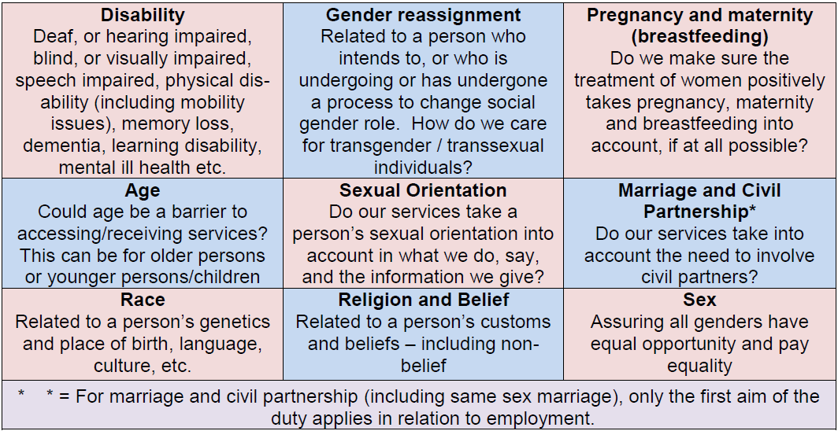
  - The flow chart below sets out the EA process:
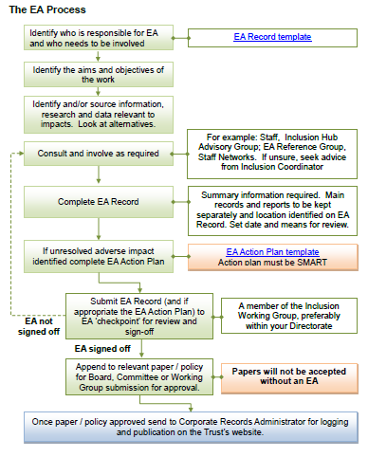
  - The EA form for completion is below. Depending on the outcome at this initial stage, an action plan may also be required. The template for actions is included below. Please contact inclusion@secamb.nhs.uk for support undertaking an EA.

Name of author and role | Lee-Ann Witney – Sustainability Lead
Directorate | Strategy and Transformation | Date of analysis: | 22/04/26
Name of policy being analysed | Vehicle Defect Procedure
Names of those involved in this EA | Lee-ann Witney Dawn Chilcott

1. Trust policies and procedures should support the requirements of the Equality Duty within the Equality Act: | - Eliminate discrimination, harassment and victimisation;  - Advance equality of opportunity between persons who share a relevant protected characteristic and persons who do not share it;  - Foster good relations between persons who share a relevant protected characteristic and persons who do not share it. | In submitting this form, you are confirming that you have taken all reasonable steps to ensure that the requirements of the Equality Duty are properly considered.

2. When considering whether the processes outlined in your document may adversely impact on anyone, is there any existing research or information that you have taken into account? | For example:  - Local or national research  - National health data  - Local demographics  - SECAmb race equality data  - Work undertaken for previous EAs | If so, please give details:

3. Do the processes described have an impact on anyone’s human rights? | The procedure supports safe vehicles being used for patient care. However, removal of vehicles from service could indirectly impact response times and assurance that escalation process in place are followed  No direct impact identified in relation to Dignity and Treatment but delays could affect patient experience but assurance needed for timely communication and safe transfer arrangements

4. What are the outcomes of the EA in relation to people with protected characteristics?
Protected characteristic | Impact  Positive/Neutral/Negative | Protected characteristic | Impact  Positive/Neutral/Negative
Age | Negative | Race | Neutral
Disability | Negative | Religion or belief | Neutral
Gender reassignment | Neutral | Sex | Neutral
Marriage and civil partnership | Neutral | Sexual orientation | Neutral
Pregnancy and maternity | Negative

5. Mitigating negative impacts:

If any negative impacts have been identified, an Equality Analysis Action Plan must be completed and attached to the EA Record. A template for the action plan is available in the Equality Analysis Guidance on the Trust’s website. Please contact inclusion@secamb.nhs.uk for support and guidance.

Protected characteristic: | Age/Disability/ | Issue identified: | Staff with physical or cognitive differences may find aspects of defect identification, reporting systems or decision-making more challenging.
Action required: | Ensure reporting systems are accessible and user-friendly  Provide appropriate training and support  Encourage escalation where staff are unsure
Action lead: | Dan Garratt
How will impact/outcome be measured? | Staff Feedback | Timescale:
Resolution of actions:

Protected characteristic: | Pregnancy & Maternity | Issue identified: | Pregnant staff may be more impacted where vehicle defects create delays, operational disruption or require changes in duties.
Action required: | Ensure risk assessments remain in place  Provide flexibility and appropriate support
Action lead: | Dan Garratt
How will impact/outcome be measured? | Staff Feedback | Timescale:
Resolution of actions:

Protected characteristic: | Socioeconomic / Vulnerable Patients | Issue identified: | Patients in rural or underserved areas, or those with limited access to alternative support, may be disproportionately impacted if vehicle availability is reduced.
Action required: | Ensure robust escalation through EOC  Prioritise patient safety and clinical need  Maintain clear communication between teams to minimise delays
Action lead: | Dan Garratt
How will impact/outcome be measured? | Operational Response times | Timescale:
Resolution of actions:

EA Sign off

EA checkpoint (Inclusion Working Group member, preferably from your Directorate) | Dawn Chilcott Associate Director of OD and Culture
By signing this, I confirm that I am satisfied the EA process detailed on this form and the work it refers to are non-discriminatory and support the aims of the Equality Act 2010 as outlined in section 1 above.
Signed: |  | Date:

- Appendix A: Vehicle Defect Process

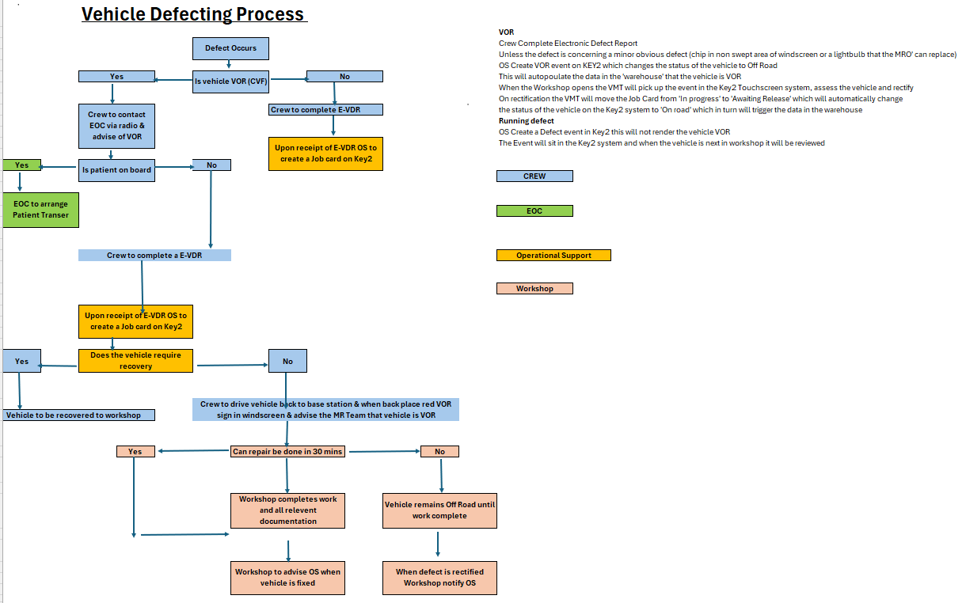

Appendix B: Document Supporting Procedure

Operational Support VOR & Running Defect SOP.docx

Vehicle Off Road & Running defect SOP016.docx

