Safeguarding Supervision Policy
(Provision of Safeguarding Support and Guidance)

Contents

Document Control 2
1. Statement of Aims and Objectives 4
2. Principles 4
3. The Supervision Session 5
4. Definitions 6
5. Responsibilities 6
6. Education and training 7
7. Monitoring compliance 7
8. Audit and Review (evaluating effectiveness) 7
9. Associated Trust Documentation 8
10. References 8
11. Equality Analysis 9
12. Quality Impact Assessment 11
13. Appendix A – Supervision Requirements Matrix 13
14. Appendix B – Supervision Agreement 14
15. Appendix C – Supervision Cycles 15

Statement of Aims and Objectives

  - South East Coast Ambulance Service NHS Foundation Trust (the Trust) is committed to providing high quality patient care and a safe and supportive working environment for all staff and volunteers.

  - This policy is applicable to all staff within the trust who have direct or indirect patient contact and sets out the support the trust can offer the workforce to effectively fulfil their responsibilities to safeguard patients and their families.

  - Safeguarding supervision offers an opportunity for containment, giving individuals the time to reflect on their practise and critically discuss cases or concerns with a suitably qualified supervisor. It is not supervision in the managerial sense.

  - Supervision aims to; ensure individuals have clarity with regards to their role and responsibilities, advocate best practice, encourage learning and development, support individuals in identifying the emotional impact of their work, develop a climate of exemplar practice and provide a safe environment where trust and confidentiality are appropriately maintained.

  - Safeguarding supervision in the Trust is not punitive nor is it linked to appraisal, Human Resources, pay progression or performance management.

  - The Trust will provide access to safeguarding supervision for all employees. Some staff groups will have mandatory supervision; all others have the opportunity to access ad-hoc supervision as and when it is required. For this latter group, it is the responsibility of the individual to seek safeguarding supervision as detailed in Appendix A.

Principles

  - The importance and provision of effective supervision is well documented in national guidance and statute to promote good standards of practice and assist individuals in making sound professional judgements. These include the Victoria Climbie Inquiry (Lord Laming, 2003), Working Together to Safeguard Children (HM Government, 2018) and the Care Act 2014 (Care and Support Statutory Guidance, Department of Health 2017).

  - The essence of good safeguarding supervision is supporting the capacity of the individual to think, reflect and develop their own solutions (Wonnacott and Wallbank 2016).

  - Section 11 of the Children Act 2004 sets out a statutory requirement that organisations should have in place arrangements ‘that reflect the importance of safeguarding… Including appropriate supervision and support for staff, creating an environment where staff feel able to raise their concerns and feel supported in their safeguarding role’ (Working together to Safeguard Children 2018).

  - The type of safeguarding supervision required by individuals will depend upon their roles, responsibilities and individual needs. Supervision may be individual (one to one) or facilitated through group supervision.

  - Safeguarding supervision does not replace any restorative or clinical supervision already in place for staff groups. For example, wellbeing and mental health practitioners will have mandatory clinical supervision in place. Safeguarding supervision can be accessed by these groups on an ad hoc basis when a need is identified.

  - If individuals require safeguarding supervision or their line managers identify a need for it, the safeguarding team can be contacted, and this will be arranged on request.

  - For those receiving mandatory supervision (see Appendix A), sessions will be scheduled in advance in consultation with you.

  - Safeguarding supervision may be requested by emailing sgsupervision@secamb.nhs.uk. A qualified supervisor will respond to your request within 5 working days. Please indicate your availability in your initial email, as well as any adjustments that you may require, e.g. a wheelchair accessible meeting room.

The Supervision Session

  - The supervision session will be at a mutually agreed time and location. If both parties are satisfied that it would be appropriate, telephone or skype may be a viable and cost saving alternative. It will usually be one hour in duration.

  - The session will be structured using the Restorative Safeguarding Supervision Model (Wallbank and Wonnacott 2016). This model is felt to be ideal as it focuses on restoring the individual’s capacity for critical thinking by reducing professional anxiety. This does not duplicate managerial supervision. The supervision cycle is developed from Kolb’s learning cycle, emphasising the importance of development. See Appendix C for further information.

  - Supervisors and Supervisees will be required to agree to a supervision agreement (Appendix B).

  - An agreement is an important part of the process as it serves to establish the meaning of supervision, clarify roles and responsibilities, establish the boundaries of the supervisory relationship, establish the importance of acknowledging the emotional aspect of safeguarding and ascertain what the supervisee should do if they have any concerns regards their supervision. The supervision agreement and any notes will be securely stored by the safeguarding team.

  - Supervisees should identify a case or associated issue to discuss in advance of the supervision session.

  - Anything discussed between the Supervisor and Supervisee within the framework of safeguarding supervision is confidential and information sharing requires the consent of both parties. This does not apply if during supervision, a risk to others is identified. If this is the case the supervisor would be expected to share their concerns with the supervisee and wherever possible work collaboratively with them to escalate their concerns.

  - Any outstanding ‘work’ that is not completed during the supervision session should be discussed as an action point to be added to the plan on the supervision agreement.

  - Possible actions might be offering further supervision, signposting to another service, completing a safeguarding referral if an issue is identified where one has not been done, or referring for further training and development.

Definitions

  - Supervision – A structured process whereby a supervisor meets with an individual to allow that person to reflect upon their safeguarding practice and assist with concerns that may require resolution.

  - Supervisor – An appropriately qualified and experienced member of staff who facilitates supervision.

  - Supervisee – The individual receiving supervision. The supervisee may be responsible for any agreed actions that emerge from supervision.

  - Employee / Staff - Includes all paid employees, trainees, apprentices, bank staff, secondees and temporary staff. Students should have opportunities to access supervision via their practice educator or educational establishment.

Responsibilities

  - The Chief Nurse overall responsibility for the safeguarding function and ensuring the trust is compliant with all statutory safeguarding requirements.

  - The Associate Director for Safeguarding and Quality (ADSQ)/Head of Safeguarding are responsible for ensuring the trust is compliant with best practice in safeguarding, including provision of safeguarding supervision arrangements that fit the profile of the trusts safeguarding activity.

  - Supervisors (ASSQ, HoS, and Specialist Safeguarding practitioners) are responsible for delivering safeguarding supervision in accordance with this policy and that set out in Appendix A. The supervisor is accountable for the advice they give.

  - Supervisees (all staff) are responsible for accessing safeguarding supervision when a need is identified, or (if applicable to their role) to engage in mandatory safeguarding supervision. The supervisee is accountable for their own practice.

  - Line Managers are responsible for signposting and supporting individuals to access safeguarding supervision.

Education and training

  - Those providing safeguarding supervision must have received safeguarding supervision training from an appropriately qualified and vetted training provider. There is no national standard for this training, but it would be expected that it is delivered by professionals with significant experience in safeguarding and providing supervision. It should be of no less than one day in duration and dedicated solely to the provision of safeguarding supervision.

  - Those providing supervision must have safeguarding training to level 3 (as defined in Safeguarding Children and Young People – Roles and Competencies for Healthcare Staff 2019).

  - Those providing safeguarding supervision must receive regular supervision of their own.

Monitoring compliance

  - The Head of Safeguarding is responsible for ensuring all those who require mandatory supervision are offered supervision at the required intervals (Appendix A) and are accessing it appropriately.

  - The Head of Safeguarding is responsible for ensuring that supervisors adhere to part B of the supervision agreement (Appendix B).

  - Non-compliance with this policy regarding offering supervision or part A of the supervision agreement will be addressed with the supervisor and may be addressed as a disciplinary issue; for example, if a supervisor failed to maintain confidentiality with no appropriate justification.

Audit and Review (evaluating effectiveness)

  - Audits on the effectiveness of safeguarding supervision will be carried out where required and this will be driven by feedback provided by Supervisees and any trends appearing in agreed action points from safeguarding supervision. Audits will not contain identifiable information.

  - All policies have their effectiveness audited by the responsible Management Group at regular intervals, and initially six months after a new policy is approved and disseminated.

  - Effectiveness will be reviewed using the tools set out in the Trust’s Policy and Procedure for the Development and Management of Trust Policies and Procedures (also known as the Policy on Policies).

  - This document will be reviewed in its entirety every three years or sooner if new legislation, codes of practice or national standards are introduced, or if feedback from employees indicates that the policy is not working effectively.

  - All changes made to this policy will go through the governance route for development and approval as set out in the Policy on Policies.

Associated Trust Documentation

  - Safeguarding Policy and Procedures for Children, Young People and Adults v7. https://secamb.sharepoint.com/sites/intranet/knowledge/corporate/Pages/Policies%20and%20Procedures/Safeguarding-Policy.aspx

  - Safeguarding Referrals Procedure v6. https://secamb.sharepoint.com/sites/intranet/knowledge/corporate/Pages/Policies%20and%20Procedures/Safeguarding-Referrals-Procedure.aspx

  - Managing Safeguarding Allegations Policy v1. https://secamb.sharepoint.com/sites/intranet/knowledge/corporate/Pages/Policies%20and%20Procedures/Managing-Safeguarding-Allegations-Procedure.aspx

References

  - Wannacott,J and Wallbank, S (2015) The integrated model of restorative supervision for use within safeguarding Community Practitioner 88(5) pp 41-45

  - Wannacott,J and Wallbank, S (2016) Safeguarding Restorative Supervision – Supporting Supervisors to Work Confidently with Emotion and Challenge in Safeguarding.

  - HM Government (2018) Working Together to Safeguard Children: A guide to inter-agency working to safeguard and promote the welfare of children.

  - [The Trust believes in fairness and equality, and values diversity in its role as both a provider of services and as an employer. The Trust aims to provide accessible services that respect the needs of each individual and exclude no-one. It is committed to comply with the Human Rights Act and to meeting the Equality Act 2010, which identifies the following nine protected characteristics: Age, Disability, Race, Religion and Belief, Gender Reassignment, Sexual Orientation, Sex, Marriage and Civil Partnership and Pregnancy and Maternity.
  - Compliance with the Public Sector Equality Duty: If a contractor carries out functions of a public nature then for the duration of the contract, the contractor or supplier would itself be considered a public authority and have the duty to comply with the equalities duties when carrying out those functions.]
  - Every policy must be accompanied by a completed and authorised Equality Analysis (EA). The guidance and template for completing this are below.
  - Once the EA is complete, this guidance should be deleted from your policy and the completed EA retained within the document.
  - Equality Analysis (EA) is a tool aimed at improving the quality of our services by ensuring that individuals and teams think carefully about the likely impact of their work on different communities or groups. It involves anticipating the consequences of the Trust’s policies, functions and services on different communities and making sure that any negative consequences are eliminated or minimised, whilst opportunities for promoting equality are maximised.
  - Systematic and robust completion of EAs will assist us to comply with the Equality Act 2010 which places a duty on the Trust to have due regard to the need to:
    - Eliminate discrimination, harassment and victimisation.
    - Advance equality of opportunity between persons who share a relevant protected characteristic and persons who do not share it.
    - Foster good relations between persons who share a relevant protected characteristic and persons who do not share it.
  - These are known as the three aims of the general equality duty. The Act sets out nine protected characteristics that apply to the equality duty, which must be considered in the EA process. The protected characteristics are:
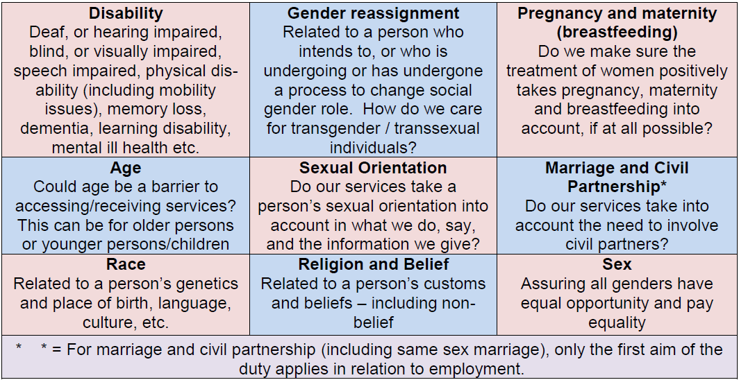
  - The flow chart below sets out the EA process:
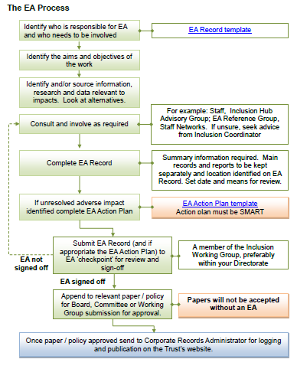
  - The EA form for completion is below. Depending on the outcome at this initial stage, an action plan may also be required. The template for actions is included below. Please contact inclusion@secamb.nhs.uk for support undertaking an EA.

Name of author and role
Directorate |  | Date of analysis:
Name of policy being analysed
Names of those involved in this EA

1. Trust policies and procedures should support the requirements of the Equality Duty within the Equality Act: | - Eliminate discrimination, harassment and victimisation;  - Advance equality of opportunity between persons who share a relevant protected characteristic and persons who do not share it;  - Foster good relations between persons who share a relevant protected characteristic and persons who do not share it. | In submitting this form, you are confirming that you have taken all reasonable steps to ensure that the requirements of the Equality Duty are properly considered.

2. When considering whether the processes outlined in your document may adversely impact on anyone, is there any existing research or information that you have taken into account? | For example:  - Local or national research  - National health data  - Local demographics  - SECAmb race equality data  - Work undertaken for previous EAs | If so, please give details:

3. Do the processes described have an impact on anyone’s human rights? | If so, please describe how (positive/negative etc):

4. What are the outcomes of the EA in relation to people with protected characteristics?
Protected characteristic | Impact  Positive/Neutral/Negative | Protected characteristic | Impact  Positive/Neutral/Negative
Age |  | Race
Disability |  | Religion or belief
Gender reassignment |  | Sex
Marriage and civil partnership |  | Sexual orientation
Pregnancy and maternity

5. Mitigating negative impacts:

If any negative impacts have been identified, an Equality Analysis Action Plan must be completed and attached to the EA Record. A template for the action plan is available in the Equality Analysis Guidance on the Trust’s website. Please contact inclusion@secamb.nhs.uk for support and guidance.

Protected characteristic: |  | Issue identified:
Action required:
Action lead:
How will impact/outcome be measured? |  | Timescale:
Resolution of actions:

Protected characteristic: |  | Issue identified:
Action required:
Action lead:
How will impact/outcome be measured? |  | Timescale:
Resolution of actions:

EA Sign off

EA checkpoint (Inclusion Working Group member, preferably from your Directorate) | [Name and role]
By signing this, I confirm that I am satisfied the EA process detailed on this form and the work it refers to are non-discriminatory and support the aims of the Equality Act 2010 as outlined in section 1 above.
Signed: |  | Date:

Appendix A – Supervision Requirements Matrix

Role / Group | Type and Format of Safeguarding Supervision | Supervisor | Number of Sessions (Per Year)
Associate Director of Safeguarding and Quality | Mandatory | External Provider | 4
Head of Safeguarding | Mandatory | External Provider | 4
Specialist Safeguarding Practitioner | Mandatory | Head of Safeguarding | 4
Safeguarding Co-Ordinator | Mandatory | Safeguarding Practitioner | 4
Freedom to Speak Up Guardian | Mandatory | Head of Safeguarding | 4
Frequent Caller Team | Mandatory | Specialist Safeguarding Practitioner | 4
Operational Staff, EOC and 111 | On Request | Trained Safeguarding Supervisor | Ad Hoc
Wellbeing Practitioners, HR, all other roles within the Trust | On Request | Trained Safeguarding Supervisor | Ad Hoc

Appendix B – Supervision Agreement
Safeguarding Children and Vulnerable Adults: Safeguarding Supervision Agreement and Action Plan

Part A – Supervisees Commitments
- To bring to the session a case involving children, vulnerable adults or concerns that I want to discuss.
- To take responsibility for making effective use of the supervision time and ensuring any action points I commit to are delivered on.
- To protect time for supervision and ensure appointments are maintained wherever possible.

Part B – Supervisors Commitments
- To assist the supervisee to explore and reflect on issues raised within the meeting, and to focus on the discussion points negotiated at the beginning of the session.
- To assist the supervisee to clarify their role and responsibilities in safeguarding children and vulnerable individuals.
- To maintain confidentiality and only disclose information shared by the supervisee when;
- A risk to others (patients, colleagues, public) is identified.
- As part of an agreed action plan with the consent of the supervisee.
- An issue related to professional practice is identified but this cannot be addressed within the confines of the session. In this case escalation to a senior member of the safeguarding team or the supervisees line manager may be required.

Part C – Joint Commitments
- To work together in a professionally respectful way, having open and constructive dialogue and ensuring feedback is acted upon.

Supervisor Signature |  | Supervisee Signature
Date |  | Location
Agreed Action Points |  | By Whom? | Completion Date
1
2
3

15. Appendix C – Supervision Cycles

SRS Model
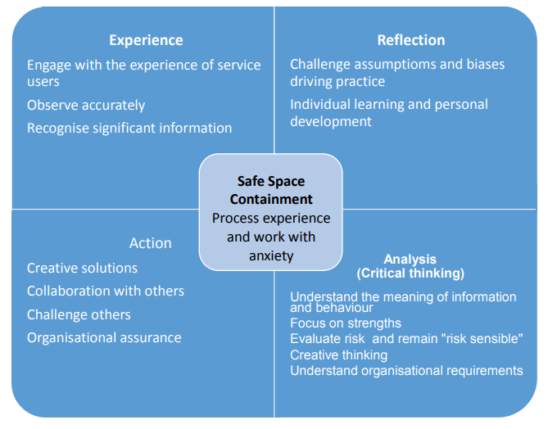
http://www.in-trac.co.uk/wp-content/uploads/2016/04/SRS-background-paper-March-2016-V021.pdf
4x4x4 Model
