Hazardous Area Response Team
Deployment
Standard Operating Procedure

Contents

Document Control 1
1. Scope 6
3 Compliance with the Core Standards 8
4 HART Operations in SECAmb 9
5 Deployment: Start of Shift 10
6 Deployment: Immediate Tasking 11
7 Deployment: Principles and Authorisation 11
8 Deployment: HART Incidents 12
9 Deployment: Mobilisation 13
11 Deployment: Stand Down 14
12 Deployment: Meal break 15
13 Deployment: End of Shift 15
14 Supporting Operations 16
15 National Deployments or Mutual Aid 17
17 Definitions 19
18 Responsibilities 20
19 Audit and Review (evaluating effectiveness) 20
20 Associated Trust Documentation 21
21 Financial Checkpoint 21
22 Equality Impact Analysis 21
Equality Impact Assessment (EIA) template (refer to guidance) 22
Appendix A: HART Deployment Principles 39
Appendix B: HART Deployment Quick Reference Guide 40
40
Appendix C: HART OTL Guidelines for 7th & 8th Operative 43
Appendix D: Mutal Aid & National Deployment Guide 44
Appendix E: Deployment from Ashford during Operation Brock 45

- Scope
  - South East Coast Ambulance Service NHS Foundation Trust (the Trust) is committed to providing high quality patient care in hazardous and high-risk environments. It can provide this care through the effective deployment of the Hazardous Area Response Team (HART).
  - The Hazardous Area Response Team is part of the Resilience and Specialist Operations Division within the Trust and is overseen by the Specialist Operations Leadership Group.
  - Hazardous Area Response Teams (HART) are a specialist capability within NHS ambulance services in England and Wales, trained and equipped to provide paramedic care to patients in the “hot zone” or “inner cordon” of hazardous environments. This may include industrial accidents, chemical, biological or radiological incidents, confined spaces, water operations, and terror-related or high-risk incidents, where operational ambulance crews cannot safely intervene.
  - The overarching aim for HART is to increase survival rates and improve clinical outcomes for patients in high-risk situations or hazardous environments.
  - HART are a crucial specialist capability within ambulance services, operating as part of the mandated NHS Emergency Preparedness, Resilience and Response (EPRR) Framework, supporting national resilience and interoperability under the Cabinet Office's National Resilience Capabilities programme.
  - The Trust has a duty to provide hazardous area capability within the service footprint whilst also maintaining a national capability. This national capability includes interoperable working alongside other Trusts and seamless working alongside other agencies.
  - Interoperability standards for HART are defined within the NHS Emergency Preparedness, Resilience and Response (EPRR) Framework and the National Interoperability Performance Standards. These require HART teams to be equipped, trained, and capable of providing mutual aid to any other NHS Trust across England. To maintain interoperability, SECAmb HART will operate in line with nationally agreed Standard Operating Procedures (SOPs), except where a formally approved local variation exists for specific operations.
  - HART must maintain compliance with the core standards set out within the Emergency Preparedness, Resilience and Response (EPRR) Framework, issued by the NHS Emergency Capabilities Unit (ECU) for NHS England as part of the EPRR Framework.

  - HART are commissioned to maintain the following tactical capabilities:
- Hazardous Materials (HAZ MAT)
- Chemical, Biological, Radiological, Nuclear (CBRN)
- High Consequence Infectious Disease (HCID)
- Marauding Terrorist Attack (MTA)
- Safe Working at Height (SWAH)
- Confined Space (ConSpace)
- Unstable Terrain/Urban Search and Rescue (USAR)
- Water Operations (SRT)
- All-Terrain Vehicle / Off Road Vehicle operations (ATV)
- Support to Security Operations (SSO)
  - To achieve compliance with the national standards this procedure outlines the operational deployment arrangements for HART, with the objectives outlined in the section below.
- Objectives
  - The objectives of this procedure are set out below:

  - To ensure that the Hazardous Area Response Team can be deployed safely and effectively in accordance with their commissioned purpose.

  - To ensure that patients in our region can be supported and cared for quickly should they become ill or injured within a hazardous environment.

  - To ensure that the Trust is compliant with the core standards.

  - To encourage the use of HART and increase the appropriate utilisation of specialist capabilities within the Trust.

  - To ensure that the HART capabilities are understood and are available when required.

  - To ensure that there is an agreed and documented mechanism for HART to be redeployed to a higher priority call should the need arise.

  - To support the Trust in delivering its strategic aims and objectives.

  - To clearly identify who is both accountable and responsible for the deployment of HART within SECAmb.

- Compliance with the Core Standards
  - The NHS Core Standards for EPRR set out a total of 32 standards for HART. The HART Deployment Standard Operating Procedure ensures that we are compliant with the following core standards:
  - H8 Organisations must maintain a minimum of six operational HART staff on duty, per unit, at all times (24/7).
  - H12 Organisations must maintain a local policy or procedure to ensure the effective prioritisation and deployment (or redeployment) of HART staff to an incident requiring the HART capabilities.
  - H13 Organisations must maintain an effective process to identify incidents or individual patients, at the point of receiving a 999 call, that may benefit from the deployment of HART capabilities. Organisations must also have systems in place to ensure unreasonable delays in HART deployments are avoided.
  - H22 A minimum of four HART staff must be available to respond to any incident requiring HART services within 15 minutes of the call being received by the Emergency Operations Centre (EOC). This does not apply to pre-planned operations.
  - H23 Once a full HART capability is confirmed as being required at scene, The Trust must ensure that 6 HART staff (including the 4 already mobilised) are released and able to respond to scene within 10 minutes of that confirmation.
  - H24 The Trust must maintain a HART service capable of placing 6 competent HART staff on scene at strategic sites of interest within 45 minutes. These sites are currently defined within the Home Office Model Response Doctrine.

  - H25 HART are required to maintain a 30-minute notice to move when activated by The Trust to respond to a mutual aid request. An exception to this time period can be claimed if the team are already providing HART capability to a local incident.

  - If the Trust is unable to maintain a full HART capability, then ECU must be informed as soon as practicable via the ECU on call system or by the daily online reporting system called PROCLUS.
- HART Operations in SECAmb
  - SECAmb provides two operational Hazardous Area Response Teams (HART) providing 24/7 coverage. These teams, commonly referred to as the “live teams” are based at Ashford and Gatwick respectively.
  - Teams are split regionally, East and West, but can provide a response anywhere in the Trust.
  - SECAmb will aim to roster eight HART operatives per site for each shift, including one HART Operational Team Leader. Six operatives will form the live deployable team, while the seventh and eighth operatives will undertake additional duties that support wider operational activity in line with organisational priorities.
  - Staffing Requirements per site
 | Minimum Requirement | Target Requirement
HART Operative | 5 | 7
HART OTL | 1 | 1
Team Total | 6 | 8
Resourcing shown is for one site, for the duration of one 12-hour shift. These requirements may be adjusted at any time by the leadership team to mitigate national or local risks.

  - The core team of six operatives deploy on a fleet of three vehicles known as HART Response Vehicles (HRV). The core fleet are given separate HART specific callsigns in accordance with national guidance. These callsigns are ALPHA, BRAVO and CHARLIE.
  - Each HRV can carry a maximum of two personnel - including the driver.
  - Each vehicle carries the necessary personal protective equipment for its operatives; however, specialist HART equipment is distributed across all three vehicles. As a result, a safe system of work can only be established once all three vehicles have arrived at the scene.
  - ALPHA – This vehicle is usually staffed by two HART Operatives and provides a local dispatch desk category 1 response capability.
  - BRAVO – Typically carries the HART Operational Team Leader, one HART Operative and a multitude of specialist kit and equipment.
  - CHARLIE – This vehicle is usually staffed by two HART Operatives, and a multitude of specialist kit and equipment.
  - HART also have the capability to utilise other vehicles within the fleet to provide the most appropriate response to the incident. This includes a Toyota Hilux 4X4, a marked personnel carrier, an unmarked personnel carrier, marked logistics vehicle and welfare vehicle. The callsign DELTA is also occasionally used.
  - HART have access to various specialist equipment such as scene lighting, shelter, high level CCTV, thermal imaging and other capabilities.
- Deployment: Start of Shift
  - HART Operatives are required to book on at the commencement of their shift via the Mobile Data Vehicle Solutions device (MDVS) and must use the notes section to specify the role of their vehicle. Typing either ALPHA, BRAVO or CHARLIE within the notes upon sign on.

  - The HART Operational Team Leader (HOTL) is responsible for checking that their team has booked on at the start of their shift. They should complete this by contacting the HART Tasking Desk (HTD) or Critical Care Desk (CCD) via the dedicated telephone number or radio channel.

  - If the HART OTL is unable to contact the HTD/CCD, they must contact the local Dispatch Team Leader (for Ashford or Gatwick respectively) without delay to advise of their availability.

  - The HART OTL will advise EOC which HART Response Vehicle (HRV) will be available for Category 1 incidents within the local dispatch desk. In most circumstances this will be the ALPHA HRV.

  - HART Operatives working on a solo response vehicle, or other vehicle types outside of the core team of 6, are individually responsible for signing on in accordance with the Dispatch Standard Operating Procedure.

  - Each HART Team has 45 minutes to carry out mandated PPE and vehicle checks at the start of shift. Should HART be assigned to an incident during this time they should inform EOC of a potential response delay.

- Deployment: Immediate Tasking
  - In the following circumstances the nearest HART Team should be deployed immediately:

  - Major Incident Stand-by
  - Major Incident Declared
  - Declaration of Operation Plato or a suspected Marauding Terrorist Attack
  - CBRN Incident (Suspected or Confirmed)
  - Aircraft Incident / Aircraft Crash
  - Incident at COMAH Site / Strategic site of interest
  - Channel Tunnel Incident
  - Established Mutli-agency operation (e.g. Operation Plato)
  - At the request of a Tactical Commander
  - Any member of EOC staff can deploy HART immediately in these circumstances.

  - Once assigned, HART will mobilise to the incident within 15 minutes.

- Deployment: Principles and Authorisation

  - The HART Deployment Principles set out in Appendix A should be used to shape and guide the Trust approach to HART Deployment.
  - The Head of Specialist Operations, supported by the HART Operations Manager, is accountable for the safe and effective deployment of HART and is ultimately accountable for their utilisation.

  - The responsibility for authorising the deployment of HART during normal business sits with the Service Delivery Manager.

  - The Service Delivery Manager and the EOC Operational Commander must be notified of every HART deployment to maintain real‑time situational awareness of team activity and resource movement.

  - The responsibility for providing authorisation can be delegated to the Resource Dispatcher overseeing specialist tasking functions within EOC, the EOC Operational Commander or the Critical Care Desk and HART Tasking Desk when available.

  - The Duty HART OTL and the HART Tasking Desk are jointly responsible for supporting EOC and ensuring that HART resources are dispatched promptly, safely and in accordance with the agreed criteria.

  - The Critical Care Desk will support the safe and effective deployment of HART; however, it must not be viewed as solely responsible for HART deployment. Owing to their role, CCD staff are well placed to identify HART-appropriate incidents and offer advice on the suitability of a HART response when capacity allows.
- Deployment: HART Incidents

  - Non-Exhaustive Definition

  - A HART Incident is any incident that involves, or is likely to involve, a hazardous environment or complex rescue scenario where the specialist capabilities of HART are required to ensure the safe treatment, extrication, or support of patients.

  - HART Incidents

  - HART incidents that meet the criteria for an immediate deployment should see HART dispatched immediately. In these circumstances the team will mobilise within 15 minutes once assigned.

  - HART incidents that meet the required criteria within HART Deployment Quick Reference Guide (Appendix B), should receive an immediate HART response. In these circumstances the team will mobilise within 15 minutes once assigned.

  - HART incidents that do not appear to meet the deployment criteria should be discussed with the HART OTL or brought to the attention of the HART Tasking Desk when available.

  - EOC staff should contact the relevant HART OTL should they feel that HART are required. Gatwick – 07827 982 140 Ashford – 07771 506 619.

  - Guidance for identifying potential HART incidents is provided in Appendix B.

  - Crew Requests for HART
  - A ‘crew request’ (for HART) will receive, wherever possible, an immediate HART response to the incident. This will be based on the availability of HART at the time of the request.
  - It may be appropriate for the HART Operational Team Leader to gather more information from the crew. However, this should not delay the deployment of the Team within 15 minutes.
  - Requests from other agencies
  - Occasionally other agencies may request HART directly by contacting the EOC or the Tactical Advisor/NILO.
  - Wherever possible, an immediate HART response to the incident will be provided. This will be based on the availability of HART at the time of the request.
  - Further interrogation of the incident by EOC and the HART OTL may be appropriate, to ascertain the need or requirement for HART.
  - Requests to support security operations (SSO) should be supported in accordance with the relevant SOP and EOC Action Card.
  - Proactive Deployment
  - In some cases, HART may need to be deployed proactively based on intelligence shared by another agency, or where EOC believes an incident is developing.
  - The HART OTL may also request a proactive deployment towards a known event or incident. This should be supported by EOC and HART should be deployed immediately.
- Deployment: Mobilisation
  - Once assigned, HART will mobilise towards an incident within 15 minutes. This time allows for the HART OTL to assess the incident and ensure that the correct vehicles and equipment are being mobilised towards the emergency. This may necessitate the need for other HART vehicles to sign on and mobilise towards the incident.
  - The Trust must ensure that four HART operatives are mobilised to any potential HART incident within 15 minutes.
  - HART Response Vehicles providing a local C1 capability will mobilise to any C1 incident within 60 seconds, as per the Dispatch SOP.
  - Where a HART Team or resource is engaged in another incident upon receipt of a HART Incident, the local resource dispatcher should utilise the Emergency Breakaway Procedure to ensure that the HART resource is able to break away from the scene.
  - Once the need for HART is confirmed, EOC has 10 minutes to ensure that all six HART operatives are mobilised to the incident. This may require use of the Trusts Emergency Breakaway Procedure.
- Deployment: Authorisation of Safe Systems
  - When deployed to any incident HART must comply with all national and local performance standards and operating procedures.
  - Any intervention at scene involving a safe system of work or safety critical PPE must be authorised by the Service Delivery Manager. Alternatively, an appropriately trained tactical commander at the scene of the incident alongside HART can also provide this authorisation, providing this authorisation is logged on the CAD.
  - Proceeding without authorisation would only be justifiable when a snatch rescue/immediate response is needed where there is a real and immediate threat to life. A rationale for this decision must be clearly documented by the responsible HART OTL. HART OTLs should consider utilising body worn video.
  - The only exception is for confirmed CBRN incidents where authorisation must be sought from Tactical Advisor/NILO.
- Deployment: Stand Down
  - Stand Down En-Route
  - The decision to stand down HART whilst en-route to an incident must be carefully considered and all available information should be reviewed. It is important to avoid the premature stand down of HART, especially when the hazards present at the scene have not been thoroughly assessed.
  - The decision to stand down HART en-route to an incident should be a shared one, between the HART Operational Team Leader, Commanders at the scene of the incident and the EOC Operational Commander.
  - Decisions to stand down should be documented on the CAD.
  - The Tactical Advisor/NILO should be utilised for decision support if required.
  - Clear on scene
  - Once HART book clear on scene consideration should be given to their availability. In some circumstances HART will need to return to base to complete equipment checks or clean equipment or uniform. This should take place ahead of the next deployment.
- Deployment: Meal break
  - During business-as-usual circumstances HART will comply with the agreed SECAmb arrangement for meal breaks as specified in the Meal Break Policy.
  - Live teams should be issued meal breaks in a staggered fashion where possible to ensure one team always remains available. (e.g. Ashford team will receive a break at a different time to Gatwick).
  - In rare and exceptional circumstances, it may be necessary for HART meal breaks to be disturbed to provide a timely or lifesaving response to a confirmed Major Incident or National Deployment. This is to safeguard our compliance with the core standards for response times and ensure that HART incidents are provided with a timely and specialised response.
  - Any disturbance to a HART meal break can only be authorised by the Service Delivery Manager (SDM) or Tactical Commander at the scene of an incident requesting HART attendance. Appropriate renumeration will be arranged by the Specialist Operations Leadership Team. Any disturbed staff should return immediately for a compulsory break after the incident.
  - This is covered by section 5.2.6 of the Meal Break Policy.
- Deployment: End of Shift
11.1. During business-as-usual circumstances HART are subject to the end of shift arrangements within the Dispatch Standard Operating Procedure.
11.2. In rare circumstances, it may be necessary for HART deploy outside of the end of shift arrangements to provide a timely or lifesaving response to a Major Incident. This is to ensure our compliance with the core standards for response times and ensure that HART incidents are provided with a timely and specialised response.
11.3. A welfare focused approach should be taken to HART deployments that are close to end of shift. EOC staff, HART OTLs and Commanders should work together to establish the most appropriate response to the incident.

- Supporting Operations
  - HART will aim to provide a range of services to the operational divisions and integrated care to support the Trust in achieving its strategic objectives.
  - Support to operations will be provided by HART alongside its core commissioned services; however, the primary role of HART and the response to HART incidents will always take precedence over any operational support activities.
  - The aspirational target for HART staff on duty is 8. When 8 operatives are available 6 will make up the core live team. Operatives 7 and 8 can be deployed by the HART OTL to support operations.
  - HART Operational Team Leaders should review Appendix C, and establish how best to deploy the 7th or 8th operative.
  - HART Supporting Operational Incidents (Non-HART Incidents)
  - The core live team of 6 may be asked to assist operational crews at the scene of non-HART incidents. This may include attending incidents to provide further analgesia, support with extrication or where additional clinicians would benefit the scene.
  - EOC staff should contact the HART OTL directly if they feel support from HART is required or would be beneficial.
  - It may be appropriate to deploy a single HRV to an incident. For example, where a DCA requires grade 2 back up, and the use of a HRV would prevent the need to dispatch a further DCA.
  - HART Tasking Desk (Virtual Support within EOC)
  - When resourcing allows, one HART Operative will attend the nearest EOC to provide the HART Tasking Desk function and support EOC with the early identification of incidents, prompt dispatch of HART and appropriate incident advice.
  - HART will also support the Critical Care Desk with the prioritisation of Category 2 incidents and stratification of risk.
  - The role of the HART Tasking Desk will be set out in the relevant local procedure.
  - HART Category 1 Response
  - In support of operations, HART will provide one HART Response Vehicle (HRV) at each site which will be available to respond to Category 1 incidents.
  - The C1 HRV will only be available to EOC when the team has 6 operatives or more.
  - Responses to category 1 incidents will be provided across the entire geographical area of the dispatch desk (Gatwick or Ashford respectively).
  - HART Response Vehicles (HRV) are large vehicles that are heavily laden with equipment. Whilst they can provide a C1 response, consideration should be given to the potential driver safety issues associated with this.
  - HART Solo Paramedic Response
  - When staffing allows HART will provide an additional response vehicle capable of responding to all categories of call. This will vary, depending on the availability of an appropriate response vehicle.
  - A co-operative approach to dispatch should be taken and the approach should mirror that of a Zonal SRV, as per the Dispatch SOP.
  - Double Crewed Ambulance
  - HART can support operations by allowing the 7th or 8th operative to crew a DCA. HART OTLs should check if there are any single crewed vehicles that would benefit from HART support to create a crew, within the local dispatch desk.
  - Other Roles
  - Operatives may be deployed to complete other priority tasks to support operations, depending on the business need.
- National Deployments or Mutual Aid
  - National Deployments
  - The Trust must ensure that all on duty HART personnel, vehicles and equipment are ready and available to provide mutual aid at 30 minutes notice.
  - The Trust must be suitably prepared to deploy its HART team anywhere in the United Kingdom and the selected team must mobilise within 30 minutes.
  - The UK NHS Ambulance Service National Mutual Aid for Spontaneous, Protracted and Pre-Planned Incidents - A Memorandum of Understanding 2020 - provides NHS Ambulance Trusts with a structured set of considerations and supporting arrangements to manage the process of requesting and providing mutual aid, as agreed between all NHS Ambulance Trusts.
  - Should a request be made to deploy HART outside of the SECAmb region the person receiving the request should inform the Tactical Advisor/NILO, Service Delivery Manager and the EOC Manager.
  - Requests for mutual aid require agreement from the Strategic Commander, and guidance can be found within the Trusts Incident Response Plan.
  - Requests for large scale interoperable capabilities, such as HART, will be facilitated and co-ordinated through the National Ambulance Coordinating Centre (NACC).
  - The process for managing a national deployment / mutual aid request for HART can be found within Appendix D.
  - Appendix D sets out the process clearly and ensures that SECAmb HART Operatives who are deployed nationally are provided with the relevant support and guidance.
  - Mutual Aid (Neighbouring Trust)
  - SECAmb may support neighbouring trusts in accordance with Managing Incidents Cross Borders Between Ambulance Trusts Memorandum of Understanding.
  - This deployment can only be authorised by the Service Delivery Manager, however this should not delay mobilisation towards the incident.
  - In these circumstances the Emergency Capabilities Unit and NACC must be informed.
  - A practical, common-sense approach, should be applied to incidents that are unlikely to be protracted and are just over the border. Consideration should be given to the impact this could have on SECAmb and how we would provide a HART capability whilst the team are over the border.

- Deployment of the HART Training Team
  - In order to maintain the various tactical capabilities and meet the core standards, the HART rota ensures that there is a training week for each team, every seventh week of the rota.
  - In most circumstances training weeks should be undisturbed and the team are not deployable to operational incidents or events during planned training.
  - The operational deployment of the HART Training team to an incident can only occur in specific circumstances which are set out below.
  - Only the Trusts Strategic Commander can authorise the deployment of the HART Training Team. They should seek advice and guidance from the Specialist Operations Leadership Group before making a decision, or the NILO/Tactical Advisor out of hours.
  - There will be occasions where deployment of the training team is simply not possible or practicable. This could be where the team is training elsewhere in the UK, or where the training being conducted would require lengthy travel, decontamination and preparation before being operationally deployable.
16.6. Consideration should also be given to the potentially significant financial implications of withdrawing a team from planned training, and the costs incurred by the Trust.
16.7. Circumstances in which the Strategic Commander can consider deployment of the HART Training Team:
- A Major Incident has been declared.
- A business continuity incident has been declared.
- The operational HART team have been deployed nationally through a mutual aid request.
- An agreed REAP Level 4 action
- Definitions
  - ECU - Emergency Capabilities Unit
  - NHSE - NHS England
  - PROCLUS - Official National Emergency Capabilities Unit dashboard
  - HART – Hazardous Area Response Team
  - SORT – Specialist Operations Response Team
  - NACC – National Ambulance Co-ordination Cell
  - CCD – Critical Care Desk
  - HTD – HART Tasking Desk
  - EOC – Emergency Operations Centre
  - EOCM – EOC Manager / EOC Operational Commander
  - NILO – National Interagency Liaison Officer
  - SOP – Standard Operating Procedure
  - SSO – Support to Security Operations
- Responsibilities
  - The Chief Operating Officer (COO) is responsible for the development of the HART Deployment Procedure within the Trust. This may be delegated on a day-to-day basis to the Divisional Director of Resilience and Specialist Operations.

  - The Head of Specialist Operations and HART Operations Managers are responsible for the implementation of the HART Deployment Standard Operating Procedure.

  - The Head of Specialist Operations and HART Operations Managers are accountable for the deployment of the Hazardous Area Response Team.

  - The Service Delivery Manager is responsible for authorising HART deployments; however, this responsibility can be delegated to the Resource Dispatcher overseeing specialist tasking functions within EOC, the EOC Operational Commander or the Critical Care Desk and HART Tasking Desk when available.

  - The HART Operational Team Leaders (HOTL) are responsible for ensuring their team are fully aware of and comply with this procedure.

  - The HART Operatives are responsible for ensuring they are aware of this procedure and adhere to its principles and content.

  - Resource Dispatchers, Dispatch Team Leaders and EOC Managers are responsible for ensuring their team are fully aware of and comply with this procedure.

  - Service Delivery Managers and Tactical Commanders are responsible for ensuring they are fully aware of and comply with this procedure.
- Audit and Review (evaluating effectiveness)
  - The HART Standard Operating Procedure will be reviewed at least once annually.
  - Effectiveness will be reviewed using the tools set out in the Trust’s Policy and Procedure for the Development and Management of Trust Policies and Procedures (also known as the Policy on Policies).
  - This document will be reviewed in its entirety every year or sooner if new legislation, codes of practice or national standards are introduced, or if feedback from employees indicates that the policy is not working effectively.
  - All changes made to this procedure will go through the governance route for development and approval as set out in the Policy on Policies.
  - The effective deployment of HART is reviewed monthly by the Specialist Operations Leadership Group.
  - HART deployments will also be reviewed as part of the core standard compliance review.
- Associated Trust Documentation
  - The following documents are associated with this procedure:
- Dispatch Standard Operating Procedure
- Incident Response Plan
- MTA Response Plan
- CBRN Response Plan
- SORT Deployment Procedure
- Maritime Response Plan
- HART Training and Development Procedure
- Meal Break Policy
- HART Tasking Desk Local Procedure
- HART Business Continuity Locality Plan
- Financial Checkpoint
  - This document has been confirmed by Finance to have no unbudgeted financial implications.
- Equality Impact Analysis

Equality Impact Assessment (EIA) template (refer to guidance)
What piece of work does this relate to: Deployment of the Hazardous Area Response Team
Lead author: Westley Shaw Role: Head of Specialist Operations

- Is this a:
- Change to an existing strategy (long term plan of action), policy or procedure ☒

- Who will be impacted by this work? Tick all that apply.
Patients  Staff |  |  | External Partners (please specify below) ☐  Fire and Rescue, Police, Other HART Teams  Other (including a particular geographical area, describe below) ☐  Click or tap here to enter text.

- Summarise the work being assessed. Describe current status followed by any changes that stakeholders would experience.
Update to the HART deployment procedure to bring it up to date with current terminology and deployment according to the latest National Standards. Stakeholders are likely to experience an improved level of service. In addition to updating terminology and alignment with national standards, this procedure ensures equitable access to specialist HART capabilities for patients across all geographical areas, including rural and hard-to-reach locations. It also supports staff by providing clear, consistent deployment processes that promote safety, fairness and inclusion in high-risk operational environments.

- Checklist

All the Trust’s policies, programmes, strategies, services and major developments affect patients, carers, service users, employees and the wider community. These will have a greater or lesser relevance to equality, diversity and inclusion.
The following questions will help you to identify how relevant your proposals are.
When considering these questions think about age, carers, disability, gender reassignment, race, religion or belief, sex, sexual orientation, pregnancy and maternity and any other relevant characteristics (for example socio-economic status, social class, income, unemployment, residential location or family background and education or skills levels).
Make notes to assist with the completion of the EIA.
Questions | Yes | No
Is there potential for/ indication of or evidence that the proposed change will affect different population groups differently (including possibly discriminating against certain groups)? | ☐ | ☒
Have there been or are there likely to be any public concerns (including media, academic, voluntary or sector specific interest) about the change? | ☐ | ☒
Could the proposal affect how our services, commissioning or procurement activities are organised, provided, located and by whom? | ☒ | ☐
Could the proposal affect our workforce or employment practices? | ☒ | ☐
Is there potential for or evidence that the proposed change will not promote equality of opportunity or promote good relations between different groups? | ☐ | ☒
If yes to any of the above, please add information in the notes
This procedure impacts workforce deployment, working conditions in high-risk environments and access to specialist services. Consideration has been given to ensuring equitable deployment, safe systems of work and inclusive operational practice.

- Equality Impact Assessment
  - Key stakeholders
A key principle for completing Equality impact assessment is that they should not be done in isolation. Consultation with affected groups and stakeholders needs to be built in from the start, to enrich the assessment and develop relevant mitigation. Detail here who you have involved with completing this EIA.

Name / Group | Organisation | Role on assessment team  e.g., service user, manager of service, specialist (which area)
Specialist Operations Leadership Group | SECAmb | Manager of service
People Services Team | SECAmb | Specialist (Employee relations, people services)
HART Operatives | SECAmb | Service Provider
SCAS HART Leaders | SCAS | Service user
HART Deployment T&F Group | SECAmb | Multiple
Staff Networks | SECAmb | - Staff Networks (e.g. enABLE, Armed Forces, Inspire Networks)  - Health & Wellbeing / Occupational Health

  - Who may be positively or negatively affected by this activity?
Protected characteristics (Equality Act 2010) | In addition, consider the following vulnerable groups:
Age ☒ | Armed forces ☐ | Socioeconomic disadvantage ☐
Disability ☒ | Carers ☐ | People with addiction or substance misuse problems ☐
Race ☒ | Digital exclusion ☐ | People on probation ☐
Gender reassignment ☒ | Domestic abuse ☐ | Prison population ☐
Marriage & civil partnership ☒ | Education (literacy) areas ☐ | Undocumented migrant, refugees, asylum seekers ☐
Pregnancy & maternity ☒ | Homeless ☐ | Sex workers ☐
Religion & beliefs (including no belief) ☒ | Looked after children ☐ | Other (please specify below) ☐
Sex (male or female) ☒ | Rural areas ☐
Sexual orientation ☒ | Urban areas ☐

  - Assessment outcomes – discussion undertaken between Click or tap to enter a date. and Click or tap to enter a date.
Protected equality characteristic | Describe here the considerations and concerns in relation to the programme/policy for the selected groups. These may be positive, negative or neutral if there is no impact. | If you have identified any negative impacts, describe here suggested mitigations to inform the actions needed to reduce inequalities.
Age | Neutral
Disability | Positive | The procedure supports safe systems of work and access to appropriate PPE and operational adjustments. Ongoing requirement to ensure reasonable adjustments are considered for staff where applicable.
Race | Neutral | No direct adverse impact identified; however, operational environments may require consideration of cultural or religious needs (e.g. PPE, welfare arrangements).
Gender reassignment | Neutral
Marriage & civil partnership | Neutral
Pregnancy & maternity | Neutral | No direct impact identified; however, deployment considerations should align with existing policies relating to pregnancy and operational duties
Religion & beliefs | Neutral | No direct adverse impact identified; however, operational environments may require consideration of cultural or religious needs (e.g. PPE, welfare arrangements).
Sex | Neutral | No direct impact identified; however, deployment considerations should align with existing policies relating to pregnancy and operational duties
Sexual orientation | Neutral

Vulnerable groups/existing inequity | Describe here the considerations and concerns in relation to the programme/policy for the selected groups. These may be positive, negative or neutral if there is no impact. | If you have identified any negative impacts, describe here suggested mitigations to inform the actions needed to reduce inequalities.
Armed forces | Neutral
Carers | Neutral
Digital exclusion | Neutral
Domestic abuse | Neutral | The deployment of HART supports patients in high-risk environments, including vulnerable groups such as those in rural locations, individuals experiencing socioeconomic disadvantage or those requiring specialist rescue. The procedure promotes equitable access to care regardless of location or circumstance.
Education (literacy) | Neutral | The deployment of HART supports patients in high-risk environments, including vulnerable groups such as those in rural locations, individuals experiencing socioeconomic disadvantage or those requiring specialist rescue. The procedure promotes equitable access to care regardless of location or circumstance.
Homeless | Neutral | The deployment of HART supports patients in high-risk environments, including vulnerable groups such as those in rural locations, individuals experiencing socioeconomic disadvantage or those requiring specialist rescue. The procedure promotes equitable access to care regardless of location or circumstance.
Looked after children | Neutral | The deployment of HART supports patients in high-risk environments, including vulnerable groups such as those in rural locations, individuals experiencing socioeconomic disadvantage or those requiring specialist rescue. The procedure promotes equitable access to care regardless of location or circumstance.
Rural/urban geographies | Neutral | The deployment of HART supports patients in high-risk environments, including vulnerable groups such as those in rural locations, individuals experiencing socioeconomic disadvantage or those requiring specialist rescue. The procedure promotes equitable access to care regardless of location or circumstance.
Socioeconomic disadvantage | Neutral | The deployment of HART supports patients in high-risk environments, including vulnerable groups such as those in rural locations, individuals experiencing socioeconomic disadvantage or those requiring specialist rescue. The procedure promotes equitable access to care regardless of location or circumstance.
People with addiction or substance misuse problems | Neutral | The deployment of HART supports patients in high-risk environments, including vulnerable groups such as those in rural locations, individuals experiencing socioeconomic disadvantage or those requiring specialist rescue. The procedure promotes equitable access to care regardless of location or circumstance.
People on probation | Neutral | The deployment of HART supports patients in high-risk environments, including vulnerable groups such as those in rural locations, individuals experiencing socioeconomic disadvantage or those requiring specialist rescue. The procedure promotes equitable access to care regardless of location or circumstance.
Prison population | Neutral | The deployment of HART supports patients in high-risk environments, including vulnerable groups such as those in rural locations, individuals experiencing socioeconomic disadvantage or those requiring specialist rescue. The procedure promotes equitable access to care regardless of location or circumstance.
Undocumented migrants, refugees, asylum seekers | Neutral | The deployment of HART supports patients in high-risk environments, including vulnerable groups such as those in rural locations, individuals experiencing socioeconomic disadvantage or those requiring specialist rescue. The procedure promotes equitable access to care regardless of location or circumstance.
Sex workers | Neutral | The deployment of HART supports patients in high-risk environments, including vulnerable groups such as those in rural locations, individuals experiencing socioeconomic disadvantage or those requiring specialist rescue. The procedure promotes equitable access to care regardless of location or circumstance.
Other | Neutral | The deployment of HART supports patients in high-risk environments, including vulnerable groups such as those in rural locations, individuals experiencing socioeconomic disadvantage or those requiring specialist rescue. The procedure promotes equitable access to care regardless of location or circumstance.

5.4 Impact on Human Rights
If a provision or feature of your policy or service potentially unlawfully interferes with a human right then it is negative . If something protects or promote a human right, then it is positive. Human rights and freedoms belong to everyone. They give the legal basis to basic values of fairness, respect, equality, dignity and autonomy. They provide a set of minimum legal standards for all public bodies, including the NHS. They protect an individual’s rights whilst considering the rights of other people and wider society.
Human Rights | Describe here the considerations and concerns in relation to the programme/policy for the selected groups. These may be positive, negative or neutral if there is no impact. | If you have identified any negative impacts, describe here suggested mitigations to inform the actions needed to reduce inequalities.
A2. Right to life (e.g. Pain relief, DNAR, competency, suicide prevention) | Neutral
A3. Prohibition of torture, inhuman or degrading treatment (e.g., Service Users unable to consent) | Neutral
A4. Prohibition of slavery and forced labour (e.g., Safeguarding vulnerable patients’ policies) | Neutral
A5. Right to liberty and security (e.g., Deprivation of liberty protocols, security policy) | Neutral
A6&7. Rights to a fair trial; and no punishment without law (e.g., MHA Tribunals) | Neutral
A8. Right to respect for private and family life, home and correspondence (e.g., Confidentiality, access to family etc) | Neutral
A9. Freedom of thought, conscience and religion (e.g., Animal-derived medicines/sacred space) | Neutral
A10. Freedom of expression (e.g., Patient information or whistle-blowing policies) | Neutral
A11. Freedom of assembly and association (e.g., Trade union recognition) | Neutral
A12. Right to marry and found a family (e.g., fertility, pregnancy) | Neutral
P1.A1. Protection of property (e.g., Service User property and belongings) | Neutral
P1.A2. Right to education (e.g., accessible information) | Neutral
P1.A3. Right to free elections (e.g., Foundation Trust governors) | Neutral

- Action plan and monitoring arrangements
Insert your action plan here (example layout provided). This should be based on mitigations recommended in 6.2. Involve your key stakeholders in monitoring progress against the actions above, and add more rows as required.
ACTIONS & DECISIONS TRACKER
What is being assessed:
What management group will have oversight of these actions (this should be the group which has oversight of the change):
Item | Initiation Date | Action/Item | Person  Actioning | Target Completion Date | Update/Notes
1 | 26/03/2026 | Monitor deployment data to ensure equitable access across geographical areas | W Shaw | 26/03/2027
2 | 26/03/2026 | Review workforce feedback to identify any unintended impacts on staff groups | W Shaw | 26/03/2027
3 | 26/03/2026 | Ensure alignment with reasonable adjustments processes | W Shaw | 26/03/2027

The above actions should be added to the action log for the named management group.

- Inclusion Working Member for directorate
Based on your assessment, please indicate which course of action you are recommending to the author. You should explain your recommendation in the blank box below.
Outcome No. | Description | Tick
Outcome One | No major change to the proposal required. This EIA has not identified any potential for discrimination or negative impact, and all opportunities to promote equality have been undertaken.  Proceed with the programme and review EIA mid-programme. | TICK
Outcome Two | Adjust the proposal to remove barriers identified by the EIA or better advance equality. Are you satisfied that the proposed adjustments would remove the barriers you identified?  Proceed with adjustments, amend programme and review EIA mid-programme.
Outcome Three | Continue the proposal despite potential for negative impact or missed opportunities to advance equality identified. You will need to make sure the EIA clearly sets out the justifications for continuing with it. You need to consider whether there are:  - Sufficient plans to stop or minimise the negative impact. Consider if risks need adding to the risk register.  - Mitigating actions for any remaining negative impacts plans to monitor the actual impact.  Proceed with programme. Monitor and evaluate. Discuss with responsible management group and Inclusion Team for advice where required.
Outcome Four | Stop and rethink the service change/proposal when the EIA shows actual or potential unlawful discrimination. Review change/proposal with the responsible management group for this area of work and identify alternative way forward
Please use the box on the right to explain the rationale for your recommendation:

- Governance

Sign off | Inclusion Working Member for directorate | Date:
27.03.2026 | Dawn Chilcott (Confirmed via Marvel) | 27/03/2026

- Version Control

Version Number | Purpose/Change | Author | Date
1.0 | EIA Initial Draft | Westley Shaw | 13/03/2026
2.0 | Final Draft | Westley Shaw | 23/03/2026
3.0 | Final Version with changes. | Westley Shaw | 26/03/2026
The above provides historical data about each update made to the EIA.
Please include the name of the author, date and notes about changes made – so that you are able to refer back to what changes have been made throughout this iterative process.
Please send an approved copy of this EA to inclusion@secamb.nhs.uk and polsandprocs@secamb.nhs.uk along with the Marvel approval e-mail.

Appendix A: HART Deployment Principles
HART Deployment Principles

The HART deployment principles have been developed to assist Emergency Operations Centre staff and those with responsibility for HART deployment in the safe and effective utilisation of HART.

- Prioritise safety

HART should be considered where incidents involve (or are likely to involve) hazardous environments or specialist rescue scenarios that exceed the safe working limits of standard ambulance resources.
This includes any situation requiring specialist PPE, technical rescue capability or structured safe systems of work.

- Ensure timely access to specialist capabilities

When patients are likely to benefit from HART’s skills, equipment, or extrication capability, the team should be considered a priority resource. The team should be dispatched early to reduce delays in care, improve outcomes, and maintain compliance with HART response time standards.

We must ensure that patients who are ill or injured in hazardous environments are provided with timely access to healthcare. The specialist capabilities should be made available to them at the earliest opportunity.

- Act early when the size, complexity, or uncertainty of an incident is high.

HART should be deployed early when an incident involves multiple casualties, emerging high-risk information, multi-agency operations, or when the size or type of hazard is uncertain. If there is any doubt, it is safer to activate HART early to prevent delays and ensure a safe system of work is established quickly.

It is always safest to deploy HART early when we suspect that a HART incident is taking place. This reduces the time taken to reach the incident and ensures that we have the specialist equipment and capabilities available if needed.

All those involved in the deployment of HART should consider the implications of inappropriate utilisation and the impact this can have on our ability to provide a HART response when it is really needed.

Appendix B: HART Deployment Quick Reference Guide
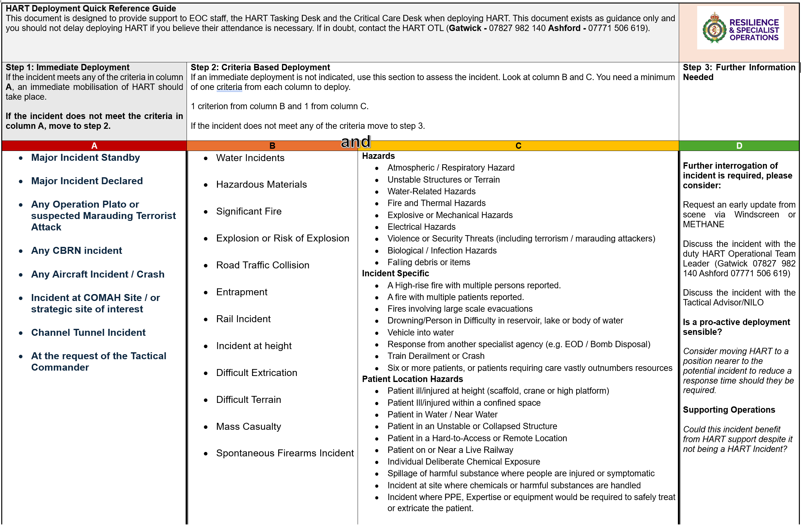

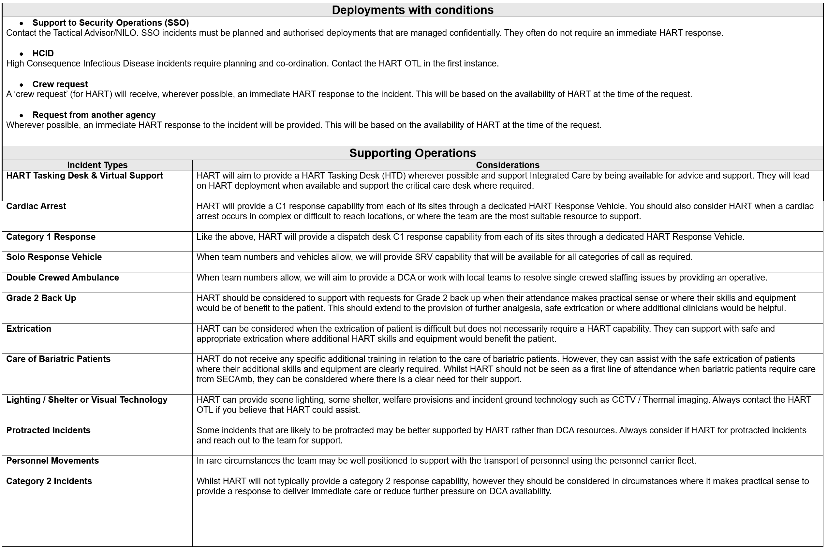

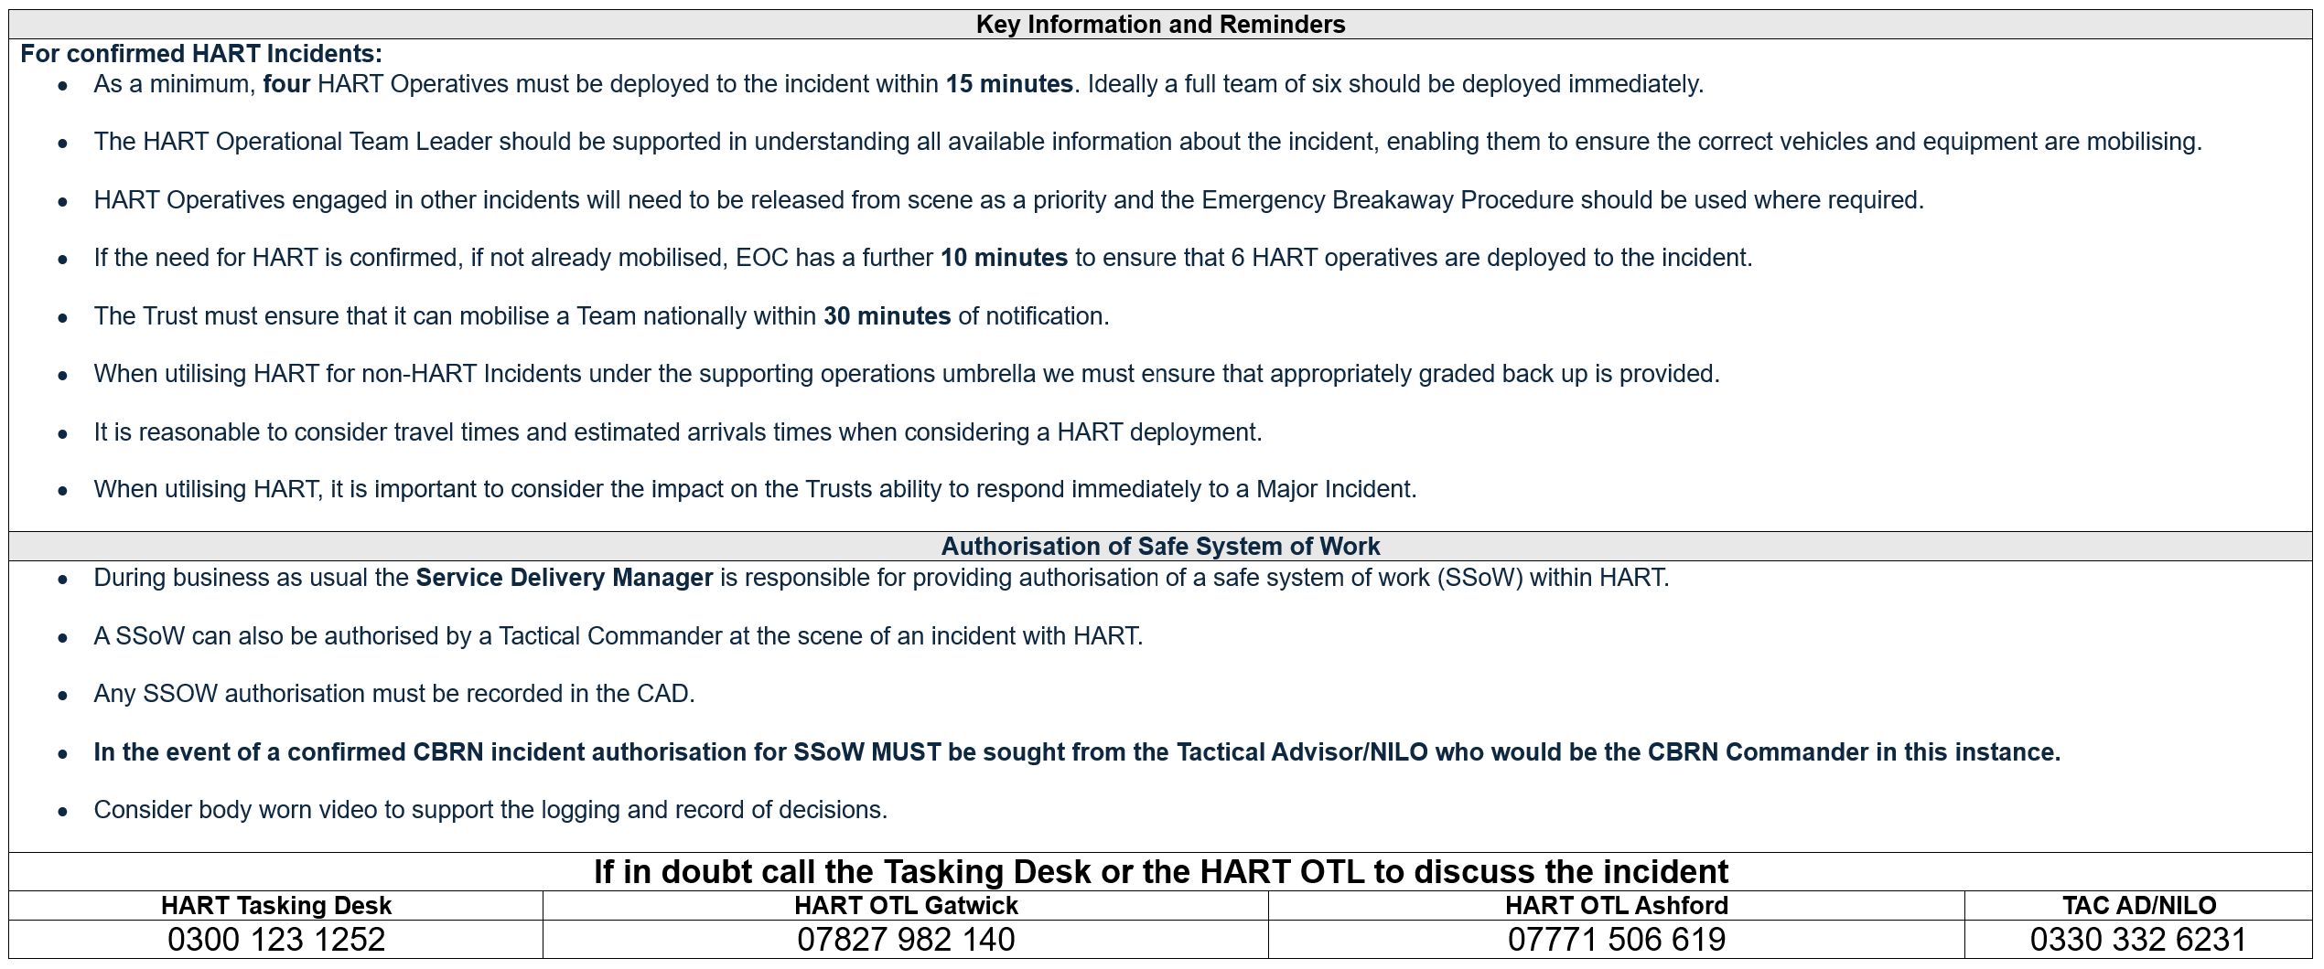

Appendix C: HART OTL Guidelines for 7th & 8th Operative
HART Operational Team Leaders should use this guidance to determine the most appropriate deployment of the 7th or 8th HART Operative on shift, with final deployment decisions resting with the HART OTL. Utilisation of staff will be reviewed monthly by the Specialist Operations Leadership Group.
Things to consider:
- Current pressure being experienced by the Trust (REAP / CSP Level)
- Planned events or ongoing incidents
- Operatives can fulfil more than one role during a shift (e.g. PPE checks followed by SRV once completed)
- The availability of vehicles and resources

Priority 1 | The HART Tasking Desk (HTD) should be covered wherever possible and is therefore a priority. There is only a requirement to provide a HTD at one EOC, and therefore H-OTLs from each site should agree which operative will fulfil this purpose.
Priority 2 | Where vehicles allow, we should provide a solo response vehicle that is capable of responding to all categories of call. This can be deployed in accordance with the Dispatch SOP and should work with local dispatch teams to target SRV appropriate incidents.
Priority 3 | Where vehicle availability allows operatives should crew a double crewed ambulance and provide a response to all calls. Additionally, it may be most appropriate to engage with local OTLs and resolve any single crewing issues.
Priority 4 | Completion of priority workstreams, agreed with HART Ops Manager (i.e. mission critical PPE or equipment checks).
Priority 5 | Completion of key work such as providing training, facilitation or other critical work in support of the core standards.

In the event of a major incident or significant incident requiring the support of HART, the 7th and 8th person may be required to support the HART incident.

Appendix D: Mutal Aid & National Deployment Guide

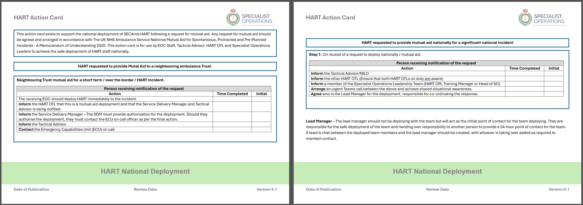

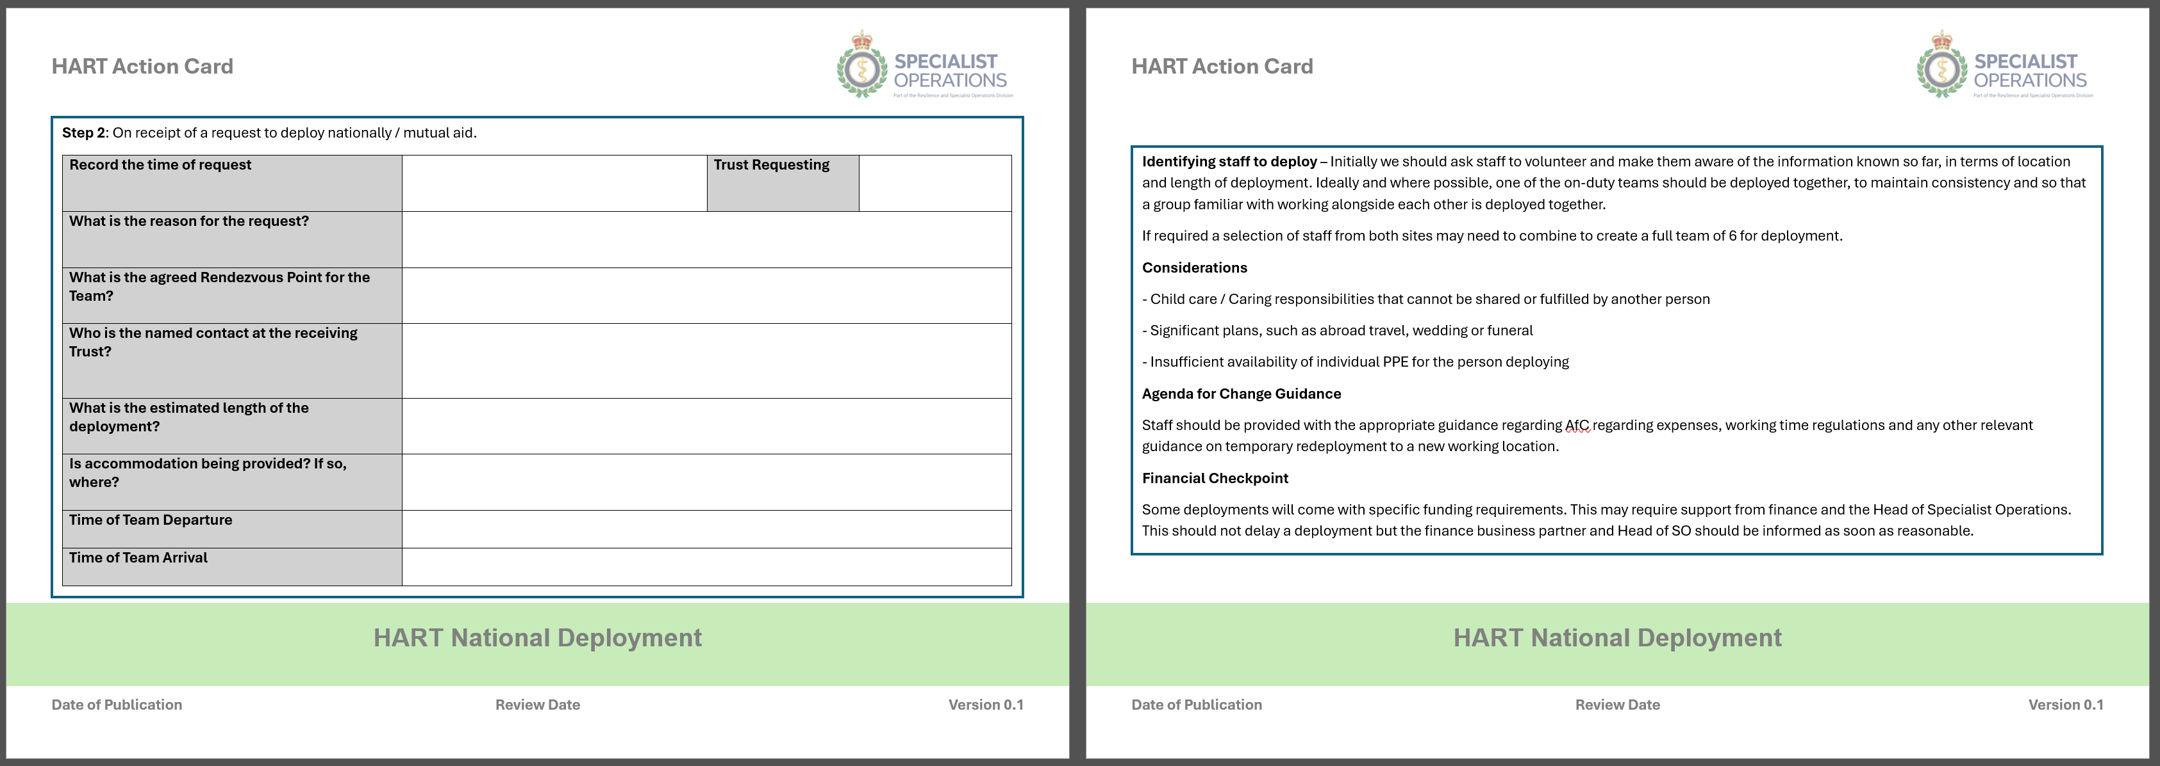

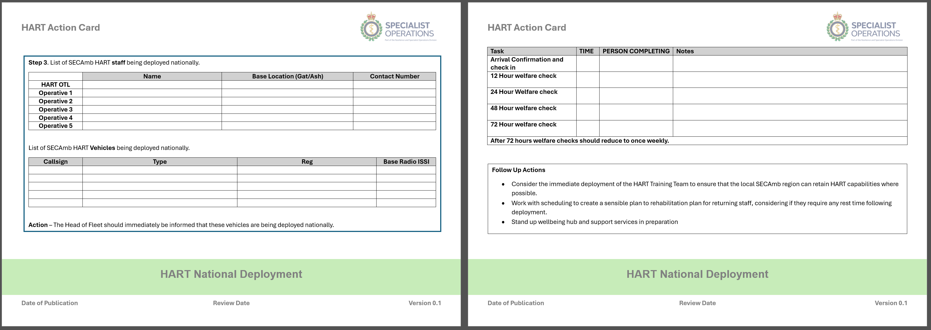

Appendix E: Deployment from Ashford during Operation Brock

Operation Brock is part of the National Highways staged approach plan to managing the flow of HGV traffic into the Channel Tunnel and Port of Dover. It consists of installing a contraflow system between junctions 8-9 London bound on the M20, 2 lanes for coastbound traffic and 2 lanes for London bound traffic, with the coast bound side of the M20 reserved for freight traffic. In the contraflow on both directions the left lane is for use by all traffic and the right lane has a width restriction of 2m.
This creates a problem for HART when they are deploying to any incident from Ashford in a London bound direction and would normally use the M20, due to the new HART Response Vehicles having a vehicle dimension width of 2.7m.
Responding to an incident within the Brock footprint would still be managed as per the Op Brock action card.
This leaves HART responding to incidents past the Brock footprint with two options:
- Respond taking the M20 and traveling through Brock in the left-hand lane, which would be at normal speed and not under 'Emergency conditions' - Blue lights and sirens.
- Respond taking the A20 using emergency conditions on the understanding that it will be busier than usual (due to local traffic avoiding Brock) and is a single carriageway road for most of its length from Ashford to Maidstone.

An ethnic group or ethnicity is a named social category of people who identify with each other on the basis of shared attributes that distinguish them from other groups such as a common set of traditions, ancestry, language, history, society, culture, nation, religion, or social treatment within their residing area. A useful guide to terminology can be found here: https://www.lawsociety.org.uk/topics/ethnic-minority-lawyers/a-guide-to-race-and-ethnicity-terminology-and-language
Digital Exclusion can be linked to the following key root causes: - Connectivity access to the internet – can include financial barriers as well as suitable broadband speeds/connectivity - Digital Skills the ability to use digital tools such as email, online shopping, digital healthcare - also includes having confidence in online safety, and how to utilise particular services or apps - Technology and Accessibility access to appropriate devices to suit their individual needs – includes access to devices suitable for use with a certain disability as well as financial and location barriers - Not wanting to use digital platforms simply not wishing to utilise digital services – this could be due to distrust of providers, online security, privacy etc.

