Critical Care Desk Policy and Procedure

Version: | V1
Name of originator/ author: | Simon King  Critical Care Clinical Operations Manager
Responsible management group: | Critical Care Governance Subgroup
Directorate/team accountable: | Medical Directorate

Policy and Procedure:
Approved by: | Executive Management Board (EMB)
Date approved: | 02/10/2024
Fit for purpose according to: | Critical Care Governance Sub-Group

Date issued: | 02/10/2024
Date next review due: | 02/10/2027
Target audience: | All Staff
Replaces (version number): | New (Critical Care Desk Dispatch Policy including Major Trauma)

Equality Analysis Record
Approved EA included Dated: | 15/07/2024
Finance Checkpoint
Finance Business Support approved – Financial implications understood.  Dated: |   26/07/2024
Data Privacy Impact Assessment
Approved DPIA included Dated: | 24/05/2024

Document Control

Formal approval:
Final approval by: | Joint Partnership Forum
Version No. V1 | Final | Date: 02/10/2024
Responsible Management Group approval by: | Critical Care Governance Sub-Group
Version No. V1 | Final | Date: 02/10/2024

Review/comments:
Person/ Committee | Comments | Version | Date
Simon King | First Draft | V0.1
Ben Paul, Calum Burnett, Tommy Lemon, Gary Balderston | Review | V0.2 | 18/07/2024
Barry Butler, Michelle Lam, Elliott Stiles | EOC Review | V0.3 | 22/07/2024
Critical Care Governance Subgroup (CCGSG) | CCGSG Review | V0.4 | 25/07/2024
Simon King | Amendments based on comments from reviews | V0.5 | 25/07/2024
Simon King | Amendments from consultation feedback (including AAKSS and legal) | V0.6 | 30/08/2024
Liam McDine, Simon King | Proof Reading amendments | V0.7 | 03/09/2024
Richard Banks | Final edits ahead of JPF submission | V0.8 | 09/09/2024
Leigh Herbasz | Approved by EMB | V1 | 02/10/2024

Circulation:
Records Management Database upload | Date: 15/10/2024
Internal Stakeholders
External Stakeholders

Review Due by responsible Management Group:
Period | Every three years or sooner if new legislation, codes of practice or national standards are introduced | Date: 02/10/2027

Record Information:
Security Access/ Sensitivity | Official (Public Domain)
Where Held | Corporate Records Register
Disposal Method and Date | In line with national guidelines

Contents

Document Control 2
1 Statement of Aims and Objectives 5
2 Staffing 5
3 Training and Assessment of Competence 5
4 Crew Down/Emergency button 6
5 CCP Welfare 6
6 Dispatch 7
7 Standby 8
8 Clinical Advice 9
9 Call Interrogation 9
10 Clinical Dispatch Support 11
11 Top Cover Consultants and Subject Matter Experts 12
12 Mutual Aid 12
13 Observers 14
14 HEMS support 14
15 HART Dispatch 15
16 Duty Critical Care Clinical Operations Manager 16
17 Planned IT outages 16
18 Unplanned IT Outages 17
19 Major Incidents 17
20 Responsibilities 18
21 Monitoring compliance 18
22 Audit and Review (evaluating effectiveness) 19
23 Associated Trust Documentation 19
24 Financial Checkpoint 19
25 Equality Analysis 19
26 Data Privacy Impact Assessment 20
Appendix A: Critical Care Desk Dispatch Criteria 21
Appendix B: CCP Standby Plan 26
Appendix C: IT Outage Action Card 27
Appendix D: Call Interrogation Flowchart 28
Appendix E: Video Streaming Flowchart 29
Appendix F: Clinical Dispatch Support Flowchart 30
Appendix G: Response to Clinical Safety Plan Escalation 31
Appendix H: AAKSS Stand Down and Peer to Peer process 32

- Statement of Aims and Objectives
  - South East Coast Ambulance Service NHS Foundation Trust (the Trust) is committed to providing high quality patient care, ensuring effective delivery of Specialist Paramedic led enhanced care.
  - This policy and procedure is applicable to all Critical Care Paramedics (CCPs) and Emergency Operations Centre (EOC) dispatch staff supporting the Critical Care Desk (CCD). Ensuring a consistent approach across all CCD tasks and practices.
  - This policy and procedure will outline the routine practices for staff operating the CCD within the EOC. This document is not intended to be read and followed in isolation and has been written in reference to various other policies and procedures that are current at the time of publishing.
  - The primary aim of the CCD is to ensure that a high level of patient care is delivered in a timely manner by dispatching CCPs effectively, providing clinical advice to operational colleagues and supporting dispatch decisions and resourcing.
- Staffing
  - The CCD will be staffed 24 hours a day with a CCP with over one year’s experience as a CCP.
  - The CCD will be covered in either East or West EOC depending on closest location to the CCP covering the CCD.
  - The CCD will be covered by operational Critical Care Team Leaders (CCTLs) and CCPs, through rota, relief planning or overtime if the shift is uncovered.
  - Bank CCPs will be able to cover CCD shifts should their SECAmb CAD access remain active and they complete regular CCD shifts.
  - Covering the core day and night CCD shifts is a priority and takes precedence over operational road cover. CCPs will be reasonably moved from road CCP shifts to cover the CCD if there are vacant shifts or short notice absences.
  - All CCPs working within EOC will wear SECAmb uniform and must comply with the Uniform and Dress Code Policy and Procedure whilst undertaking their duties.
- Training and Assessment of Competence
  - CCPs must have been trained and signed off to use both Cleric (CAD) and LifeX (CROPS) Radio system prior to commencement of their CCD mentoring. Training will be conducted by the EOC training team and will routinely commence at 10 months post qualifying as a CCP.
  - Three mentoring shifts will be undertaken supernumerary with an experienced CCD operative, a fourth shift will be undertaken with a CCTL or Critical Care Clinical Operations Manager (CCCOM) to assess competence and complete a ‘sign off’ shift for the CCP.
  - A CCD portfolio of competence must be completed and signed off during the mentoring period to ensure competence in all aspects.
  - If a CCP is unsuccessful on the sign off shift, they will have an individual action plan designed to support them with further mentoring shifts and a subsequent sign off shift. Should a further assessment/sign off shift be unsuccessful the individual CCP will have a meeting with the CCCOM responsible for the CCD to discuss suitability.
  - CAD profiles will lock following 6 months of inactivity. CCPs will be required to attend a Cleric retraining session with the EOC training team to reactivate the account. Following retraining an individualised mentoring plan will be designed depending on the needs of the individual to ensure competency on the CCD.
- Crew Down/Emergency button
  - Any resource that activates their ‘crew down/emergency button’ on channel 16,17 or 350 will require the CCD operative to take immediate action.
  - Crew welfare is paramount and all crew down activations will take priority over current ongoing tasks.
  - The Dispatch Team Leader (DTL) covering the dispatch desk of the resource requiring assistance will take responsibility for ambient listening and arranging police attendance. The CCD operative must ensure that contact is made with that DTL. If unable to reach that specific DTL they must liaise with an available DTL to ensure ambient listening and that police attendance is arranged as priority.
  - The CCD operative and dispatch teams will follow the EOC Emergency ‘Crew Down’ Button Procedure
- CCP Welfare
  - CCP welfare, including the CCD operatives, is paramount due to the frequent exposure to high acuity incidents. CCPs should routinely receive a welfare call from the CCD following their clear status from particularly challenging or stressful incidents.
  - It is the responsibility of all CCPs and the critical care leadership team to ensure welfare across the Critical Care Operating Unit (CCOU), the CCD operative is ideally placed for overall situation awareness. A welfare flag should routinely be raised by completing the ‘Critical Care Welfare Escalation’ Microsoft Form available on both the CCD and CCP Operations Teams channels. This form alerts the OU leadership team to a CCP requiring welfare and will ensure they have appropriate follow up welfare.
  - Immediate welfare needs should be flagged initially to the duty CCTL or the duty CCCOM.
  - CCPs should be placed ‘out of service’ on the CAD for a debrief or appropriate rest period following challenging or stressful incidents if required.
- Dispatch
  - Operational CCPs will routinely be marked on the CAD as ‘C1 only’, allowing for auto-allocation when closest to a Category 1 (C1) call, whilst also showing as available to the Resource Dispatchers (RDs) when closest to a C1 call or Grade 1 backup request. All other allocations will be the responsibility of the CCD.
  - On Duty CCPs, CCTLs and Critical Care Response Capable Managers (RCMs) will be shown or moved on to the ‘Specialist Tasking’ stack, which is monitored by the CCD.
  - CCPs will be dispatched to C1 calls in line with the Dispatch SOP – if the CCP is the closest resource to a C1call they will routinely be auto-allocated by the CAD, allocated by the RD for that Operational Dispatch Areas (ODAs) dispatch desk or by the CCD. The RD/DTL should update the CCD following allocation of a critical care resource.
  - Operational CCPs will routinely monitor CAD Online for their ODAs and neighbouring ODAs to identify incidents that the CCD may not be aware of. This is especially important during high levels of escalation in the Clinical Safety Plan (CSP), see Appendix G.
  - Primacy of CCP dispatch sits with the CCD operatives and will be in line with the CCP dispatch criteria in Appendix A. Specific high acuity incidents may require multiple CCPs to be dispatched especially if no HEMS assets are available or there is a prolonged run time for HEMS, due to multiple enhanced care interventions needing to be carried out.
  - Grade 1 backup requests must be highlighted by the RD/DTL and trigger an immediate CCP interrogation, with a low threshold for CCP dispatch unless information is presented suggesting enhanced care may not be required or is being provided by an alternative agency.
  - The routine response to a crew request for CCP support is that a CCP is dispatched whilst further information is gained and if required, remote clinical advice provided to the crew.
  - CCPs will be updated verbally en route to incidents by the CCD operative, with pertinent information including scene safety issues.
  - CCPs will only be stood down by the CCD operative following clinical information either presented prior to ambulance arrival or following a clinical discussion by the CCP in EOC with the resources on scene. All clinical updates received by the CCD will be recorded with ‘Save Notify’, to ensure that dispatch staff are aware of the update.
  - CCP travel time should not routinely exceed 45 minutes. Solo worker fatigue should be considered with longer journey times. Significant, critical and major incidents may require longer travel times to ensure appropriate enhanced care resources are available at the incident.
  - CCPs will only be marked ‘Out of Service’ if there is a reason that they are unable to respond. CCPs will not routinely be marked as ‘C1 – Cardiac Arrest Only’ unless there are four or less CCPs on duty across the Trust, and duty Emergency Operations Centre Managers (EOCMs) should be made aware. Should dynamic cover not be achievable (see section 7) then leaving only one CCP on duty in a county, they may be marked as ‘C1 – Cardiac Arrest Only’. Any CCPs marked ‘C1 – Cardiac Arrest Only’ due to low cover must be dispatched immediately to confirmed cardiac arrests and still be dispatched in line with the CCP dispatch criteria.
  - The CCD is only responsible for the dispatch of CCPs, other resources (ie. OTLs/DCAs/APPs) should not be allocated or stood down by the CCD, unless there is prior agreement with the relevant RD/DTL.
  - CCP (RCMs) should be considered by the CCD if booked on and are the closest resource to a patient requiring enhanced care. Should an RCM be out of service, the CCD operative will call the RCM to check their availability and dispatch in a timely manner.
  - CCPs will routinely provide a clinical update to the CCD shortly after arrival at an incident and should the CCP not be required and the patient safely left with other ambulance clinicians on scene, they will declare themselves ‘delayed available’. A delayed available status indicates that the CCP is no longer required on their current incident and available to break away if required for an alternative CCD tasking.
  - The CCD will not call a CCP on scene of an incident to advise of another ongoing incident or request an update of their availability unless the CCP on scene has already declared themselves ‘delayed available’. This will prevent biased decision making for the CCP on scene and reduce premature clearing.
- Standby
  - Standby points are used to maximise the reach and minimise travel times operational CCPs will have for the patients across the Operating Unit (OU) footprint.
  - It is the responsibility of operational CCPs, the CCD operative and the duty CCCOM to ensure cover is dynamically spread across the region, ensuring CCPs are in a central/suitable location for the area that they are providing enhanced care for. The CCP cover plan can be viewed in Appendix B.
  - Where practicable all reasonable efforts to spread CCP cover should be made, ensuring that solo worker fatigue is considered and that the CCP is returned to their base location prior to the end of their shift.
  - Dynamic standby should be considered if a neighbouring CCP is likely to be committed to an incident for a prolonged period.
- Clinical Advice
  - The CCD is available to provide remote clinical advice to operational resources enroute to or on scene of incidents via radio, phone or video call.
  - Clinical advice given will be in line with current clinical guidelines and should ensure that the resources on scene remain within the scope of practice relevant for their clinical grade. The clinicians on scene are responsible for remaining within their scope of practice.
  - Additional information may be sought from a variety of sources to support decision making and clinical advice including (but not limited) to:
- Previous 999/111 calls on CAD
- Shared patient care records (IBIS/Graphnet)
- Current or previous ePCRs including images uploaded of ECGs or injuries
- Video streaming the scene with the crew
  - Where capacity allows, the CCD operative will be able to view ePCRs and may proactively contact crews enroute or whilst on scene of incidents to provide clinical advice. This may be important for ensuring high acuity patients are not delayed on scene and receive timely interventions and conveyance.
  - All clinical and triage advice provided by the CCD will be recorded within the CAD notes by the CCD operative providing the advice. The slashcode ‘/CCDA’ must be entered if advice is given for recording purposes. The crew’s callsign must also be documented.
  - Remote clinical advice from the CCD will be audited by the CCTLs, including both the call notes and voice recordings. CCTLs can access CCD notes through CAD, CAD online or the CCD PowerBI dashboard. Voice recordings for CCTLs are available on Liquid Voice. The advice will be audited through the critical care governance process.
- Call Interrogation
  - The purpose of call interrogation is to gain more information surrounding the incident from the patient or the caller, to support enhanced care dispatch. The capacity and workload of the CCD operative may prohibit some appropriate calls from being interrogated.
  - Primary triage will take place by the Emergency Medical Advisor (EMA) utilising NHS Pathways. The 999 call will not be interrupted for purposes of CCD call interrogation, including adding additional questions for the EMA to ask. Immediate life-saving interventions may be entered into the call notes for the EMA, if deemed to be critical and life saving
  - Call interrogation is to support enhanced care dispatch only and will not be used to re-triage or change the category of the call. If an immediate threat to life is identified and requires a C1 disposition, this will be a manual upgrade by the CCD. CPR advice will be given by the CCD operative if required by using NHS Pathways Solo or a backup flowchart if NHSP Solo not available. A flowchart is available in Appendix D.
  - Any other concerns around categorisation that requires changing of a calls category should be flagged to the Clinical Safety Navigator (CSN), on extension 63427 or 63428. If the CSN is unavailable contact the Clinical Dispatch Support line 60016.
  - Silent monitoring may be used to gather information about the patient to gain a clinical interpretation of the call whilst it is being taken. Silent monitoring provides a level of clinical insight into the call that may prove beneficial for dispatching enhanced care resources.
  - The CCP in EOC can call the caller back with the aim of speaking to the patient or someone with the patient to seek further information that may support the dispatch of enhanced care resources. A record of the call and information gained must be recorded in the call notes, with the slash code ‘/CCDCallBack’ entered.
‘/CCDCallBack’ – Critical Care Desk calling scene for further clinical information.
  - Video streaming will be used if there is a perceived benefit to viewing a scene, patient or their injury/illness to support enhanced care dispatch or delivering remote clinical advice to operational crews on scene. The use of video streaming will be included in the CAD notes. A flowchart is available in Appendix E. The slashcode ‘/CCDVideo’ must be entered when video streaming is utilised.
‘/CCDVideo’ – Critical Care Desk utilising video streaming.
  - Patient confidentiality must be maintained at all times and video streaming should only be carried out on CAD computers that are not overlooked within the EOC. Only the CCP will view the live streamed image.
  - Caller and patient safety is paramount and they must be in a safe position to stream the scene and not put themselves or others in danger to do so.
  - Live video streams will be viewed only, no recording, picture taking of or screen grabbing is permitted.
  - All information gathered from patient callbacks or video streaming will be accurately documented within the call notes.
- Clinical Dispatch Support
  - The aim of clinical dispatch support is to support dispatch staff with appropriate resourcing of C1 calls and high acuity incidents through clinically reviewing these calls. This will depend on the capacity and workload of the CCD operative.
  - The CCD operatives will routinely monitor all incoming calls to the Trust with clinical information being presented or identified to suggest resourcing in line with the Dispatch SOP may not be appropriate and only one resource is required. For example, a C1 cardiac arrest call where the patient is obviously deceased or resuscitation may not be deemed to be in the patient’s best interests.
  - Information gained through call interrogation will support the clinical decision making regarding appropriate resourcing of incidents.
  - Clinical rationale will clearly be documented by the CCD operative in the call notes of the specific incident to justify their decision making.
  - The RD or DTL will be informed of the clinical decision by the CCD operative. The RD/DTLs still hold overall responsibility for incidents and will be responsible for standing down further resources as advised by the CCD. The CCD will not stand down any resources apart from CCPs. The CCP will be accountable for clinical decision making along with subsequent impact that this may have on resourcing and patient care.
  - If resourcing is reduced of a C1 or high acuity incident as a result of the CCP review, the attending resource must be informed by radio and MDT by the CCD operative. The slashcode ‘/CCDResource’ will be entered in to the crew notes. The attending resource should routinely be asked to provide an early update and request the appropriate grade of backup if they require further assistance on their arrival. Clinical Support will be available from the CCD on channel 16.
‘/CCDResource’ - ** CCD – clinically deemed only one resource required. If further support is required on arrival please call control on priority **
  - A Datix should be submitted by dispatch staff for all incidents where the CCD has suggested a reduction in resourcing against the dispatch SOP and the initial resources have proceeded to request Grade 1 backup. The purpose of the Datix is to clinically review the incident, ensure patient safety and to allow for future learning
  - All incidents where resourcing has been altered will be recorded.
  - A flowchart for clinical dispatch support is available in Appendix F.

- Top Cover Consultants and Subject Matter Experts
  - Consultant support is available through the SECAmb Strategic Medical Advisor (SMA) 24 hours a day. CCD operatives can access the duty SMA contact details through the Trust’s PowerBI on call report.
  - Occasionally remote clinical advice may be provided by other Subject Matter Experts (SME), such as the Trust’s Consultant Midwife. Remote clinical advice should only be provided by those associated with the Trust.
  - Should a CCP or other resource on scene require additional advice that can’t be provided by the CCD they should contact the CCD via phone for a conference call with the duty SMA or appropriate SME. The CCD will make every effort (workload dependent) to listen to these calls and make an accurate record of the clinical discussion in the CAD notes.
  - The CCD operative can also contact the duty SMA or appropriate SME on behalf of the crew or CCP on scene. A clear record of the conversation should be made within the call notes.
  - The CCD operative should ensure that any drug advice given remains within the remit of the SECAmb PGDs.
  - All clinical advice calls are recorded and can be used for governance purposes. Whilst carrying out a clinical advice call with an SMA or SME, the CCD operative will leave the phone off the hook and muted to ensure recording continues.
- Mutual Aid
  - There may be incidents that meet CCP dispatch criteria with no CCPs available or within a reasonable proximity to dispatch. London Ambulance Service, Advance Paramedic Practitioners – Critical Care (LAS APP-CCs) are able to provide support for incidents on the LAS border. Incidents that require enhanced care mutual aid should be requested through the LAS APP-CC desk. LAS APP-CCs base locations are Brent, Croydon, Ilford and Westminster.
    - The following details need to be confirmed with the LAS APP-CC desk:
- Exact address of the 999 call as per the SECAmb CAD
- Nature of incident
- Time of initial 999 call
- SECAmb reference number
- Location of APP-CC and estimated travel time
- LAS reference number (to be logged in the CAD)

    - The call notes of the SECAmb incident must be updated with information regarding LAS dispatching an APP-CC and their travel time. An LAS callsign will be allocated to the call as ‘LASAPP1’, ‘LASAPP2’ or ‘LASAPP3’. Times for the callsign will need to be manually updated in the CAD and confirmed with the LAS APP-CC or their desk.

    - Enhanced Care resources attending SECAmb incidents will change their radio to mutual aid talk group 350 for direct communication with the CCD, this must be monitored by the CCD operative.
  - Requests for CCP support in LAS will be made in the same manner with a direct request to the CCD from the LAS APP-CC desk. LAS will need to provide the same information provided in 13.1.1. If a CCP is available within a reasonable distance/timeframe then a running call will be created on the CAD by the CCD operative or with support from the dispatch teams.
    - The call must have the following:
    - Coded as a C2 with ‘Running Call’ selected as the Nature of Call
    - Have the exact address provided and confirmed by LAS
    - ‘CCP’ must be entered into the instruction box to ensure it is clear to other EOC staff that the incident is for CCP attendance only.
    - Documentation in the call notes regarding information provided by LAS, including LAS reference number
    - SECAmb CCP resource allocated
    - The attending CCP will switch their handheld Airwave radio to LAS Mutual Aid talk group 230 for direct communication with the LAS APP-CC Desk.

    - The attending CCP will practice within their SECAmb scope of practice and follow SECAmb CPGs and PGDs. A SECAmb ePCR must be completed as a record of patient care.

  - Requests from other HEMS organisations should be made to the Air Ambulance Charity Kent Surrey Sussex (AAKSS) dispatcher. Operational CCPs may be tasked to assist depending on the nature of the incident and the distance from the closest available CCP, at the discretion of the CCD operative. The requesting HEMS organisation must confirm that they have no HEMS resources available or that their teams are attending an incident with multiple patients or a SECAmb CCP has a shorter travel time, therefore arriving first.

  - All HEMS mutual aid requests are the responsibility of the AAKSS dispatcher and not the responsibility of the CCD operative. Any requests for HEMS mutual aid to a SECAmb incident should be passed to the AAKSS dispatcher.

  - The Dispatch SOP will be followed for incidents where C1 assistance is requested by a neighbouring ambulance service for general cross border working.

- Observers
  - All internal observers on SECAmb resources should be logged on to the vehicle with their SECAmb payroll number. External observers should be logged on to the vehicle on with an observer pin as seen below. The CCD operative must ensure that this is accurately reflected and that observers are added through the ‘Shift Update’ option on the CAD.
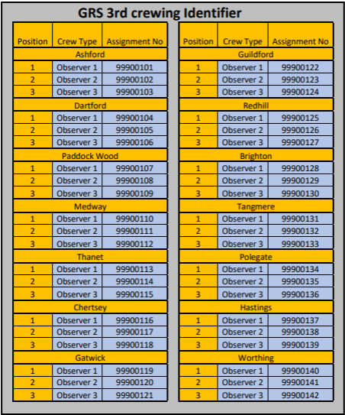
  - Observers to the CCD should be requested through the Critical Care Marval observation request form and authorised by a CCCOM.
- HEMS support
  - The CCD works closely with the AAKSS dispatcher and should work collaboratively to ensure patients receive the appropriate enhanced care resource.
  - Primacy of identification of incidents and dispatch for AAKSS resources sits with the AAKSS dispatcher.
  - If the CCD identifies a clinical requirement for AAKSS to attend then the HEMS dispatcher must be informed and a clinical rationale explained. HEMS will be dispatched if the incident has a clear clinical need meeting HEMS rules.
  - Should an incident not meet the HEMS rules the AAKSS dispatcher will discuss the incident with their duty manager. If required, the AAKSS duty manager will then discuss the requirement directly with the CCP on the CCD. The final decision on HEMS dispatch remains with the AAKSS duty manager.
  - All clinical rationale from the CCD operative will be documented in the call notes.
  - All requests for AAKSS from CCPs or crews on scene should be passed to the HEMS dispatcher even if felt not to be appropriate. Some requests may then require further discussion with the HEMS duty manager.
  - Mutual aid requests for external HEMS services will be made directly by AAKSS and not requested by the CCD operatives.
  - HEMS stand downs (see Appendix H for flowchart).
    - Following AAKSS dispatch, a stand down request for AAKSS from resources on scene must be agreed by both the HEMS dispatcher and the CCP in EOC. The CCP acts as the SECAmb senior decision maker.
    - AAKSS stand downs must be based on a clinical assessment and where possible the triage decision should also be noted.
    - In the unlikely event that a consensus regarding standing down of HEMS is not reached, the decision should be deferred to the AAKSS duty manager, either by the CCP or HEMS dispatcher.
  - The CCD and AAKSS dispatchers are entitled to manage their own breaks, ensuring adequate screen and refreshment breaks. Breaks should be coordinated between the desks to ensure that neither the CCD or AAKSS dispatcher are out of EOC at the same time, To allow for continuous identification of patients requiring an enhanced care resource.
- HART Dispatch
  - Primacy for identifying Hazardous Area Response Team (HART) suitable incidents remains with the HART Tasking Desk (HTD), but if no HTD is operating then incidents should be flagged to the CCD to dispatch HART resources. Incidents can be flagged to the CCD by the duty HART TL or dispatch teams within EOC.

  - Due to the workload of the CCD, the CCD operative will not be responsible for identifying HART incidents but can dispatch HART if they identify the need for HART attendance inline with their deployment procedure.

  - Should the CCD dispatch HART, the nearest available HART will be allocated with a follow up phone call to the HART TL to inform them of pertinent incident information.

  - The HART Deployment Procedure will be used for dispatch of HART assets.
- Duty Critical Care Clinical Operations Manager
  - A duty CCCOM be available 24 hours per day. Urgent issues requiring escalation from the CCD or regarding the CCD should be made to the duty CCTL or duty CCCOM.

  - The duty CCCOM should be informed of any issues immediately affecting cover on the CCD or those having a significant impact on operational CCP cover.

  - All immediate CCP staff welfare or significant injuries sustained at work must be escalated to the duty CCCOM by the CCD operative.

  - The duty CCCOM will also carry out the role of Tactical Medical Advisor (TMA) when required by the Trust, including attendance at significant, critical and major incidents.

  - For significant, critical and major incidents there will routinely be an East and West TMA on call, covered by both SECAmb CCCOMs and AAKSS Clinical Operations Managers (COMs). The appropriate TMA for the incident will formally be notified by EOC as part of the command structure. The CCD will still notify the SECAmb duty CCCOM for awareness due to the likely involvement of enhanced care resources or remote clinical and/or triage advice.
- Planned IT outages
  - Pre-planned IT outages are put in place to facilitate a variety of situations including infrastructure upgrades. The pre-planned outages are well organised and managed by the Critical Systems team allowing all departments to make appropriate plans.
  - The nature of the planned IT outage will be known in advance and a plan put in place and disseminated to the CCD and operational CCPs.

  - The CCD should follow the EOC action cards depending on the systems affected by the IT outage.
  - A minimum of three CCPs will be required to attend EOC:
- Clinical gatekeeper East EOC
- Clinical gatekeeper West EOC
- CCD – dispatch and clinical advice

  - The clinical gatekeeper for each EOC will be collocated with the EOC dispatch gate keeper to identify high-acuity incidents and ensure appropriate and timely enhanced care dispatch. Incidents highlighted for enhanced care dispatch will be flagged to the CCD and/or HEMS dispatcher. Incident t-Cards (paper working incident cards) will not be taken away from the dispatch function.

  - All clinical advice given by the CCP in EOC whilst on paper working will be recorded on a ‘Clinical Advice’ T-card, the paper reference must be recorded to ensure it can be correlated with the correct incident. Once completed should be attached to the correlating incident t-card. If the advice was recorded for an incident in the opposite EOC, the t-cards must be collated and saved for uploading at a later stage.

  - Critical Care resources will have a corresponding callsign card, that will be held by the clinical gatekeeper and handed to the RD dispatching that incident. Times will be collated by the CCD and passed to the RD to update the incident t-card.
- Unplanned IT Outages
  - Unplanned IT outages affecting EOC systems can present significant risk to the function of the CCD. These must be escalated to the duty CCCOM immediately for oversight and tactical planning of enhanced care resourcing.
  - The priority remains for safe and effective delivery of remote clinical advice and dispatch of enhanced care resources to the appropriate incidents.
  - The CCD action card in Appendix C must be followed for all unplanned CAD outages.
  - All actions in section ‘17. Planned IT outages’ should be followed.
  - The CCD operatives should follow the EOC action cards depending on the systems affected by the IT outage.
  - A minimum of three CCPs will be required to attend EOC, with the closest available CCPs to EOC to ensure:
- Clinical gatekeeper East EOC
- Clinical gatekeeper West EOC
- CCD – dispatch and clinical advice

  - Consideration should be given to non-operational CCPs attending EOC or supporting (i.e. CCPs on clinical governance/OU support)

  - All remote clinical advice given by the CCP whilst on paper working will be recorded on a ‘Clinical Advice’ T-card, the paper reference must be recorded to ensure it can be correlated with the correct incident.
- Major Incidents
  - The CCD has no formal role within a major incident unless requested to support through the EOC command structure.
  - The CCD operatives have primacy of dispatching CCPs to incidents, however the ongoing management of the incident remains with the Major Incident Dispatcher.
  - All scene updates (including windscreen/METHANE reports) or remote clinical advice provided through channel 16 will be recorded in the CAD notes, with ‘Save Notify’ pressed. Paper notes and records made during a major incident must be kept as per the Trusts Emergency Preparedness, Resilience and Response Policy.
  - In the event that a major incident talk group is set up, the expectation is that all radio communication is open mode on the designated talk group. The CCD will not contact scene unless requested to do so by the EOC command function.
  - Operational CCPs responding to a major incident will change to the appropriate major incident talk group once it has been established, and will then pass updates through the designated major incident talk group and not channel 16.
  - Please refer to the Trust’s Incident Response Plan for further information related to major incidents.
- Responsibilities
  - The Chief Executive Officer is the overarching executive lead for the trust.
  - The Chief Medical Officer has responsibility for ensuring patient care is of the highest standard and that CCPs practice within recognised guidelines, delivering a high level of clinical care.
  - The Consultant Paramedic for Critical Care and Resuscitation has overall responsibility for the Critical Care OU and standards of care.
  - The Critical Care Governance Subgroup is responsible for the ongoing effectiveness of this policy and procedure.
  - Critical Care Team Leaders and Critical Care Clinical Operations Managers are responsible for the governance and oversight of this policy and procedure.
  - All employees are responsible for adhering to this policy.
- Monitoring compliance
  - Compliance with this policy will be monitored by both the Critical Care Clinical Operations Managers and Critical Care Team Leaders to ensure the policy is being followed by Critical Care Desk Operatives.
  - Compliance will be a rolling process to ensure regular reviews of activity undertaken on the CCD.
- Audit and Review (evaluating effectiveness)
  - All policies and procedures have their effectiveness audited by the responsible Management Group at regular intervals, and initially six months after a new policy and procedure is approved and disseminated.
  - Effectiveness will be reviewed using the tools set out in the Trust’s Policy and Procedure for the Development and Management of Trust Policies and Procedures (also known as the Policy on Policies).
  - This document will be reviewed in its entirety every three years or sooner if new legislation, codes of practice or national standards are introduced, or if feedback from employees indicates that the policy is not working effectively.
  - All changes made to this policy and procedure will go through the governance route for development and approval as set out in the Policy on Policies.
- Associated Trust Documentation
  - CAD Outage Paper Working Procedure
  - Clinical Safety Plan
  - Cross Trust Border Memorandum of Understanding
  - Dispatch Standard Operating Procedures
  - HART Deployment Procedure
  - Incident Response Plan
  - Uniform and Dress Code Policy and Procedure
- Financial Checkpoint
  - To ensure that any financial implications of changes in policy or procedure are considered in advance of document approval, document authors are required to seek approval from the Finance Team before submitting their document for final approval.
  - This document has been confirmed by Finance to have no unbudgeted financial implications.
- Equality Analysis
  - The Trust believes in fairness and equality, and values diversity in its role as both a provider of services and as an employer. The Trust aims to provide accessible services that respect the needs of each individual and exclude no-one. It is committed to comply with the Human Rights Act and to meeting the Equality Act 2010, which identifies the following nine protected characteristics: Age, Disability, Race, Religion and Belief, Gender Reassignment, Sexual Orientation, Sex, Marriage and Civil Partnership and Pregnancy and Maternity.
  - Compliance with the Public Sector Equality Duty: If a contractor carries out functions of a public nature then for the duration of the contract, the contractor or supplier would itself be considered a public authority and have the duty to comply with the equalities duties when carrying out those functions.
  - An EIA has been authorised and approved for the policy, available upon request.
- Data Privacy Impact Assessment
  - A DPIA has been completed and authorised for the use of GoodSAM video streaming and is available if required.
  - No other new systems have been introduced that would require a DPIA

Appendix A: Critical Care Desk Dispatch Criteria
The below dispatch criteria is not exhaustive but outlines immediate and interrogated dispatch for CCP dispatch:

Immediate Dispatch – These are typically patients who have a mechanism or injury suggestive of major trauma and a high risk of bleeding or are likely to have actual or evolving brain injury (including medical and cardiac arrest patients). The primary aim is to dispatch a CCP as soon as practically possible after the 999 time. It is recognised that there will be a stand down burden associated with immediate tasking, however this is offset by the potential benefit of being able to offer Critical Care earlier.
A CCP is allocated as soon as reasonably practicable after the information presented either from silent monitoring or the EMA call notes. The call can be further monitored and the CCP stood down if information becomes available to suggest there is no requirement for a CCP. CCP allocation should not be delayed in these patients whilst further information is gained. If a CCP is not allocated to any immediate dispatch criteria the rationale must be documented in the call notes.
If a CCP is not available to attend calls that trigger the immediate dispatch this should also be recorded in the CAD notes.

Interrogated Dispatch – The information in these calls may be limited initially and require further information to determine if a CCP is required. If information presented during the 999 call indicates that a CCP may add benefit to patient care then a CCP should be dispatched. It is also recognised that not all patients in the interrogated dispatch criteria will require a CCP response. If the decision is made to not send, this should be documented in the CAD notes, dependent on CCD workload and demand.
Cardiac Arrests
Immediate Dispatch | Interrogated Dispatch
Medical Cardiac Arrests with BLS ongoing
Dispatch if it appears the patient may be suitable for a resuscitation attempt. Otherwise, CCD to contact crew within 10 minutes of arrival for further clinical discussion and support.
Cardiac arrests in a public place (inclusive of leisure and sports facilities)
Special Circumstances:
Paediatric arrest
Traumatic cardiac arrest
Drownings/Hypothermia
Obstetric Emergencies
Immediate Dispatch | Interrogated Dispatch
Consider CCP requirements if midwife already on scene
Post-Partum Haemorrhage | Normal Birth >32 week gestation
Shoulder Dystocia | Antepartum Haemorrhage
Breech Birth | Cord Prolapse (low threshold for advice or CCP dispatch)
Maternal Seizures (over 24 weeks pregnant or ≤48 hours post delivery)
Preterm imminent delivery (22-32 week gestation)
Maternal Cardiac Arrest
Trauma
Immediate Dispatch | Interrogated Dispatch
Unconsciousness following trauma (RTC/Major Trauma) | Paediatric falls with clinical concerns
RTC – Pedestrian Vs Vehicle >30mph road | Fall from horse
RTC – Paediatric bullseye  RTC – Rollovers with patients still trapped | Rail incidents
Fall from first floor or above | Obvious fractures with deformity or open fractures
Penetrating trauma or shooting triggering MTTT | Spinal injury with abnormal neurology
Fractures/dislocations with clear evidence of vascular compromise | Near Drowning/pulled from water
Amputations proximal to wrists and ankles | Burns and Scalds
Explosions/significant burns | Building fires – persons reported
Building fires - confirmed patients or persons unaccounted for | Advanced analgesic requirements
Medical
Immediate Dispatch | Interrogated Dispatch
Brittle Asthma (declared by caller or CAD history marker) | Reduced GCS of unknown cause - consider history
Fitting – rescues meds administered and still fitting | Anaphylaxis with potential airway compromise
Fitting - prolonged seizures >5 minutes | Overdoses:  - Unconsciousness  - Opiates  - Evidence of ABC compromise
Unstable Respiratory Patients:
- Asthma NoC/declared life threatening asthma
- Tracheostomy complications/ventilated patients
- Breathing problems with potential for CPAP requirements

Unstable Cardiac Patients:
- Tachyarrhythmias
- Bradyarrhythmias
- STEMI
Mental Health
Immediate Dispatch | Interrogated Dispatch
Severe non-traumatic agitation requiring restraint | Section 136 NoC  Mental Health calls with imminent risk  Moderate non-traumatic agitation with restraint
End of Life Patients
Primacy for EOLC patients should sit with Urgent Care Hubs and Advanced Paramedic Practitioners.
Crew request for JiC medications with no Urgent Care specialists available should be supported by CCPs
Critical/Major Incidents
Immediate Dispatch | Interrogated Dispatch
Declared Major Incident  Resourcing variable depending on incident – minimum 3 CCPs to be dispatched | Major Incident Standby  Mass casualty/critical incidents

Appendix B: CCP Standby Plan
Critical Care Paramedics should be dynamically deployed to strategic standby locations throughout their shifts. If cover is reduced throughout a shift either for the whole shift or temporarily due to an ongoing incident attend by other CCPs, the CCD and local CCP will be responsible for dynamic cover. Ensuring CCP cover is equally distributed whilst ensuring CCP welfare and solo worker fatigue is considered.
The standby locations remain the responsibly of the CCD operative depending on distribution of CCP cover across the Trust, this should be discussed with the duty CCP. This decision can be made in conjunction with the duty CCTL or CCCOM if required.
Below is an example of reduced cover locations:
County | Base Location | Routine Standby | Reduced Cover | One Resource
Kent | Dartford | Strood North ACRP | Larkfield ACRP | Faversham ACRP
Kent | Paddock Wood | Larkfield ACRP | Larkfield ACRP | Faversham ACRP
Kent | Thanet | Manston ACRP | Canterbury West ACRP | Faversham ACRP
Kent | Ashford | Folkestone Central ACRP | Canterbury West ACRP | Faversham ACRP
Sussex | Brighton | Brighton MRC | Burgess Hill (reduced cover to the North) | Burgess Hill ACRP
Sussex | Hastings | Battle ACRP | Polegate (reduced cover to the West) | Burgess Hill ACRP
Sussex | Worthing | Arundel ACRP | Worthing (reduced cover to the East) | Burgess Hill ACRP
Surrey | Chertsey | Chertsey MRC | Gatwick MRC | Leatherhead ACRP
Surrey | Gatwick | Gatwick MRC | Gatwick MRC | Leatherhead ACRP
Surrey | Tongham | Tongham AS | Tongham AS | Leatherhead ACRP

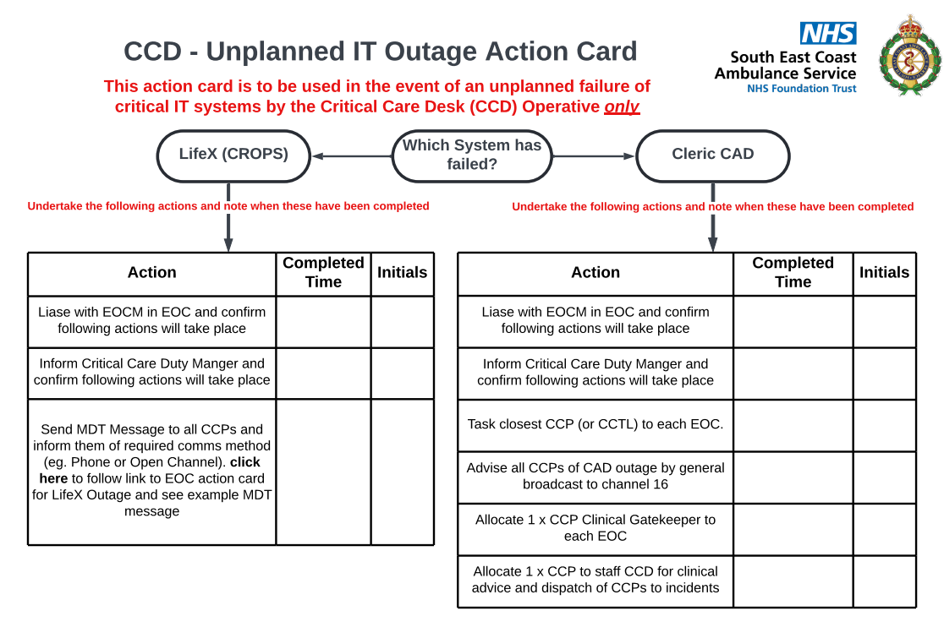
Appendix C: IT Outage Action Card

Appendix D: Call Interrogation Flowchart
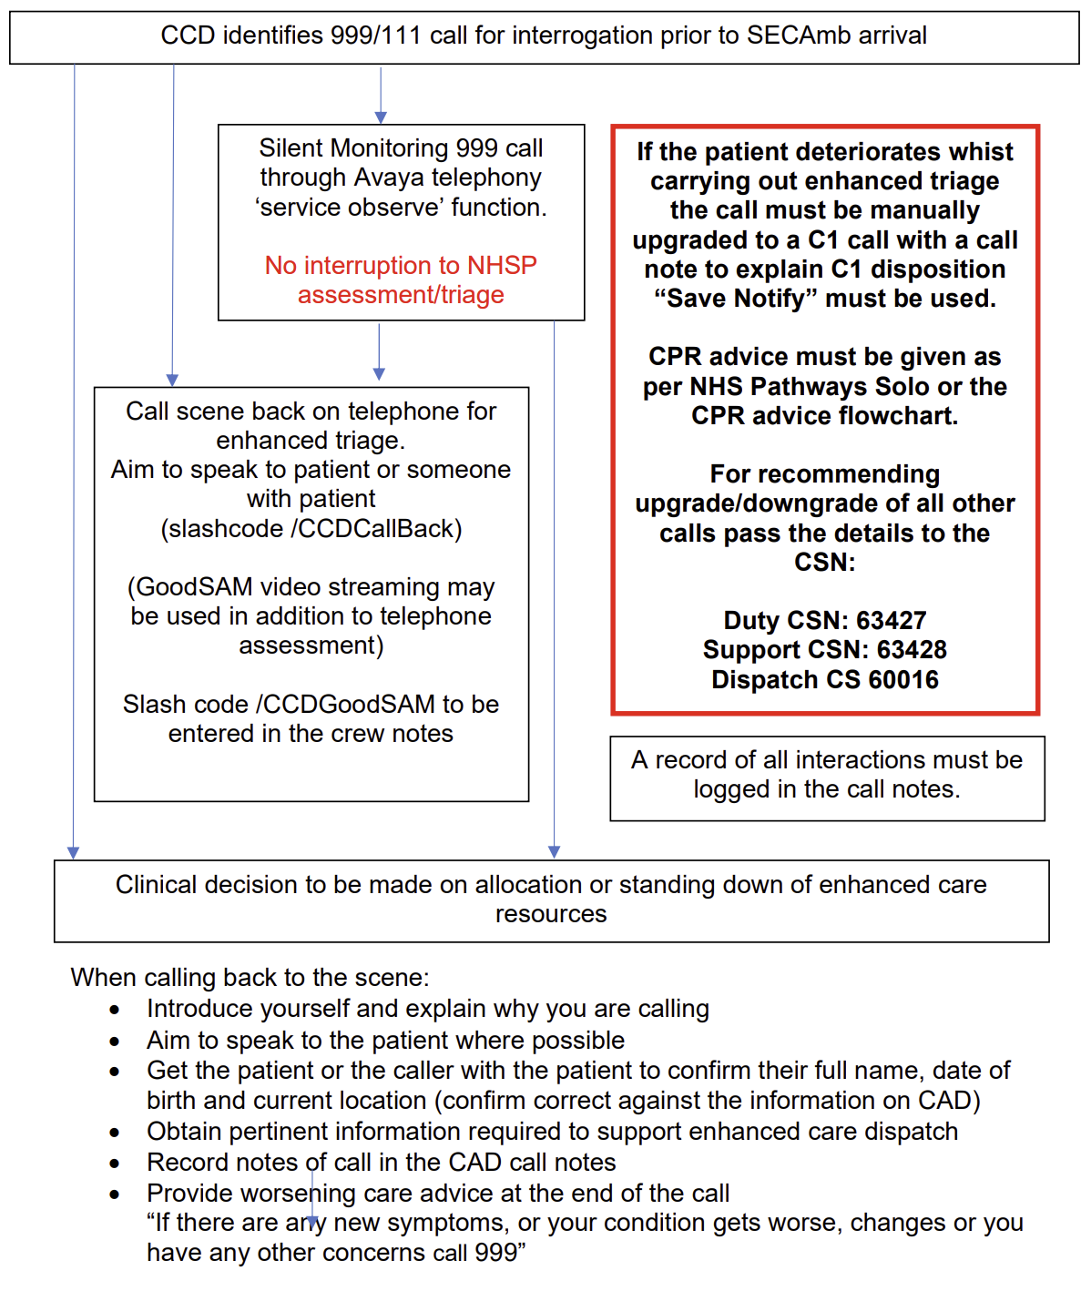

Appendix E: Video Streaming Flowchart
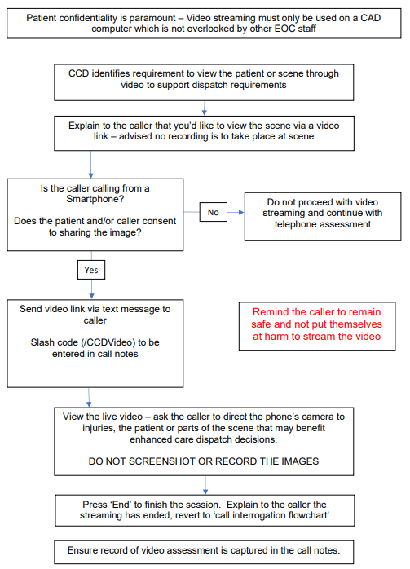

Appendix F: Clinical Dispatch Support Flowchart

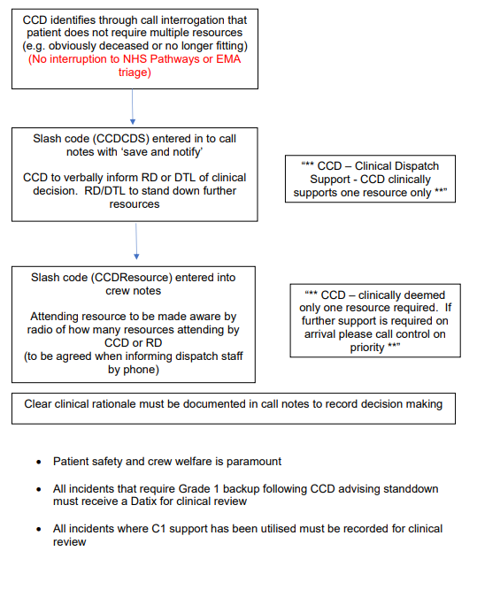

Appendix G: Response to Clinical Safety Plan Escalation
 | CCP Tasking | Operational CCPs | Duty CCTL/Duty CCCOM  Duty CCCOM to maintain oversight and availability as Tactical Medical Advisor | Other actions
CSP 1 | Normal threshold | CAD scanning, supporting CCD  C1 available | Booked on, out of service. Available to the CCD. | As normal
CSP 2 | Normal Threshold | As above | As above | As above
CSP 3 | Review high risk outstanding calls, Paramedic back-up if nearest paramedic resource.  Reviewing C1 calls for resource needs. | As above + reviewing outstanding calls within ODA for risk  + mobilise under normal conditions to C1s/CCP jobs & contact EOC if unable to contact desk within 2 minutes. | As above | As above
CSP 4 | As above | As above + mobilise under normal conditions to C2s/CCP jobs & contact EOC if unable to contact desk within 5 minutes. | As above  Monitor CAD for outstanding calls for risk.  Self-tasking as appropriate | Consider availability of non-patient facing CCPs
BCI | Dynamic as required for BCI scenario – to be discussed with Strategic Commander, Strategic Medical Advisor and Duty Critical Care Clinical Operations Manager.

Appendix H: AAKSS Stand Down and Peer to Peer process
