Uniform and Dress Code Policy and Procedure

Contents

1 Statement of Aims and Objectives 5
2 Principles 5
3 Dress Conduct – All Colleagues 6
4 Uniform Provision and Wear – Uniformed Employees 6
5 Uniform Care, Replacement and Disposal – Uniformed Colleagues 11
6 Uniform Safety and Security – Uniformed Colleagues 11
7 Safety and Security 12
8 Definitions 13
9 Responsibilities 13
10 Monitoring Compliance 13
11 Audit and Review (evaluating effectiveness) 13
12 Associated Trust Documentation 14
13 References 14
14 Financial Checkpoint 15
15 Equality Impact Assessment (EIA) 15
Appendix A: Standard Uniform and Allowances 15
Appendix B: Authorised Epaulettes 20
Appendix C: Rank Slide Definitions 22
Appendix D: Hi-Vis Flash Identification and Helmet Colour 23

Statement of Aims and Objectives
  - South East Coast Ambulance Service NHS Foundation Trust (the Trust) is committed to providing caring, compassionate, sustainable, and innovative healthcare.
  - This policy and procedure applies to all members of the Trust.
  - This policy and procedure replace Uniform and Work Attire Procedure (also known as Uniform Procedure).
  - This policy and procedure sets out an organisation-wide view of the presentation of uniform and dress code, and how uniform should be used. It provides a consistent framework for all employees concerning work clothing and defines the uniform that should be provided where relevant for the employee’s role.
  - This policy and procedure does not set out how uniform is ordered.
  - This policy and procedure does not set out all health and safety or infection prevention and control policies or procedures concerning uniform or Personal Protective Equipment (PPE) wear and does not duplicate content documented in
- Infection Prevention and Control Manual Procedure
- Infection Prevention and Control Policy
- Infection Prevention Ready Procedure
- Personal Protective Equipment Policy

Principles
  - The public image of the Trust is linked with the appearance of its employees. It is therefore essential that work clothing, uniformed or non-uniformed, is smart, safe, effective, appropriate and professional.
  - The three principles of this policy and procedure are personal, patient and colleague safety (be safe), public and stakeholder confidence (be professional) and colleague comfort and identity (be yourself).
  - Be safe: All colleagues must dress in a manner that does not present a risk to their health and safety, or that of others. For colleagues in healthcare settings, effective hygiene and preventing infection transmissions are absolutes. The clothes that colleagues wear must support care practices and minimise any risk to patients or themselves. Uniforms and work clothing must not impede effective hand hygiene.
  - Be professional: The way all colleagues dress is an important influence on people’s overall perception of the Trust. All colleagues must be smart, neat, and professional in appearance.
  - Be yourself: Colleagues should feel comfortable and express their identity where this does not interfere with the other principles. This includes being able to dress in accordance with their cultural or religious practices.
  - The Trust will provide uniform for those that require it for their role.

Dress Conduct – All Colleagues
  - Common sense should prevail, and no-one should dress or present themselves in a manner that is likely to offend the public, other colleagues or damage the reputation of the Trust.
  - Colleagues dress must be professional, neat, tidy, and clean. For example, uniform and work clothing must not be creased.
  - Any other matters concerning standards of dress conduct are covered within this policy and procedure, by the Trust Values and by the employee’s terms and conditions of employment.
  - Employees are only required to cover tattoos that are likely to offend the public or damage the reputation of the Trust.

Uniform Provision and Wear – Uniformed Employees
  - The following section concerns uniformed employees only.
  - Only authorised staff who require uniform shall be provided it as per the allowance list within the Appendix A.
  - Uniform issued by the Trust remains the property of the Trust. Any uniform remaining at the termination of employment must be returned.
  - Employees may only wear uniform and equipment when authorised by the Trust and as appropriate to their role and duties within the Trust. For example, students must only wear their university uniform when on placement & no fleece jackets to be worn by staff within Field Operations.
  - SECAmb uniform can only be worn when undertaking official duties and must not be worn at private events unless authorised by a manager. For example, attending as an Ambulance Liaison Officer.
  - Any non-clinical staff member who wears green uniform, must cover up their uniform when not in a SECAmb premises or alternative authorised location. Uniform must always be covered up for commuting, when in the public eye or when not carrying out work related activities.
  - Non-compliance may be managed under other trust policies and procedures.
  - Uniform must always be worn in its entirety while undertaking SECAmb duties. This includes while on placement outside of the trust, training activities and within office environments. For example, issued footwear must be worn and epaulettes visible.
  - Exceptions to these rules may be authorised by the employee’s line manager. For example, pregnant staff may be granted adjustments to their uniform as part of the pregnancy and maternity risk assessment in agreement with the employee’s line manager. Exceptions involving new attire will require the involvement of relevant IPC teams as part of a risk assessment.
  - Smoking, the use of e-cigarettes, vaping, drinking of alcohol or purchasing these products will not be permitted in public view in displayed uniform. For example, colleagues may wear a civilian jacket to cover any Trust insignia on uniform.
  - Patient facing operational employees must keep a spare set of uniform at their place of work, for example, in case of soiling, or requests from the police to take items of uniform.
  - Epaulettes
  - Colleagues must wear the correct epaulettes on their Trust uniform.
  - All identified and required staff within Field Operations, Integrated Care, Resilience & Specialist Operations, and other identified roles must wear epaulettes on their uniform. Please see Appendix B
  - Green epaulettes denote a clinical role such as paramedic, red epaulettes denote, specialist advanced or consultant clinicians and medical staff such as doctors. Dark blue denotes emergency responders, light blue student paramedics, black non-clinical roles. See Appendix B for colour authorisations.
  - Only staff who are trained and authorised commanders (authorised by the Resilience Department) are permitted to wear rank. Please see Appendix C for rank slide definitions.
  - An authorised epaulette list has been agreed and will be available via the uniform ordering process Appendix B.
  - Epaulettes for new job roles will need to be requested via the Uniform & PPE working group and authorised by an Associated Director of Operations Support or Head of Logistics.
  - Shirts, Trousers and Shorts
  - Operational shirts will be tucked neatly into waistbands.
  - The collar will be folded down and worn as the shirt design is intended.
  - Trousers must not be tucked into boots or socks.
  - Maternity Uniform
  - The trust does not currently supply maternity uniform due to the complexity of individual sizing and compatibility. Pregnant colleagues who are no longer patient facing or in a role that will not require the use of workwear may wear their own clothing in line with the principles of this policy for corporate staff.
  - This should be in line with Section 3
  - Footwear
  - All uniformed operational employees will only wear approved footwear, either as issued by the Trust, or as approved by management to meet safety specifications (Complies with EU Regs for Personal Protective Equipment (EU2016/425) and meets requirements of European Standard EN ISO 20345:2011), when in uniform.
  - Footwear will be maintained in a clean and serviceable condition. Any defects must be notified to the colleague’s line manager.
  - Operating Units will store spare boots in every size for emergency use.
  - Colleagues who require PPE boots and have specific medical or cultural needs concerning footwear, are advised to seek support from their local management and occupational health provider. If an alternative boot is approved, colleagues are permitted to claim back up to the same value of the current supplied trust issued boots. Please contact logistics for the current cost price.
  - Staff purchasing their own boots via this process must ensure they meet the above safety requirements.

  - Integrated Care Division (EOC/111) Only – Footwear Guidelines
  - Footwear is not provided to staff in the Integrated Care Division. Staff are asked to comply with the guidance below:
  - Acceptable Footwear:
  - Black leather or faux leather shoes (flat or with a low heel)
  - Black smart lace-up or slip on shoes
  - Black loafers or brogues
  - Black flat ankle boots (polished and smart in appearance)
  - Black smart trainers (plain, minimal branding)
  - All footwear should be clean, professional in appearance and suitable for a control room setting.
  - Open-toe shoes, sandals and overly casual or worn-out footwear are not permitted.
  - Fleeces
  - Only fleeces that have been authorised and issued by the trust may be worn by staff.
  - Fleeces may only be worn by non-patient facing roles for example EOC/111. They must not be worn in a clinical setting.
  - Hair and Head Covering
  - For all colleagues, hair (including facial hair) must be maintained in a clean, presentable, and tidy condition.
  - For patient facing colleagues, hair (including facial hair) must not obstruct the correct wearing or secure fitting of required personal protective equipment (PPE).
  - Any worn clips or hair ties must be secure and allow for the correct fitment of PPE.
  - Patient facing colleagues will ensure that hair does not interfere with patient care. Patient facing colleagues with long hair must tie it back to prevent it from being grabbed by or contacting the patient.
  - Frontline staff of Sikh faith have a legislative exemption for the need to wear safety helmets where they would be commonly donned by staff at incidents and will be provided safety goggles by the Trust. The only amendment to this would be where a Sikh colleague works within HART and due to the risk profile, they would be required to wear a safety helmet during such times as when helmets would be donned by the HART team.
  - The colour of a turban can carry personal, cultural, and sometimes religious significance for someone of the Sikh faith and as such will have the choice to wear a Turban colour of their choosing.
  - Belts
  - If you wish to wear a belt, only Trust-issued belts or unadorned plain black belts must be worn.
  - Vegan belts are available on request.
  - Jewellery
  - Piercings are worn at the colleague’s own risk.
  - Necklaces should not be visible and worn under uniform and not be at risk of being pulled or caught.
  - Current guidance for clinical staff of the wearing of wrist watches and rings please refer to the Infection Prevention and Control Policy regarding “bare below the elbow” standards required.
  - Resilience & Specialist Operations
  - HART and SORT depending on the type of incident are required to wear additional uniform or PPE as set out by the National Emergency Capabilities Unit (NECU).
  - This uniform or PPE is not managed under this Policy and Procedure and is procured as directed by the national equipment data sheet (EDS) framework.
  - HART / SORT staff, when working frontline duties outside of their specialist role are required to comply to this policy and procedure as per other field operations staff.
  - HART & SORT staff will be made identifiable via epaulettes and Hi-Vis Flashes (Appendix B & D)
  - HART staff are issued and authorised to wear sweatshirts (alternative colour than green) within the training environment or protracted incidents when not working in a clinical setting or providing direct patient care.
  - Command Support Roles
  - Loggists will be provided 1 set of blue operational support uniform / PPE (allowance in Appendix A) to be worn only when acting as a Loggist and will be required to wear on scene or in other multi agency environments, regardless of whether there normal day to day uniform is green. This may not be required in other internal environments such as command suit duties within EOC.
  - When acting as the duty on-call Loggist, staff are required to have immediate access to their blue uniform for the duration of the on-call period.
  - Uniform Authorisation
  - Standard uniform allowance shall be approved by the requesting staff members line manager, in conjunction with the allowance within the appendix.
  - Approving line managers are required to ensure replacement of uniform is justified and required.
  - Command (rank) epaulettes, white helmets, incident surcoats and Loggist uniform requests shall require authorisation from the Resilience Department.
  - Uniform for new job roles will need to be requested via the Uniform & PPE working group and authorised by an Associated Director of Operations Support or Head of Logistics.

Uniform Care, Replacement and Disposal – Uniformed Colleagues
  - It is the responsibility of each employee to take appropriate care of all issued items of uniform, and to follow the manufacturer’s instructions, and infection control procedures, regarding cleaning and storage.
  - Items that are visually identifiable as the whole or part of a Trust uniform (e.g. due to their colour or style), have the Trust insignia, or are otherwise unique to the Trust and which are not suitable for re-use, must be disposed of securely. They must be returned to the line manager for onward passage to Logistics for disposal by an approved contractor.
  - All uniform that is returned for shredding must be in a clear plastic bag with a card label stating, ‘Old Uniform for shredding.’ All returns must be checked for any items that are not uniform (e.g. iPads, ID cards), before sending as the Logistics Team will not open the bags once received. Do not put new exchanges in the bag, please use a separate bag clearly marked ‘Exchanges.’ Refer to your line manager for specific enquiries about arrangements.
  - Exchanges and replacement of uniform (e.g. due to soiling, loss, change of specification due to change of body shape, general wear, and tear) will be completed on an item for item basis. e.g. 3 worn shirts exchanged for 3 new shirts.
  - Prior to replacement uniform being sent out, the returns form must be completed and the returned items received back to logistics.
  - The uniform returns form can be found on The Zone.

Uniform Safety and Security – Uniformed Colleagues
  - Uniform must always be stored securely and out of public sight when not in use.
  - When not representing the Trust, employees must cover or remove uniform or identification bearing the Trust insignia.
  - Colleagues must be aware of national guidance regarding threat level and the impact this may have on safety and security when in uniform.
  - Loss or Theft
  - If an item of uniform is lost or stolen, the employee is responsible for informing their line manager as soon as possible. A Datix incident report form must also be submitted.
  - Where the loss is substantial, or part of a wider loss of Trust equipment, the Local Security Management Specialist (LSMS) must be informed.
  - In circumstances where theft is suspected, the police must be notified. This would normally be undertaken by the employee’s line manager or out of hours duty manager. This is particularly important when security concerns are heightened.
  - Personal Protective Equipment (PPE)
  - PPE is documented in Personal Protective Equipment Policy for Health and Safety PPE and Infection Prevention and Control Manual Procedure for Infection Prevention Control.

  - Please ensure issued PPE is available to you when on duty. For example, high visibility jacket and helmet.

  - Helmets are available via a vehicle-based assurance system, to comply with Health & Safety compliance.

  - HART Staff & Response capable managers will be individually issued helmets as required.

  - There are 2 colours of helmets used by The Trust. See Appendix D for definitions:

- Green to be worn by all clinical staff.
- White to only be worn by authorised commanders.
- Safety and Security
  - Identification and badges
  - Trust employees must always carry their Trust ID card while on duty and be prepared to present it upon request.
  - Only badges issued by the Trust or approved by the Trust’s Uniform and PPE Working Group may be worn. Badges worn on uniform shirts must not obscure any logos.
  - It is recognised as best practice for patient facing colleagues to display their first name by wearing a trust issued hello my name is badge.
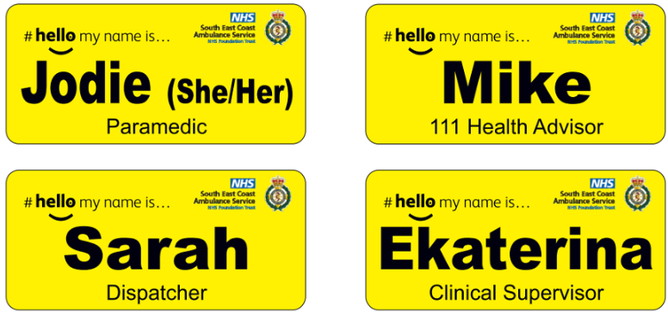
  - Non-patient facing colleagues also have the option of displaying a trust issued hello my name is badge.
  - Anything attached to uniforms must be able to be cleaned to the required infection control standards.

Definitions
  - Datix Incident Form: The form for employees to report incidents.

  - EOC: Emergency Operations Centre.

  - Epaulette: A decoration worn on the shoulder to denote rank or title.

  - Personal Protective Equipment (PPE): Issued above the standard uniform issue to protect against a specific risk to health and safety.

Responsibilities
  - The responsibility for ensuring that the policy and procedure is enforced lies with the Trust Board and Chief Executive Officer.
  - The Divisional Directors are responsible for overseeing the implementation of this policy and procedure.
  - The Head of Operations are responsible for the monitoring of this policy and procedure.
  - Logistics, Procurement and Finance Departments will ensure appropriate resources, facilities and associated supplies for employees to adhere effectively to this policy and procedure are available and maintained. All uniform issued to employees by the Trust will remain the property of the Trust at all times and must be returned at the termination of employment and reconciled with a list of items issued at the beginning and during the employment. Failure to do so could result in delay in payment of monies due or in extreme cases police involvement.
  - All Operational Managers, Clinical Managers, Line Managers and Team Leaders are responsible for ensuring that this policy and procedure is routinely applied by all uniformed employees and that suitable and necessary facilities to support this procedure are readily available in all Trust settings.
  - All employees are individually responsible for adhering to this procedure.

Monitoring Compliance
  - Monitoring of uniform and work clothing according to this policy and procedure will be undertaken by line managers.

Audit and Review (evaluating effectiveness)
  - All policies and procedures have their effectiveness audited by the responsible Management Group at regular intervals, and initially six months after a new policy and procedure is approved and disseminated.
  - Effectiveness will be reviewed using the tools set out in the Trust’s Policy and Procedure for the Development and Management of Trust Policies and Procedures (also known as the Policy on Policies).
  - This document will be reviewed in its entirety every three years or sooner if new legislation, codes of practice or national standards are introduced, or if feedback from employees indicates that the policy is not working effectively.
  - All changes made to this policy and procedure will go through the governance route for development and approval as set out in the Policy on Policies.

Associated Trust Documentation
  - Recruitment and Selection Policy
  - Personal Protective Equipment Policy
  - Smoke Free Environment Policy and Procedure
  - Equality, Diversity, and Inclusion Policy
  - Health & Safety Policy
  - Infection Prevention and Control Policy
  - NHS IPC Manual
  - Infection Prevention Ready Procedure
  - Security Management Policy
  - Menopause Policy

References
  - Uniforms and Workwear: guidance for NHS employers: Link
  - Department of Health (2008) The Health and Social Care Act 2008: (rev 2015): Code of practice for the prevention and control of healthcare associated infections. London: DoH.
  - Department of Health (2007) Uniforms and Workwear: (rev 2010) An evidence base for developing local Policy. London: DoH.
  - Department of Health (2007) Saving Lives: reducing infection, delivering clean and safe care. London: DoH.
  - Health and Safety Executive (INDG174 rev 08/05) A short guide to the Personal Protective Equipment at Work Regulations 1992. Suffolk: HSE books.
  - Health and Safety Executive (2005) COSHH a brief guide to regulations: What you need to know about the Control of Substances Hazardous to Health Regulations 2002. Suffolk: HSE books.
  - The Health and Safety at Work Act 1974 sections 2 and 3. Section 2 covers risks to employees and Section 3 to others affected by their work e.g. patients.
  - Health and Safety Executive (1999) Management of Health and Safety at Work Regulations 1999 (Management Regulations), that extend the cover to patients and others affected by microbiological infections and include control of infection measures.
  - ‘Securing Health Together’ The Health and Safety Executive (HSE) long term strategy for occupational health that commits HSE/Health and Safety Commission and their fellow signatories (including the Department of Health) to a 20 per cent reduction in ill health caused by work activity by 2010.
  - Health Act 2006 Code of Practice, Duty 4 to maintain a clean and appropriate environment includes at section (g) that the supply and provision of linen and laundry reflects Health Service Guidance HSG95 (18), as revised from time to time and at section (h) that clothing (including uniforms) worn by employees when carrying out their duties is clean and fit for purpose. Health Professions Council, Standard of Proficiency section 10.
  - Manchester Arena Enquiry Report and Recommendations
  - NARU guidance

Financial Checkpoint
  - This document has been confirmed by Finance to have no unbudgeted financial implications.
- Equality Impact Assessment (EIA)

Appendix A: Standard Uniform and Allowances
Only the below identified groups shall be provided uniform
Green Uniform – Restricted to:
- Operational, patient-facing clinical staff & Emergency Responders (volunteers)
- On-call rota staff* (Field Operations, EOC, Resilience & Specialist Operations, Paramedical)
- Infection Prevention & Control Leads
- Community Resilience Leads & Managers
- SORT Instructor
- Clinical Education
- EOC, 111, Critical Systems

Blue uniform – restricted to:
- Fleet staff
- Estates Team
- Logistics staff (Including Resilience & Specialist Operations)
- Make Ready Centre Managers & Assistants
- On-call rota Loggist
- Driving Instructors
- Pharmacy Team
- Health & Safety (PPE Only)

Any staff not mentioned above requiring a visible identity can request a yellow “My Name Is” badge as an alternative.
Uniform is ordered via Logistics by following this link to the uniform order portal.
Allocated uniform and quantities are shown below:
Field Operational Staff  Community Resilience  Green Uniform |  |  |  | 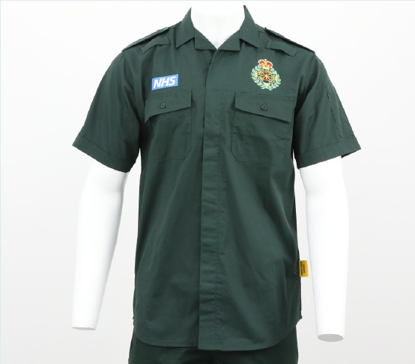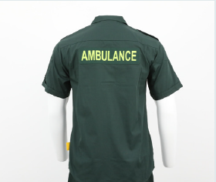  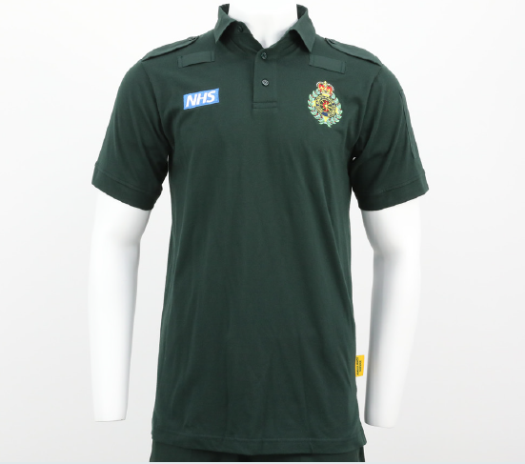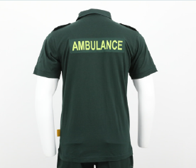
Item | Full Time | Part Time | RCM / Bank / Emergency Responders
Pilot or Polo Shirt | 5 | 3 | 2
Ops Trousers | 3 | 2 | 2
3 in 1 Coat | 1 | 1 | 1
Epaulettes | 4 | 4 | 4
T-shirt | 5 | 3 | 2
Trousers Belt | 1 | 1 | 1
Boots | 1 | 1 | 1
Kneepads | 2 | 1 | 1
Hi-Viz Insert (1x Large / 1x Small) | 2 | 2 | 2
Hi-Viz Jacket | 1 | 1 | 1
Hi-Vis Over Trousers | 1 | 1 | 1
Green Holdall | 1 | 1 | 1
Knit Hat | 1 | 1 | 1
Gloves | 1 | 1 | 1
Baseball Cap | 1 | 1 | 1
Radio Clip | 1 | 1 | 1
Morphine Holder* | 1 | 1 | 1 | *Paramedics only

On-Call Rota Staff* – Green Uniform
Item | Full Time | Part Time
Pilot or Polo Shirt | 3 | 2
Ops Trousers | 2 | 2
3 in 1 Coat | 1 | 1
Epaulettes | 4 | 4
T-shirt | 3 | 2
Trousers Belt | 1 | 1
Boots | 1 | 1
Kneepads | 1 | 1
Helmet | 1 | 1
Helmet Bag | 1 | 1
Hi-Viz Insert (2x Large / 2x Small) | 2 | 2
Hi-Viz Jacket | 1 | 1
Hi-Viz Over Trousers | 1 | 1
Green Holdall | 1 | 1
Knit Hat | 1 | 1
Gloves | 1 | 1
Baseball Cap | 1 | 1
Radio Clip | 2 | 2

Clinical Education (Clinical)
IPC Staff
Chaplain – Green Uniform
Item | Full Time | Part Time | Chaplain
Pilot or Polo Shirt | 3 | 2 | 1  (Shirt Only)
Ops Trousers | 2 | 2 | 1
3 in 1 Coat | 1 | 1 | 1
Epaulettes | 4 | 4 | 4
Trousers Belt | 1 | 1 | 1
Boots | 1 | 1 | 1
Kneepads | 1 | 1 | 1
Green Holdall | 1 | 1 | 1

EOC / 111 Staff – Green Uniform  (*Including Critical Systems) |  |  |  | 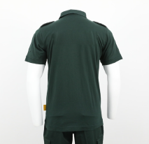  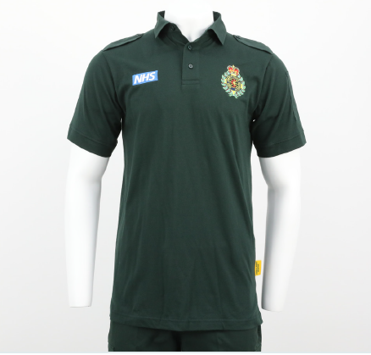
Item | Full Time | Part Time | Bank
EOC Polo Shirt | 5 | 2 | 2
Trousers | 3 | 2 | 2
Fleece | 1 | 1 | 1
Epaulettes | 1 (*4) | 1 | 1
Trousers Belt | 1 | 1 | 1
*3 in 1 Coat* | (*1) | (*1) | (*1) | *Critical Systems Only

Blue Support Uniform  Make Ready Centre Managers /  Assistants  Logistics Staff (Including Resilience & Specialist Operations  Clinical Education Uniform (Driving Training / Equipment)  Pharmacy Team |  |  | 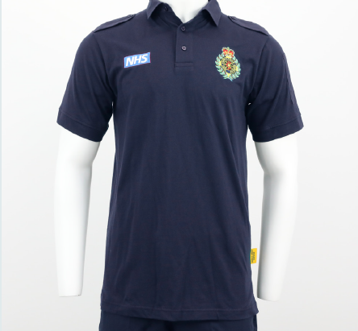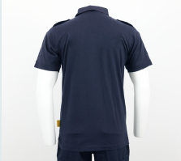
Item | Full Time | Part Time
Polo Shirt | 5 | 2
Trousers | 3 | 2
3 in 1 Coat | 1 | 1
T-shirt | 3 | 2
Trousers Belt | 1 | 1
Boots | 1 | 1
Hi-Viz Jacket (Full Yellow) | 1 | 1

Fleet Staff – Blue Support Uniform
Item | Qty
Blue Polo Shirt | 5
Sweatshirt | 2
Trousers | 3
Fleece | 1
3 in 1 Coat | 1
(Overalls, boots & Hi-Vis provided by Fleet)

Health & Safety Team
Item | Qty
Boots | 1
Hi-Viz Jacket (Full Yellow) | 1
Hi Vis Over trousers | 1
Green Holdall | 1
On Call rota Loggist - Blue Support Uniform
Item | Qty
Blue Polo Shirt | 1
3 in 1 Coat | 1
Trousers | 1
Boots | 1
Hi-Viz Jacket | 1
Hi-Viz Insert | 1
Green Holdal | 1
Knit Hat | 1
Gloves | 1
Baseball Cap | 1
Radio Clip | 1
Hi Vis Over trousers | 1

CFR – Red Uniform |  | 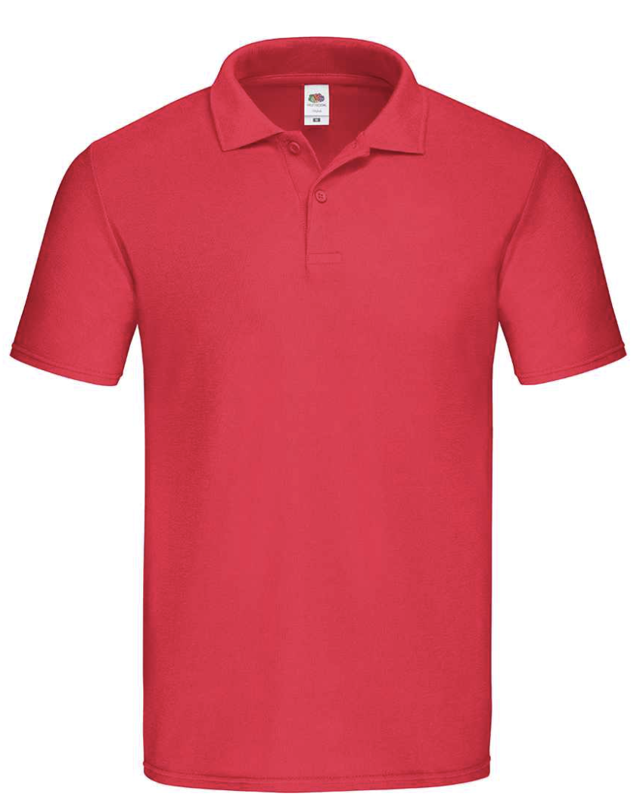
Item | Qty
Red Polo Shirt | 2
Black Trousers | 2
Boots | 1
Hi-Viz Jacket | 1
Hi-Viz Insert | 1
Hi Vis Over trousers | 1
Green Holdal | 1
Knit Hat* | 1 | *Optional
Gloves* | 1 | *Optional
Baseball Cap* | 1 | *Optional
Radio Clip* | 1 | *Optional

Welfare Volunteer – Light Blue Uniform |  | 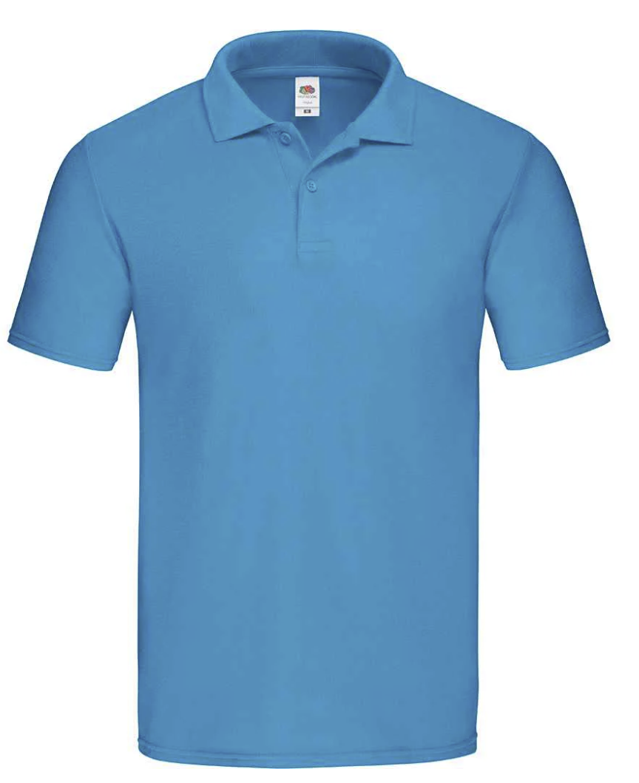
Item | Qty
Light Blue Polo Shirt
*Currently under review and to be confirmed based on new strategy

Appendix B: Authorised Epaulettes
The below epaulettes have been agreed and will be held in stock and can be ordered via the usual process.
Any other epaulettes that are not listed below will need to be requested via the Uniform & PPE working group and authorised by Associated Director of Operation Support or Head of Logistics. In regard to command rank, authorisation from the Resilience Department will be required.
Epaulettes will conform to a colour coordinated system to indicate non-clinical vs. clinical and identification of specialists.
- Black – Non-Clinical
- Dark Blue – Emergency Responder
- Light Blue – Student Paramedic (External)
- Green – Clinical
- Red – Clinical with advanced practice
The Exception to this will be the strategic & executive ranks that will all be green.
Authorised Epaulettes - Clinical
VOLUNTEER EMERGENCY RESPONDER | DARK BLUE
EMERGENCY CARE SUPPORT WORKER | GREEN
SORT EMERGENCY CARE SUPPORT WORKER | GREEN
TRAINEE ASSOCIATE AMBULANCE PRACTITIONER | GREEN
ASSOCIATE AMBULANCE PRACTITIONER | GREEN
SORT ASSOCIATE AMBULANCE PRACTITIONER | GREEN
TECHNICIAN | GREEN
SORT TECHNICIAN | GREEN
STUDENT PARAMEDIC (EXTERNAL) | LIGHT BLUE
STUDENT PARAMEDIC (INTERNAL) | GREEN
PARAMEDIC | GREEN
SORT PARAMEDIC | GREEN
HART PARAMEDIC | GREEN
STUDENT CRITICAL CARE PARAMEDIC | GREEN
CRITICAL CARE PARAMEDIC | RED
TEAM LEADER - CRITICAL CARE PARAMEDIC | RED
AREA CLINICAL LEAD - CRITICIAL CARE PARAMEDIC | RED
STUDENT ADVANCED PARAMEDIC PRACTITIONER | GREEN
ADVANCED PARAMEDIC PRACTITIONER | RED
AREA CLINICAL LEAD - ADVANCED PARAMEDIC PRACTITIONER | RED
CONSULTANT MIDWIFE | RED
CONSULTANT PARAMEDIC | RED
Authorised Epaulettes – EOC/111 (Non-Clinical)
DISPATCH TEAM LEADER | BLACK
DISPATCH COACH | BLACK
EMERGENCY MEDICAL ADVISOR | BLACK
EMERGENCY MEDICAL ADVISOR COACH | BLACK
EMERGENCY MEDICAL ADVISOR TEAM LEADER | BLACK
HEALTH ADVISOR | BLACK
HEALTH ADVISOR COACH | BLACK
HEALTH ADVISOR TEAM LEADER | BLACK
RESOURCE DISPATCHER | BLACK
RESPONSE DESK COORDINATOR | BLACK
SENIOR EMERGENCY MEDICAL ADVISOR | BLACK
SENIOR HEALTH ADVISOR | BLACK
SERVICE ADVISOR | BLACK
DUTY CONTACT CENTRE MANAGER | BLACK
CRITICAL SYSTEMS | BLACK

Authorised Epaulettes – EOC/111 (Clinical)
CLINICAL ADVISOR | GREEN
CLINICAL SUPERVISOR | GREEN
MENTAL HEALTH PRACTITIONER | GREEN
MIDWIFE | GREEN
NURSE | GREEN
CLINICAL SAFTEY NAVIGATOR | GREEN
CLINICAL CAS NAVIGATOR | GREEN
OPERATIONS MANAGER CLINICAL | GREEN

Authorised Epaulettes - Other
PARAMEDIC - CLINICAL EDUCATION | GREEN
DRIVING INSTRUCTOR | BLACK
SORT INSTRUCTOR | GREEN
INFECTION PREVENTION CONTROL TEAM | GREEN
COMMUNITY RESILIENCE TEAM | GREEN
SOUTH EAST COAST AMBULANCE SERVICE | BLACK
Authorised Epaulettes - Command (Rank)
2 X PIP | GREEN / BLACK
3 X PIP | GREEN / BLACK
CROWN | GREEN / BLACK / BLUE
CROWN OVER | GREEN / BLACK / BLUE
LAUREL | GREEN
PIP OVER LAUREL | GREEN
2 PIPS OVER LAUREL | GREEN
CROWN OVER LAUREL | GREEN
CROWN PIP OVER LAUREL | GREEN

Appendix C: Rank Slide Definitions
The correctly issued epaulette must be worn with Trust uniform.
Below are the functions and roles associated with each rank.
Although certain roles may have the same command function, the rank also denotes seniority within The Trusts internal structure. For example, a Head of Operations will have seniority over a Deputy Head of Operations.
Rank should be used to display the command function of staff only. Staff will wear their command rank day to day but should wear alternatives when acting up or carrying out an alternative role.
Only staff who are trained and authorised commanders (as directed by the Resilience Department) are permitted to wear rank.
Authorisation for Rank sitting outside of the agreed rank structure will need authorisation from the Resilience Department.
 | Image | Command Function | Role
Crown, Pip & Cartwheel | 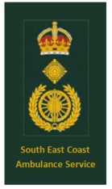 | Accountable Officer | Chief Executive Officer
Crown & Cartwheel | 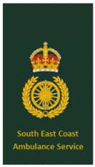 | Accountable Emergency Officer | Chief Operating Officer / Executive Director of Operations  Medical Director  Chief Paramedic
2 Pips & Cartwheel |  | Strategic Commander  This is a senior officer rank and will therefore form part of the Strategic cadre, responsible for the strategic level of management with overall control over the organisation during any specific event. | Divisional Director
Pip & Cartwheel |  |  | Deputy / Associate Director  Head Of Integrated Urgent Care
Cartwheel | 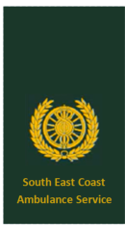 |  | Acting Strategic Commander  Strategic Liaison Manger
Crown & Pip | 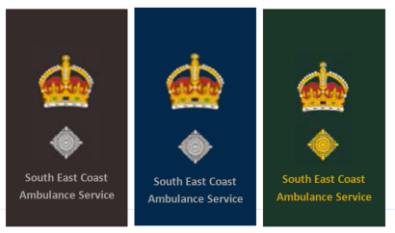 | Tactical Commander  This rank will form part of the Tactical Cadre, Responsible for the tactical level of management and interagency liaison (NILO) | Head of Operations – Field Ops  Operating Unit Managers - EOC  Head of Resilience  Head Of Specialist Operations
Crown | 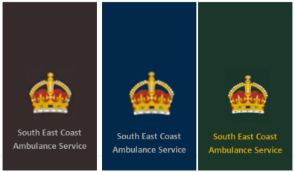 |  | Deputy Head of Operations  Service Delivery Manager  National Inter-Agency Liaison Officer (NILO)
3 pips | 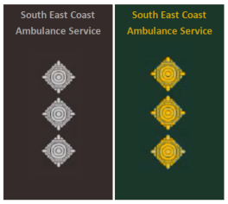 | Operational Commander  This rank will form part of the Operational cadre, responsible for the operational level of management at the scene or control rooms | Operational Team Leader  HART Team Leader  Emergency Operations Centre Manger
2 pips | 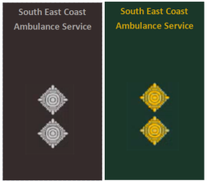 | Non-Command Team Leader / Manager | Development commander at any level - awaiting command training.

Appendix D: Hi-Vis Flash Identification and Helmet Colour
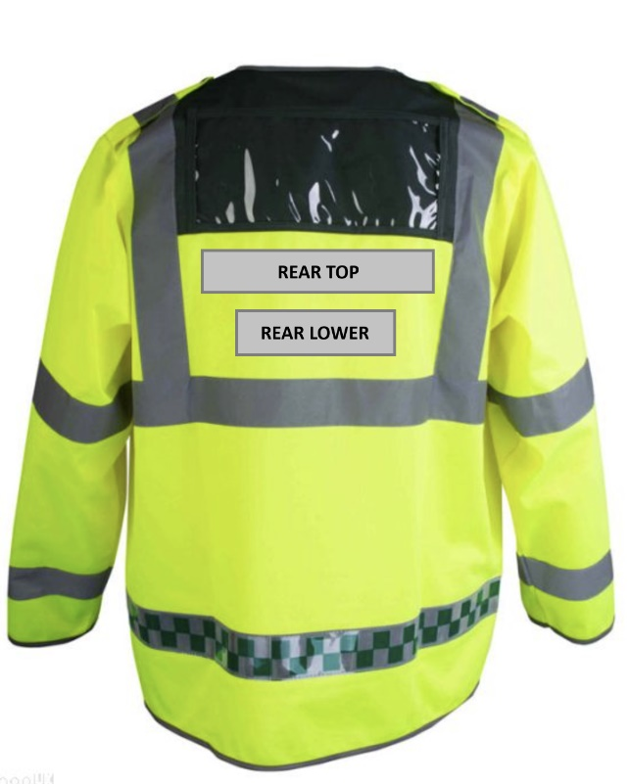
Clinical Command Grade | Hi Vis Inserts (Rear Top) | Hi Vis Inserts (Rear Lower)
Community First Responder | Community First Responder | AMBULANCE
Emergency Responder | Emergency Responder | AMBULANCE
Emergency Care Support Worker | Emergency Care Support Worker | AMBULANCE or *SORT
Trainee Associate Ambulance Practitioner | Trainee Associate Ambulance Practitioner | AMBULANCE or *SORT
Associate Ambulance Practitioner | Associate Ambulance Practitioner | AMBULANCE or *SORT
Technician | Technician | AMBULANCE or *SORT
Student Paramedic (Internal) | Student Paramedic | AMBULANCE or *SORT
Student Paramedic (External) | Student Paramedic | AMBULANCE
Paramedic (including NQP) | Paramedic | AMBULANCE or *SORT
HART Paramedic | Paramedic | AMBULANCE or *HART
Student Critical Care Paramedic | Paramedic | AMBULANCE
Critical Care Paramedic | Critical Care Paramedic | AMBULANCE
CCP Team Leader | Critical Care Paramedic | AMBULANCE
Student Advanced Paramedic Practitioner | Paramedic | AMBULANCE
Advanced Paramedic Practitioner | Advanced Paramedic Practitioner | AMBULANCE
Area Clinical Lead | Advanced Paramedic Practitioner  Critical Care Paramedic | AMBULANCE
Consultant Paramedic | Advanced Paramedic Practitioner  Critical Care Paramedic | AMBULANCE
Doctor | Doctor | AMBULANCE
Commander (in development) | Clinical Grade as Required | AMBULANCE
HART Team Leader | Paramedic | HART TEAM LEADER
Operational Team Leader | Paramedic | OPERATIONAL TEAM LEADER
Tactical Commander | Clinical Grade as Required | AMBULANCE OFFICER
Tactical Advisor / NILO | Clinical Grade as Required | AMBULANCE OFFICER
Strategic Commander | Clinical Grade as Required | AMBULANCE OFFICER
Response Capable Manager  (Not command authorised) | Clinical Grade as Required | AMBULANCE

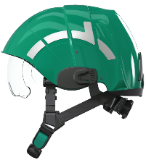
Green - To be worn by all grades of clinical staff who require PPE.
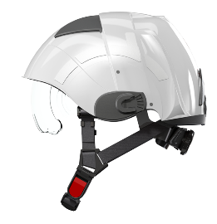
White - To be worn by Authorised Commanders only in line with trust rank structure.

Clinical Grade | Helmet Colour
COMMUNITY FIRST RESPONDER | Not Issued
VOLUNTEER EMERGENCY RESPONDER | GREEN
EMERGENCY CARE SUPPORT WORKER | GREEN
TRAINEE ASSOCIATE AMBULANCE PRACTITIONER | GREEN
ASSOCIATE AMBULANCE PRACTITIONER | GREEN
TECHNICIAN | GREEN
STUDENT PARAMEDIC | GREEN
PARAMEDIC | GREEN
SORT PARAMEDIC | GREEN
HART PARAMEDIC | GREEN
STUDENT CRITICAL CARE PARAMEDIC | GREEN
CRITICAL CARE PARAMEDIC | GREEN
STUDENT ADVANCED PARAMEDIC PRACTITIONER | GREEN
ADVANCED PARAMEDIC PRACTITIONER | GREEN
NURSE | GREEN
MIDWIFE | GREEN
CONSULTANT MIDWIFE | GREEN
CONSULTANT PARAMEDIC | GREEN
DOCTOR | GREEN
RESPONSE CAPABLE MANAGER (Not Command Authorised) | GREEN
COMMANDER IN DEVELOPMENT | GREEN
OPERATIONAL TEAM LEADER | WHITE
HART TEAM LEADER | WHITE
TACTICAL COMMANDER | WHITE
NATIONAL INCIDENT LIAISON OFFICER | WHITE

