Trust Pool / Hire Vehicle Policy

Contents

1 Statement of Aims and Objectives 3
2 Principles 3
3 Definitions 4
4 Responsibilities 4
5 Compliance 5
6 Policy Review 5
7 Scope 6
8 Procedure 6
9 Competence 7
10 Monitoring 7
11 Audit and Review 7
12 Equality Analysis 8
13 Associated Documentation 8
14 References 8
Appendix A 9
Document Control 13

- Statement of Aims and Objectives
  - The Trust is providing an alternative option of how employees travel from A - B to fulfil their job functions. Examples include, but are not limited to, training courses, meeting travel and visits to alternate Trust locations that are not an employee’s designated place of work. The following policy has been developed for all Trust employees who have previously used their own personal vehicle for business travel. Trust arranged lease cars are outside of this policy.

  - The Trust intention with this policy is to provide staff with an alternative option to using their own private vehicle. This option will provide a safe and legally compliant vehicle to use on Trust business whilst ensuring appropriate governance and reducing the overall travel cost.

  - This policy applies to all Trust employees and staff on courses facilitated by Clinical Education who do not have access to a Trust lease car and would otherwise use their own private vehicle.

  - In accordance with the External Provider (EP) a Privacy Notice personal information may be used for / shared with:

- Marketing purposes:
- Rental transactions:
- Customer service-related queries:
- Disputes & law enforcement:
- Subsidiaries:
- Franchises:
- Service Providers and Business Partners:

EP offers the provision for Employees to ‘opt-out’ of having them.
personal information shared for direct marketing purposes, should they
wish to do so.

  - The Trust Employee Privacy Notice has been updated to reflect this.
change.

  - All staff making a request for a vehicle are required to read this policy and comply with the requirements herein.
- Principles
  - The Trust seeks to eliminate unlawful discrimination against colleagues, potential employees, patients or providers on the grounds of sex, marital status, disability, sexual orientation, gender identity, age, race, ethnic or national origin, religion, pregnancy/maternity, political opinion, or trade union membership and to promote equality of opportunity and good relations between employees and providers.
2.2. This document sets out how employees can use this additional option to travel on Trust business, to meetings, training courses and to visit other locations in order to carry out Trust business.
2.3. Providing this option of either a pool or hire car to staff rather than asking staff to declare vehicle serviceability, licence details and insurance compliance for business use will maximise the assurance that vehicles used on Trust business are fit for purpose, appropriately serviced and roadworthy.
2.4. This option ensures maximum value for money for the Trust whilst reducing the running costs of staff using their own private vehicle.
- Definitions
  - Trust – South East Coast Ambulance Service NHS Foundation Trust
  - EP – External Provider
  - OSD – Operational support desk
  - PCN – Penalty Charge Notice
- Responsibilities
  - Associate Director of Operational Support will be responsible for: - Overseeing the policy and procedures are adhere to its requirements.
  - Head of Fleet will be responsible for: - Ensuring the policy and procedures are disseminated effectively to the appropriate team.
  - Fleet Admin Manager will be responsible for: - For the implementation and day to day management of the Travel Desk.
  - The Operational Support Admin Team will be responsible for: - Ensuring all vehicles requested via Marvel are dealt with in time for the vehicle to be available for travel when required. Any issues raised are promptly resolved or escalated to the fleet admin manager.
  - Line managers will be responsible for: - Approving the request raised by their staff before the vehicle can be arranged.
  - Staff will be responsible for: - Ensuring they have completed the Marvel request for a Trust pool or Hire vehicle and providing accurate information about the booking. Reading and agreeing to the T&Cs listed on the Travel Desk form.
  - Having the correct and current driving licence and signing up to the Trust’s approved driving licence checking system.
  - Completing a standard pre-travel check on the vehicle and informing the Travel Desk of any concerns.
  - If you are not present when the vehicle is delivered, then the check must be done before you start your journey. Note and take pictures of any damage to the vehicle. Contact Operational Support Admin and the hire company branch; all details can be found on your booking reference.
  - The Trust remains responsible for the condition of the vehicle for 4 business hours after rental termination or up until the vehicle is collected whichever is earlier.
  - Reporting any accident damage to the Operational Support Admin Team and EP as soon as possible. In the event of hospitalisation or similar this must be completed by the line manager or colleague.
  - If the vehicle is un-drivable the EP should provide a replacement within 4 business hours.
  - Covering the full cost of any Penalty Charge Notice (PCN) issued to the Trust (including admin fees). There is a no smoking policy all hire and Trust vehicles.
  - To ensure the safety and security of the vehicle when left unattended the following should be adhered to.

    - The vehicle must be parked legally and not cause any obstructions.

    - The parking brake must be engaged.

    - The ignition key must be removed from the vehicle.

    - All doors and window must be closed and locked.

    - Any loose equipment is to be stored out of sight and removed when leaving the vehicle.

    - Vehicle keys must always be kept secured.

  - The hire company is responsible for: - Ensuring the cars provided are cleaned and maintained appropriately, ensuring they are serviced on or before the manufacture stated intervals.
- Compliance
  - All staff are required to request a vehicle for use via the Marvel platform through the Travel Desk and this is to be approved by their line manager.
  - No SECAmb pool vehicle or hire vehicle is to be used without prior authorisation and this process being followed.
- Policy Review
  - All policies and procedures have their effectiveness audited by the responsible Management Group at regular intervals, and initially six months after a new policy and procedure is approved and disseminated.
  - Effectiveness will be reviewed using the tools set out in the Trust’s Policy and Procedure for the Development and Management of Trust Policies and Procedures (also known as the Policy on Policies).
  - This document will be reviewed in its entirety every three years or sooner if new legislation, codes of practice or national standards are introduced, or if feedback from employees indicates that the policy is not working effectively.
  - All changes made to this policy and procedure will go through the governance route for development and approval as set out in the Policy.
- Scope
  - The travel desk’s prime functionality is to help facilitate and enable Trust staff to have an alternative option for business travel purposes other than mileage claims on personal vehicles. This will provide staff with a safe and legally compliant alternative transport method to personal mileage expense claims and reduce travel costs providing the Trust with an efficiency saving benefit. There is also reduced wear and tear on staff members’ personal vehicles utilising this option thus providing them a benefit also.
- Procedure
    - Staff should request a Vehicle for use via the Marvel platform (this can be found on the SECAmb ZONE staff website). (Appendix A)
- From the SECAmb Zone Staff Website
  - Click on Marvel Icon or from the favourite’s menu select “Service Desk Portal”.
  - Click on “My Services”
  - Click on “Fleet”
  - Click on “Travel Desk”
  - Click on “Create Request”
  - Complete the request ensuring all information is entered into the required fields and is accurate.
  - The authorising manager email address will auto fill requesters details. This should be changed to authorising managers email address for the approval.
  - Click Next Step.
  - Read and agree the T&C’s declaration.
  - Submit the request.
    - All requests will need to be approved by an applicant’s line manager before the vehicle can be arranged via the travel desk. If the vehicle is hired through EP the staff member will receive a booking reference from the hire company. If the vehicle is a trust car the staff member will receive a confirmation email via the Operational Support admin team.
  - The Travel Desk will prioritise the supply of a Trust car before booking a hire car from an EP.
  - Out of hours emergency vehicle requests will be arranged by the OSD and followed up as soon as the travel desk are back in the office. Information on how to book out of hours can be found on the Travel Desk form via Marvel.
Refuelling of vehicles

    - Trust issued pool cars will be supplied with a fuel card for use at accredited external fuel stations. Additionally, there will be a Fuel key that can be used to draw diesel fuel from Trust bunkered fuel sites which should be used as a preference.

    - Please refer to the fuel card and key policy for use on Trust Fuel Cards and Fuel keys.

    - Externally provided hire vehicles should come fully fuelled and returned with the same amount of fuel.

    - All refuelling receipts need to be kept, and monies claimed back via E-expenses attaching receipts as proof of purchase.

    - Pool cars will have a vehicle logbook that must be completed for every journey.

- Competence

  - Advice and guidance on this policy for all staff including line managers will be provided by the Operational Support Admin Team.

- Monitoring

  - Operational Support Admin will monitor the application of the policy and procedure. Statistics and feedback will be recorded and provided to the board in partnership with Fleet and the EP.

- Audit and Review
  - All policies and procedures have their effectiveness audited by the responsible Management Group at regular intervals, and initially six months after a new policy and procedure is approved and disseminated. Effectiveness will be reviewed using the tools set out in the Trust’s Policy and Procedure for the Development and Management of Trust Policies and Procedures (also known as the Policy on Policies).
  - This document will be reviewed in its entirety every three years or sooner if new legislation, codes of practice or national standards are introduced, or if feedback from employees indicates that the policy is not working effectively.
  - All changes made to this policy and procedure will go through the governance route for development and approval as set out in the Policy on Policies.
  - Compliance with this procedure will be looked after by the fleet admin team.

  - Information, feedback and statistics will be provided by Fleet and EP.

- Equality Analysis

  - The Trust believes in fairness and equality, and values diversity in its role as both a provider of services and as an employer. The Trust aims to provide accessible services that respect the needs of each individual and exclude no-one. It is committed to comply with the Human Rights Act and to meeting the Equality Act 2010, which identifies the following nine protected characteristics: Age, Disability, Race, Religion and Belief, Gender Reassignment, Sexual Orientation, Sex, Marriage and Civil Partnership and Pregnancy and Maternity.

  - Compliance with the Public Sector Equality Duty: If a contractor carries out functions of a public nature, then for the duration of the contract, the contractor or supplier would itself be considered a public authority and have the duty to comply with the equalities duties when carrying out those functions.

- Associated Documentation

  - Fuel Card and Fuel Key Policy

- References

  - NHS Terms and Conditions of Service Handbook

Appendix A
Marvel – Travel Desk Process
When on Secamb Zone Staff Website
- Click on Marvel Icon 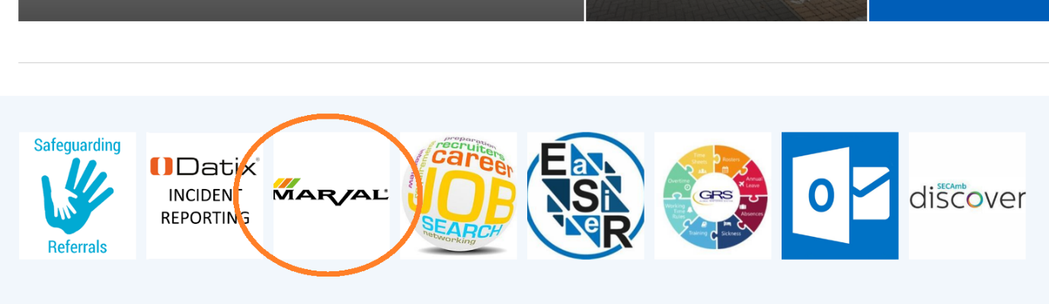

Or from the favourite’s menu select “Service Desk Portal”

- Click on “My Services”
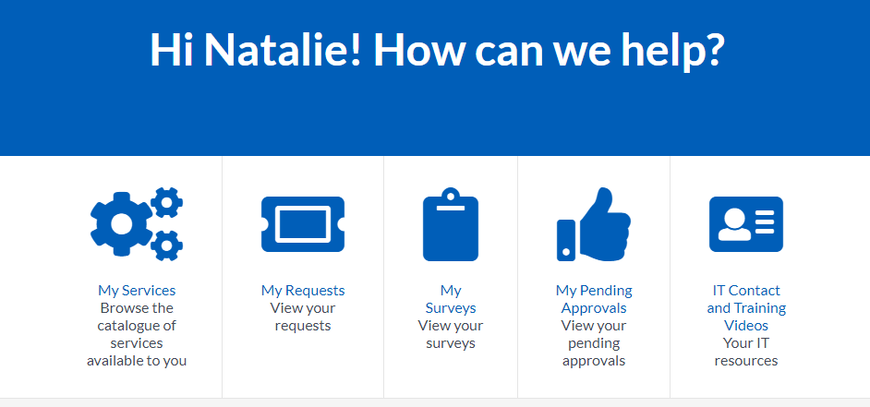

- Select and click on “Fleet”

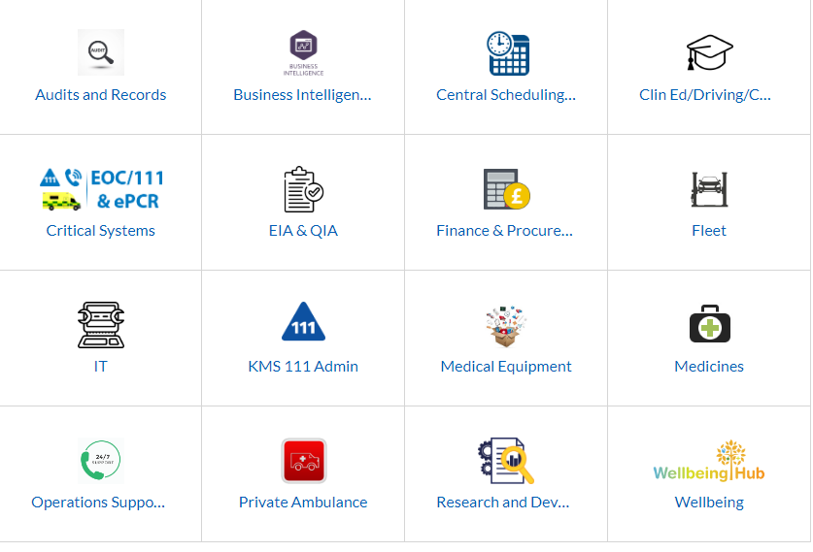
- Select and click on “Travel Desk”
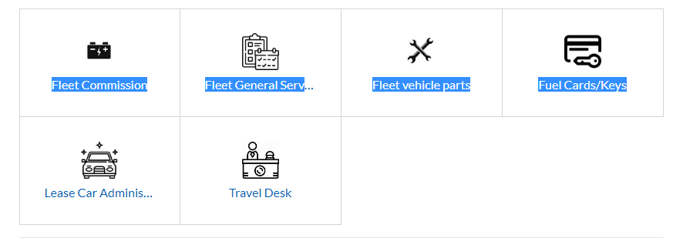
- Click and select “Create Request”

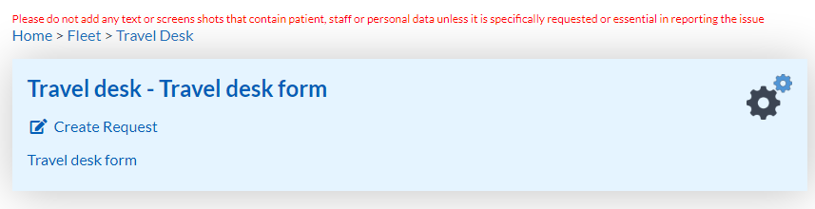
- Please complete the form and all data fields including details of start date and time and end date and time.
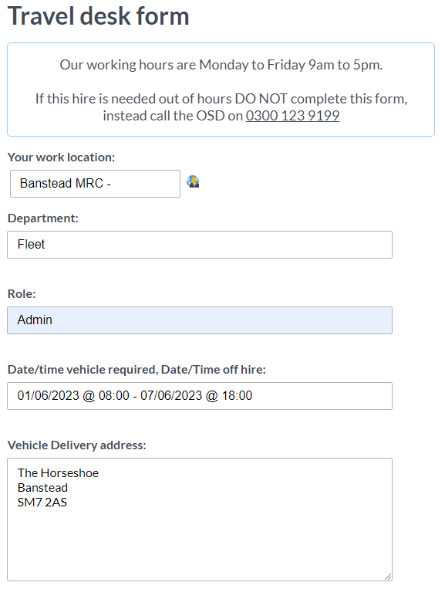
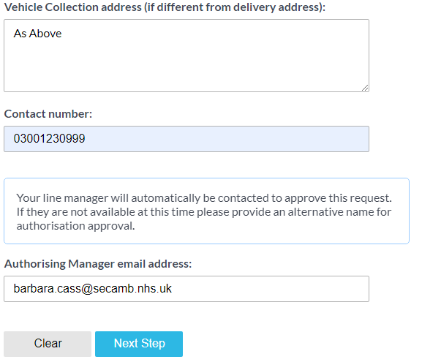

- Please note – Authorising manager email address will auto fill requesters details – please ensure this is changed to authorising managers email address for the approval. Then click Next Step.
- Please read and agree T&C’s ensuring to check Agree box, as booking cannot be completed without it.
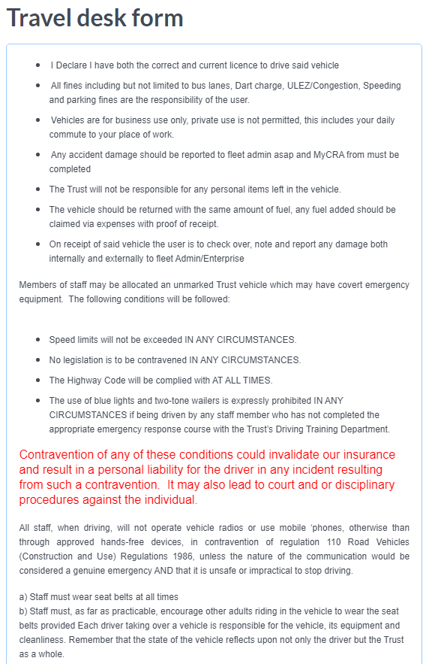
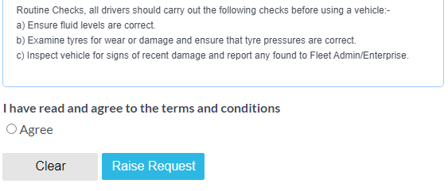
- Once all complete click “Raise Request”

Document Control
Manager Responsible
Name: | Barbara Cass
Job Title: | Fleet Admin Manager
Directorate: | Operational Support

Committee/Working Group to approve
Version No. 1.00 | Final | Date: 16/07/2024
Draft/Evaluation/Approval (Insert stage of process)
Person/Committee | Comments | Version | Date
List stakeholders/working groups consulted and the dates/ comments | B. Cass  J Griffiths | 0.1  0.2 | 26/02/24  26/02/24
 | B Cass | 0.3 | 26/02/24
 | J Griffiths | 0.4 | 26/02/24
 | UnionJPF, | 0.5 | 5/23
 | B Cass | 0.6 | 26/2/24
Richard Banks Assistant Company Secretary | Final edits ahead of JPF submission | V.1 | 26/2/2024
Circulation
Records Management Database | Date: 16/07/2024
Internal Stakeholders
External Stakeholders
Review Due
Manager | Rob Martin
Period | Every three years or sooner if new legislation, codes of practice or national standards are introduced | Date: 16/07/2027
Record Information
Security Access/Sensitivity | [eg: Official (Public Domain) or Official – Sensitive]
Publication Scheme | Yes / No
Where held | Records Management database
Disposal Method and date:
Supports Standard(s)/KLOE
 | Care Quality Commission (CQC) | IG Toolkit | Other
Criteria/KLOE: | Name core service area and CREWS elements

