Attendance at HM Prison Services Standard Operating Procedure

Contents

Document Control 2
2 Procedure 5
3 Responsibilities 7
4 Audit and Review (evaluating effectiveness) 8
5 Associated Trust Documentation 8
6 References 8
7 Financial Checkpoint 9
8 Equality Analysis 9
Equality Impact Assessment (EIA) template (refer to guidance) 12

- Scope
  - South East Coast Ambulance Service NHS Foundation Trust (the Trust) is committed to providing high quality patient care.
  - This procedure is intended to facilitate seamless attendance at HM Prisons (HMP) where a call is received via the 999-telephony system.
  - This procedure is applicable to all EOC and Operational staff.
- Procedure
    - 999 Calls from HMP will usually be made from the control centre within the prison.
    - For the purposes of this SOP, the control centre, who will be acting on behalf of the Health Care Professional (HCP) responsible for the prison site, will be considered an “other authorised person”.
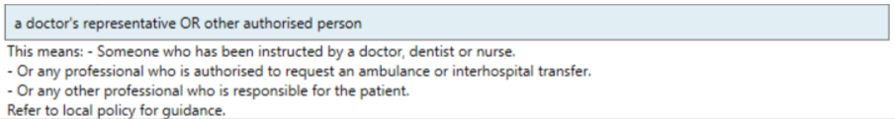
    - With this in mind, most calls from the prison service will be dealt with under the HCP section or via the attend incident section of NHS Pathways.

  - Ambulance Requests
    - Prisons calling 999 will follow the Prison SOP PSI 03/2013 September 2021. Prison control rooms will call 999 and pass any pertinent clinical information they have available.
    - In all cases, Emergency Medical Advisors (EMAs) will still ask the question “Is the patient breathing?” HMP will endeavour to provide this information at all times. Where it is confirmed that the patient is not breathing a Category 1 response must be generated.
    - The standard response to prison incidents will be Category 2. Unless information has been provided that warrants a Category 1 response.
    - When an Ambulance response is requested, the EMA will select the problem nature “Prison Incident” and type the immediate nature if known, e.g. Hanging/Chest Pain etc in the free text problem box on the Computer Aided Dispatch (CAD).
    - All calls from the prison service are made from an agent of the health care practitioner, who will be making their way to the prisoner. EMA’s are to use Attend Incident or HCP Pathway.
    - Where the question “What level of response is required?” is presented, it will always be answered “Category 2 18 Minute response” unless the call is from the HCP and they request a lower level of response.
    - Calls where an HCP has assessed the patient and determined that transport to hospital is required will be dealt with using the HCP pathway. Such calls will usually originate from the HCP personally or their representative. All other calls will be dealt with utilising Attend Incident.
  - Clinical Prioritisation and Welfare
    - Upon receiving a request with limited information, it may be appropriate to carry out a further clinical assessment. Enabling the clinical function to clinically prioritise incidents where it is identified dispatch desks are under pressure in terms of unassigned activity. If this is undertaken by a clinician a clinical re-triage to an appropriate response would be suitable.
    - A welfare call may be performed by welfare callers when the Trust is experiencing high levels of demand. The expectation would be from the prison to provide an update on the patient’s condition, especially in terms of worsening symptoms.
  - Security
    - The prison control centre may request the registration number of the crews attending the prison, along with the names of the personnel on the vehicle. This should be provided from the CAD resource information tab.
    - It is a trust requirement that crews always carry their trust ID card with them during operational duty. The prison service reserves the right to refuse entry where one cannot be produced.
  - Operations
    - When responding to an emergency call from a prison, the crew may be required to leave their vehicle in the “Sterile Area” where one exists. This is the area between the two gates separating the prison from outside.
    - Staff attending prisons are asked to secure their personal mobile phones in the lockers in the sterile area or leave on the vehicle locked away. Airwave radios are to be always kept on the staff members person. It is an offence for personal mobiles to be carried by staff into the prison. Electronic Patient Care Reporting (ePCR) devices can be carried and utilised in the prison setting.
    - HMP are aware that we may send multiple staff and units to a serious incident at one of the prisons to facilitate specialist care of the patient. These additional staff will be permitted access.
  - Escorts
    - Escorts must be readily available to convey and escort patients, especially during time-critical incidents.
    - When escorting a prisoner, only two escorts can safely travel with the patient in the ambulance. If more than two officers are required as escorts for a prisoner, the transportation must be done in a prison van. Secamb personnel will also travel in the van to provide care and interventions en route to hospital.
  - Reporting
    - Datix is the Trust’s incident management system.
    - Any delay in gaining access to the prison or delayed care resulting in harm or potential harm should be reported promptly via a Datix.
- Responsibilities
  - The Chief Executive Officer is accountable for this procedure.

  - The Executive Director of Operations is responsible for deployment of this procedure.

  - The Operating Unit Managers for both EOC and Field Operations are responsible for implementing this procedure.

  - The Emergency Operations Centre Managers and the Operations Manager Clinical are responsible for the day-to-day operation on this procedure.

  - Team Leaders are responsible for disseminating this procedure and ensuring their staff are competent in its delivery.

  - Operational & EOC staff are responsible for their own compliance with this procedure.
- Audit and Review (evaluating effectiveness)
  - The document will be audited against any adverse incidents generated by the Datix system, or any concerns raised by His Majesty’s Prison Services.
  - The SOP will be reviewed every three years or sooner if new legislation, codes of practice or national standards are introduced.
  - All procedures have their effectiveness audited by the responsible Management Group at regular intervals, and initially six months after a new policy is approved and disseminated.
  - Effectiveness will be reviewed using the tools set out in the Trust’s Policy and Procedure for the Development and Management of Trust Policies and Procedures (also known as the Policy on Policies).
  - This document will be reviewed in its entirety every three years or sooner if new legislation, codes of practice or national standards are introduced, or if feedback from employees indicates that the policy is not working effectively.
  - All changes made to this procedure will go through the governance route for development and approval as set out in the Policy on Policies.
- Associated Trust Documentation

  - EOC Call Handling Procedure
  - Dispatch Standard Operating Procedures.docx (sharepoint.com)
- References

  - Attendance of an Emergency Ambulance – National Guidance Document - National Offender Management Service (NOMS) & Association of Ambulance Chief Executives (AACE) 2017.
  - Medical Emergency Response Codes – HM Prison & Probation Service 09/09/2021

- Financial Checkpoint

  - To ensure that any financial implications of changes in policy or procedure are considered in advance of document approval, document authors are required to seek approval from the Finance Team before submitting their document for final approval.
  - This document has been confirmed by Finance to have no unbudgeted financial implications.
- Equality Analysis
  - The Trust believes in fairness and equality, and values diversity in its role as both a provider of services and as an employer. The Trust aims to provide accessible services that respect the needs of each individual and exclude no-one. It is committed to comply with the Human Rights Act and to meeting the Equality Act 2010, which identifies the following nine protected characteristics: Age, Disability, Race, Religion and Belief, Gender Reassignment, Sexual Orientation, Sex, Marriage and Civil Partnership and Pregnancy and Maternity.
  - Compliance with the Public Sector Equality Duty: If a contractor carries out functions of a public nature then for the duration of the contract, the contractor or supplier would itself be considered a public authority and have the duty to comply with the equalities duties when carrying out those functions.
  - Every procedure must be accompanied by a completed and authorised Equality Analysis (EA). The guidance and template for completing this are below.
  - Once the EA is complete, this guidance should be deleted from your procedure and the completed EA retained within the document.
  - Equality Analysis (EA) is a tool aimed at improving the quality of our services by ensuring that individuals and teams think carefully about the likely impact of their work on different communities or groups. It involves anticipating the consequences of the Trust’s policies, procedures, functions and services on different communities and making sure that any negative consequences are eliminated or minimised, whilst opportunities for promoting equality are maximised.
  - Systematic and robust completion of EAs will assist us to comply with the Equality Act 2010 which places a duty on the Trust to have due regard to the need to:
  - Eliminate discrimination, harassment and victimisation.
  - Advance equality of opportunity between persons who share a relevant protected characteristic and persons who do not share it.
  - Foster good relations between persons who share a relevant protected characteristic and persons who do not share it.
  - These are known as the three aims of the general equality duty. The Act sets out nine protected characteristics that apply to the equality duty, which must be considered in the EA process. The protected characteristics are:
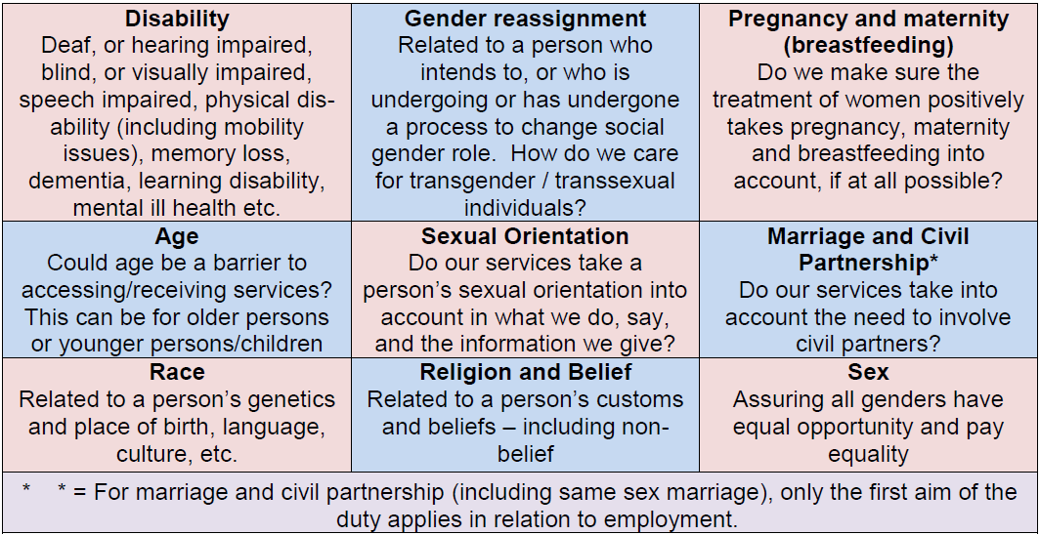
  - The flow chart below sets out the EA process:

  - The EA form for completion is below. Depending on the outcome at this initial stage, an action plan may also be required. The template for actions is included below but can be deleted if not required. Please contact inclusion@secamb.nhs.uk for support undertaking an EA.

Equality Impact Assessment (EIA) template (refer to guidance)
What piece of work does this relate to: Attendance at HM Prison Services Standard Operating Procedure

Role: Operating Unit Manager for Dispatch

- Is this a:
- Change to an existing strategy (long term plan of action), policy or procedure ☒
- Change to a service or function (actions or activities) ☐
- A new strategy or policy/procedure/business case/ ops bulletin etc. ☐
- A new service or function ☐
- Project which requires approval at Board or Working group ☐

- Who will be impacted by this work? Tick all that apply.
Patients x  Carers ☐  Staff x | Student/learners ☐  Trade unions ☐  Suppliers ☐ | Volunteers ☐ | External Partners (please specify below) ☐  HM Prison Services  Other (including a particular geographical area, describe below) ☐  Click or tap here to enter text.

- Summarise the work being assessed. Describe current status followed by any changes that stakeholders would experience.
Procedure out of date, reviewed and minor adjustments have been made to bring procedure and terminology current.

- Checklist

All the Trust’s policies, programmes, strategies, services and major developments affect patients, carers, service users, employees and the wider community. These will have a greater or lesser relevance to equality, diversity and inclusion.
The following questions will help you to identify how relevant your proposals are.
When considering these questions think about age, carers, disability, gender reassignment, race, religion or belief, sex, sexual orientation, pregnancy and maternity and any other relevant characteristics (for example socio-economic status, social class, income, unemployment, residential location or family background and education or skills levels).
Make notes to assist with the completion of the EIA.
Questions | Yes | No
Is there potential for/ indication of or evidence that the proposed change will affect different population groups differently (including possibly discriminating against certain groups)? | ☐ | ☒
If yes, please add information: | ☐ | ☒
Have there been or are there likely to be any public concerns (including media, academic, voluntary or sector specific interest) about the change? | ☐ | ☒
If yes, please add information: | ☐ | ☒
Could the proposal affect how our services, commissioning or procurement activities are organised, provided, located and by whom? | ☐ | ☒
If yes, please add information: | ☐ | ☒
Could the proposal affect our workforce or employment practices? | ☒ | ☐
Staff will need to adhere to the procedure when taking a call, dispatching an emergency resource and for Trust staff attending prisons | ☒ | ☐
Is there potential for or evidence that the proposed change will not promote equality of opportunity or promote good relations between different groups? | ☐ | ☒
If yes, please add information: | ☐ | ☒

- Equality Impact Assessment
  - Key stakeholders
A key principle for completing Equality impact assessment is that they should not be done in isolation. Consultation with affected groups and stakeholders needs to be built in from the start, to enrich the assessment and develop relevant mitigation. Detail here who you have involved with completing this EIA.

Name / Group | Organisation | Role on assessment team  e.g., service user, manager of service, specialist (which area)
Sean Daisy | Secamb | Business Support Manager

  - Who may be positively or negatively affected by this activity?
Protected characteristics (Equality Act 2010) | In addition, consider the following vulnerable groups:
Age ☒ | Armed forces ☐ | Socioeconomic disadvantage ☐
Disability ☒ | Carers ☐ | People with addiction or substance misuse problems ☒
Race ☒ | Digital exclusion ☐ | People on probation ☐
Gender reassignment ☒ | Domestic abuse ☐ | Prison population ☒
Marriage & civil partnership ☒ | Education (literacy) areas ☐ | Undocumented migrant, refugees, asylum seekers ☐
Pregnancy & maternity ☒ | Homeless ☐ | Sex workers ☐
Religion & beliefs (including no belief) ☒ | Looked after children ☐ | Other (please specify below) ☐
Sex (male or female) ☒ | Rural areas ☐
Sexual orientation ☒ | Urban areas ☐

  - Assessment outcomes – discussion undertaken between 13/02/2024 and 13/02/2024
Protected equality characteristic | Describe here the considerations and concerns in relation to the programme/policy for the selected groups. These may be positive, negative or neutral if there is no impact. | If you have identified any negative impacts, describe here suggested mitigations to inform the actions needed to reduce inequalities.
Age | Neutral
Disability | Neutral
Race | Neutral
Gender reassignment | Neutral
Marriage & civil partnership | Neutral
Pregnancy & maternity | Neutral
Religion & beliefs | Neutral
Sex | Neutral
Sexual orientation | Neutral

Vulnerable groups/existing inequity | Describe here the considerations and concerns in relation to the programme/policy for the selected groups. These may be positive, negative or neutral if there is no impact. | If you have identified any negative impacts, describe here suggested mitigations to inform the actions needed to reduce inequalities.
Armed forces | Neutral
Carers | Neutral
Digital exclusion | Neutral
Domestic abuse | Neutral
Education (literacy) | Neutral
Homeless | Neutral
Looked after children | Neutral
Rural/urban geographies | Neutral
Socioeconomic disadvantage | Neutral
People with addiction or substance misuse problems | Neutral
People on probation
Prison population | Positive | Bespoke SOP for attending Prisons and reviewed NOMS and AACE and Prison Services relevant documentation and policies
Undocumented migrants, refugees, asylum seekers | Positive | Bespoke SOP for attending Prisons and reviewed NOMS and AACE and Prison Services relevant documentation and policies
Sex workers
Other

5.4 Impact on Human Rights
If a provision or feature of your policy or service potentially unlawfully interferes with a human right then it is negative . If something protects or promote a human right, then it is positive. Human rights and freedoms belong to everyone. They give the legal basis to basic values of fairness, respect, equality, dignity and autonomy. They provide a set of minimum legal standards for all public bodies, including the NHS. They protect an individual’s rights whilst considering the rights of other people and wider society.
Human Rights | Describe here the considerations and concerns in relation to the programme/policy for the selected groups. These may be positive, negative or neutral if there is no impact. | If you have identified any negative impacts, describe here suggested mitigations to inform the actions needed to reduce inequalities.
A2. Right to life (e.g. Pain relief, DNAR, competency, suicide prevention) | Positive
A3. Prohibition of torture, inhuman or degrading treatment (e.g., Service Users unable to consent) | Neutral
A4. Prohibition of slavery and forced labour (e.g., Safeguarding vulnerable patients’ policies) | Neutral
A5. Right to liberty and security (e.g., Deprivation of liberty protocols, security policy) | Neutral
A6&7. Rights to a fair trial; and no punishment without law (e.g., MHA Tribunals) | Neutral
A8. Right to respect for private and family life, home and correspondence (e.g., Confidentiality, access to family etc) | Neutral
A9. Freedom of thought, conscience and religion (e.g., Animal-derived medicines/sacred space) | Neutral
A10. Freedom of expression (e.g., Patient information or whistle-blowing policies) | Positive
A11. Freedom of assembly and association (e.g., Trade union recognition) | Neutral
A12. Right to marry and found a family (e.g., fertility, pregnancy) | Neutral
P1.A1. Protection of property (e.g., Service User property and belongings) | Neutral
P1.A2. Right to education (e.g., accessible information) | Neutral
P1.A3. Right to free elections (e.g., Foundation Trust governors) | Neutral

- Action plan and monitoring arrangements
Insert your action plan here (example layout provided). This should be based on mitigations recommended in 6.2. Involve your key stakeholders in monitoring progress against the actions above, and add more rows as required.
ACTIONS & DECISIONS TRACKER
What is being assessed: N/A
What management group will have oversight of these actions (this should be the group which has oversight of the change):
Item | Initiation Date | Action/Item | Person  Actioning | Target Completion Date | Update/Notes
1
2
3
4

The above actions should be added to the action log for the named management group.

- Version Control

Version Number | Purpose/Change | Author | Date
The above provides historical data about each update made to the EIA.
Please include the name of the author, date and notes about changes made – so that you are able to refer back to what changes have been made throughout this iterative process.
Please submit a completed version on the EIA section of Marval. The approval note from Marval can be used as evidence as approval. Once approved please send to polsandprocs@secamb.nhs.uk

An ethnic group or ethnicity is a named social category of people who identify with each other on the basis of shared attributes that distinguish them from other groups such as a common set of traditions, ancestry, language, history, society, culture, nation, religion, or social treatment within their residing area. A useful guide to terminology can be found here: https://www.lawsociety.org.uk/topics/ethnic-minority-lawyers/a-guide-to-race-and-ethnicity-terminology-and-language
Digital Exclusion can be linked to the following key root causes: - Connectivity access to the internet – can include financial barriers as well as suitable broadband speeds/connectivity - Digital Skills the ability to use digital tools such as email, online shopping, digital healthcare - also includes having confidence in online safety, and how to utilise particular services or apps - Technology and Accessibility access to appropriate devices to suit their individual needs – includes access to devices suitable for use with a certain disability as well as financial and location barriers - Not wanting to use digital platforms simply not wishing to utilise digital services – this could be due to distrust of providers, online security, privacy etc.

