Dispatch Standard Operating Procedures

Contents
1. Introduction 12
2. Objectives 12
3. Scope 12
4. General Principles 12
5. The Principals of Dispatch 13
6. Intelligent Dispatch 16
7. Dispatch Start of Shift Arrangements 18
8. Response Desk Coordinator (RDC) Responsibilities 18
9. Integrated Care Safety Briefing Document 20
10. Operational Start of Shift Arrangements 20
11. Type of Resources and Responders 23
12. Specialist Resources 36
13. Area Cover (System Status Plan) 42
14. Resource Optimisation 44
15. Local Community Dispatch Model (LCDM) 44
16. Incidents in Neighbouring Ambulance Trusts 45
17. Passing Out of Area Incidents 46
18. Incident Resourcing 46
19. Specific Incidents 51
20. Inter-Facility Transfers 59
21. Incident Review 63
22. Incidents to Escalate 68
23. On Scene Reports (STEPS) 70
24. Duplicate Incidents 72
25. No Trace Incidents 75
26. Staff Safety and Welfare 76
27. Trauma Risk Management (TRiM) 78
28. Requests for Police 79
29. Requests for Back-Up 80
30. Re-Tasking Resources 81
31. Manual MDT/MDVS/Incident Changes 81
32. Clearing At Scene 82
33. Crews Clearing at Hospital/Clearing at Hospital 83
34. Returning Medical Escorts 85
35. Information Broadcasts 86
36. Out of Service (OOS) 86
37. Meal Breaks, Refreshment Breaks and Facility Usage 87
38. Crew End of Shift Arrangements 88
39. Dispatcher End of Shift Arrangements 90
40. Responsibilities 90
41. Glossary 91
42. Audit and Review 95
43. Associated Trust Documents 96
44. Financial Checkpoint 97
45. Equality Analysis 97
Appendix 1 – SECAmb Dispatch Model 98
Appendix 2 – Back-Up Request Model 100
Appendix 3 – Dynamic Risk Assessment 101
Appendix 4 – Dispatch Handover Checklist 103
Appendix 5 – METHANE Template 105
Appendix 6 – HART Deployment Parameters 107
Appendix 7 – Child Death Procedure 112
Appendix 8 – EOCM Alerting Criteria 114
Appendix 9 – Take ACTION Guidance for Dispatch 116

Introduction
  - The Dispatch Standard Operating Procedure has been written in conjunction with service procedures and protocols to ensure that staff within the Emergency Operations Centre (EOC) & all operational A&E staff are clear on what is required of their role. This will ensure consistent working practices operationally and within the EOC.

Objectives

  - To rationalise existing procedures into a single governed document to ensure consistent working practices across the Trust. This document outlines the structure, function, role, reporting and responsibilities of the EOC Dispatch functions within South East Coast Ambulance Service (SECAmb) NHS Trust.
  - This document details the processes for the deployment of resources to all categories of 999, urgent and appropriate routine calls during normal working arrangements.
  - The overriding consideration of these procedures and protocols is to promote patient safety and clinical excellence, and to ensure that best practise is delivered at all times.

Scope

  - This procedure is applicable to all Operational Staff and sets out the processes and guidance for the EOC Dispatch Function and Operational Resources at South East Coast Ambulance Service NHS Foundation Trust (referred to as the Trust).

General Principles

  - When implementing this procedure, staff involved in resourcing incidents and deploying resources act with the authority of the Chief Executive Officer. Issues and concerns relating to tasking can be discussed at the time of the request if this doesn’t delay patient care.
  - All other queries must be followed up on completion of the request with the Duty Operational Team Leader (OTL) and/or Emergency Operations Centre Manager (EOCM).
  - In developing this procedure, Datix Cloud IQ (DCIQ), Complaints and Patient Safety Incidents (PSI’s) have been reviewed. Some practices may appear time consuming, however all processes have a specific rationale to reduce the potential for adverse incidents and minimise risk to patient safety.

The Principals of Dispatch

  - The overarching principles of dispatch are:
- All patients should receive the nearest and most appropriate response in the quickest time possible, utilising intelligent methodology in conjunction with the Local Community Dispatch Model (LCDM)
- Responding to patients takes priority over covering System Status Plan (SSP)
  - The Emergency Dispatch Principles which the Dispatchers must follow at all times are listed below:
- Ensure that all resources are booked on and set up correctly in the Computer Aided Dispatch (CAD) including confirmation and set up of all staff, shift times and skill levels.
- Check that all First responders (including all types of Community responders) are booked on correctly on CAD if they are available and their responding location is showing accurately.
- Ensure the most appropriate and nearest Community First Responder (CFR) is assigned to an incident if applicable (in accordance with the incident type and/or location) and confirm they are mobile.
- Allocate the nearest appropriate available resource/s to all Category 1 Incidents, reviewing and amending Auto Dispatch allocations.
- Undertake General Broadcasts (GB) via Airwave for all Category 1 Incidents and Grade 1 Back Up requests. The RD must provide the ETA of the initial resource and update if a response capable manager (RCM), OTL or specialist resource is also attending. If the incident is in a suburb/district of a city/town this must also be relayed. Example “C1 Cardiac Arrest Patcham Brighton, para crew running from Seven Dials with an ETA of 5 minutes and OTL also responding from Brighton MRC”.
- Monitor, open and review all incidents on the dispatch stack continually to ensure any updates and scene safety markers are noted and assign a suitable resource when:
  - The time exceeds 240 seconds, and the incident remains uncategorised.
  - The incident has been categorised (i.e.C1, C2 etc.)
  - Continually review all incidents and dispatch decisions until a responding resource is in attendance with the patient. Ensuring Responses Per Incident (RPI) are kept to a minimum where possible.
- Divert resources from lower acuity incidents to higher acuity incidents as necessary.
- Consider and respond other suitable specialised resources to the emergency if appropriate and in accordance with incident type and/or location such as Helicopter Emergency Medical Service (HEMS), Hazardous Area Response Team (HART), Critical Care Paramedic (CCP), Advanced Paramedic Practitioner (APP), Operational Team Leader (OTL) etc. liaising with the Specialist Tasking Desks as appropriate.
- Double Crewed Ambulances (DCAs) & Single Response Vehicles (SRVs) must respond to any outstanding incidents or backups (including those in neighbouring Dispatch Desks or dispatch desks that have a requirement for additional front-line support) rather than maintain cover, utilising the Intelligent Dispatch Model and LCDM.
- OTLs should not be routinely overriding dispatch decisions. If this occurs, the OTL must provide clear rationale for the decision making and this must be documented clearly in the notes. If there is a disagreement escalate the matter to Ops Tactical/EOCM at the time for immediate review. Consider DCIQ if the decision may have caused harm to the patient.
  - Dispatchers must ensure:
- All staff will be stood down for a meal break or refreshment break in line with the current meal break policy and associated documentation.
- Crews finish on time subject to emergency 999 calls in conjunction with End of Shift arrangements.
- All incidents that have a CFR resource assigned must receive back up immediately, apart from a CFR Falls resource who can assess and advise on nature of call Fall Category 3 & 4 incidents. All other CFR responses must be assigned a resource at the earliest opportunity as a Grade 2 response.
- All HART resources must receive backup as Grade 2 unless an update from scene is received stating otherwise.
- Potential delays, high activity, and other service pressures (i.e., staffing) are proactively reported to the Dispatch Team Leader (DTL).
- DTLs must have oversight of every out of time incident on the dispatch stack and review every C1, signing off every missed C1 call. C1 sign offs will also require EOCM validation and sign off.

Intelligent Dispatch

  - It is imperative as a dispatch function that we maximise efficiencies to ensure the patients we respond to receive a timely response and are not left waiting unnecessarily for a face-to-face assessment.
  - In order to minimise inefficiencies avoiding unnecessary long-distance driving under emergency conditions or resources that are crossing over, it will be necessary for all dispatchers to follow the principles below supported by the Dispatch Team Leaders (DTLs):
- Establish how many calls are outstanding on your Dispatch Desk
- Confirm how many resources are currently available, or likely to come available shortly from hospital, non-conveyances and near completion of meal breaks
- Ensure resources are not crossing over unnecessarily or running from a distance with nearer appropriate resources available
- Continually review suggestions and map (if in doubt escalate to your DTL/EOCM for a shared decision) Do not click and forget
- Consider asking crews for an ETA as traffic, road networks and weather conditions can increase or decrease drive times - suggestions is a tool to aid the dispatcher and should be used in conjunction with the map and not solely in isolation
Consider using the Emergency Breakaway Procedure in cases of confirmed cardiac arrests.
  - Resource Dispatchers should also review the following:
- Crews booking or due to book on (start of Shift Arrangements)
- Crews handed over at hospital. (Consider calling crew to see if they are near to coming clear)
- Crews Out of Service (OOS) with an ETA becoming available. (No ETA check with crew and OTL)
- Crews on scene (Scene updates must be taken using the STEPS acronym). Check with crews when they will be coming clear
- Crews on meal break and refreshment breaks plan next incidents for when they are near end of break period
- End of shift arrangements – ask crews if they would like another incident that is appropriate to ensure shift finishes on time where possible
  - If utilising intelligent dispatch, Dispatchers must ensure that comprehensive notes are input to explain why they are holding on assigning an incident.
  - If there are more emergency calls outstanding which cannot be resourced, the dispatcher should liaise with neighbouring Dispatch Desks to ensure the most appropriate response is utilised.
  - If there are Category 2 (C2) incidents outstanding which cannot be resourced within the Ambulance Response Programme (ARP) the dispatcher should assign the closest resource from a neighbouring Dispatch Desk and inform the dispatcher from the neighbouring dispatch desk. Category 3 (C3) and Category 4 (C4) calls should be escalated as per LCDM.
  - It is of the utmost importance when crews are assigned to incidents with a long running time to scene, the dispatcher is dynamically reviewing to confirm if a nearer and more suitable resource is available to deploy.
  - Dispatch Team Leaders should be monitoring ongoing incidents with their dispatch pods and if they or another dispatcher identifies any incidents where there are closer resources available or resources attending newer/lower acuity incidents, immediate escalation to the other dispatcher or relevant DTL using the specific call signs and CAD incident numbers should be best practice.

Dispatch Start of Shift Arrangements

  - At shift start, dispatchers and DTLs must provide a comprehensive verbal handover to the oncoming dispatcher.
  - A handover checklist has been created as a tool to assist with this process and is contained in Appendix 4.
  - The dispatchers and DTLs should ensure they log into all systems under their own profiles as soon as possible, with their dispatch desk being covered by a DTL or another dispatcher. This is in line with Information Governance and supporting personal KPIs.
  - This process is to be repeated any time the dispatcher or DTL leaves their desk. This to ensure oversight of incidents, patient and crew safety.

Response Desk Coordinator (RDC) Responsibilities

  - To ensure seamless communication and readiness of the Emergency Operations Centre (EOC) through regular checks and established procedures for the Response Desk Coordinator Computer-Aided Dispatch (CAD)/Telephony System.
  - At the start of the shift, the Response Desk Coordinator (RDC) logs into the CAD system and the telephony system ensuring they are both working correctly.
  - If the RDC desk is uncovered, the DTL responsible for the Dispatch desk will assume overall responsibility for CFR welfare.
  - All RDs, RDCs and DTLs must ensure the relevant CFR desk is selected for their responsible area and the desk selection is also selected, ensuring pop up messages are enabled.
  - CFRs must use the designated emergency numbers only for safety issues
- Priority East - 0300 123 7783 Delivers to CROPS: Ashford, Dartford, Hastings, Medway, Paddock Wood, Polegate, Thanet, DTL East EOC
- Priority West - 0300 123 5561 Delivers to CROPS: Banstead, Brighton, Chertsey, Gatwick, Guildford, Tangmere, Worthing, DTL West EOC
  - Routine contact
- For West RDC, use number 0300 123 9106
- For East RDC, use 0300 123 5826
  - If the call to the designated number goes unanswered, it diverts to the next available DTL.
  - If the RDC logs out the phone and is not staffed, the call will divert to the opposite RDC desk in the first instance.
  - If there is no answer in a timely manner, the CFR is to dial 999. Ask for the Emergency Medical Advisor Team Leader (EMATL) and provide the incident number and reason for the call. The EMATL can then transfer the call to the DTL/RDC or raise verbally in the EOC for immediate assistance from the RDC or DTL.
  - If the RDC leaves their desk, they must provide a handover to a DTL if there is no other RDC on duty. On return, the DTL must provide a handover back to the RDC.

Integrated Care Safety Briefing Document

  - Dispatch Team Leaders are required to fill in the Integrated Care Safety Huddle at the start of each shift.
  - Staff shortages should be reviewed and mitigated against before the daily EOCM check in, working with the DTLs in the other EOC.

Operational Start of Shift Arrangements

  - All operational staff will commence and finish their shift at a recognised make ready / ambulance station with the appropriate facilities that support health, safety and medicines management arrangements.
  - Operational crews are required to book on at the commencement of their shift on the MDT/MDVS and must complete an airwave radio test within the first five minutes of their shift.
  - Where available, resources will commence their shift by logging on to their MDT/MDVS terminal in their vehicle with their personal identification numbers.
  - Some vehicles do not have the ability to transmit data. Any staff without an MDT/MDVS must book on via the SMS system or book on manually by contacting the relevant Dispatcher/DTL.
  - Response Capable Managers engaged on administrative duties can opt to be available to attend any category of incident. They must inform the relevant dispatcher of their availability.
  - Admin OTLs must sign on at start of shift as C1 available, informing dispatch if they are available for other categories of calls and any planned downtime.
  - Any delays in signing on must be escalated to the duty OTL so they can follow up with the crew. If a crew are late on, due to a previous shift overrun or have no vehicle to book onto, they must inform EOC at the earliest opportunity.
  - Up to the first 15 minutes of each shift will continue to be allocated for staff to:
- Collect vehicle keys and drugs
- Locate their assigned vehicle
- Complete the legally required Vehicle Daily Inspection (VDI), following the mnemonic (POWDERY)
- Stow PPE and personal belongings
  - During this 15-minute window, unless the crew indicate that they have completed safety critical checks, no calls will be allocated to ensure uninterrupted time. On arrival at work the process to be followed is:
- Collect keys to allocated vehicle and crew to book on through MDT/MDVS as soon as possible to indicate presence. This initial booking on will be treated by EOC as on duty
- Complete VDI, collect drugs and other equipment
- Once safe to respond and to undertake a journey on a public highway (i.e. safety critical checks complete within the 15-minute window) the crew should report ready for all categories of call to EOC, which will place them ready to respond
- If there is a safety issue, the crew should contact EOC via the radio within the 15-minute window. EOC will liaise with the crew as needed
- At the end of the 15-minute window EOC will place crew fully available on the CAD, unless they have been informed of a problem with safety critical checks. If out of service (OOS) Vehicle Daily Inspection should be the reason selected on the CAD
  - The POWDERY CHECKLIST is a comprehensive tool for conducting vehicle checks, ensuring all critical aspects of the vehicle are reviewed before starting the shift. Here is the mnemonic breakdown for the Vehicle Daily Inspection (VDI):
- P – Petrol/Diesel/Electric: Check fuel levels
- O – Oil: Any warnings lights visible, inform EOC and check with OSD, appropriate action
- W – Water: Check screen wash and radiator water levels, including coolant/anti-freeze
- D – Damage: Inspect both interior and exterior for any damage or insecure items
- E – Electrics: Test lights (main, dipped), brakes, reverse, indicators, number plate lights, emergency warning equipment, and horns/two-tone systems, as well as windscreen wipers (front/rear)
- R – Rubber: Examine wheels, checking tread depth, wheel nut security, cuts, bulges, pressure, and wheel flags
- Y – You: Confirm your fitness to drive
  - Further information in the Driving Standards Policy, Procedure,Emergency Driving and the Law. A training video alongside communication materials will be available to all operational staff via the Zone. Walking through the steps for a thorough VDI using the POWDERY mnemonic. Enabling a consistent understanding and execution of VDI procedures.
  - In the instance of one crew member being late for duty on a double crewed vehicle, the remaining crew member must still sign on at the shift start time and should ensure the vehicle is commissioned ready to respond as soon as their colleague arrives. Such vehicles may be used to single respond to their scope of practice, but this should be an exception as opposed to routine.

Type of Resources and Responders

  - Voluntary Responders and Additional Personnel on Vehicles

    - The Observer procedure seeks to ensure there is a safe, consistent, and auditable approach across the Trust for our staff (non-operational) and members of the public when observing on Trust vehicles.
    - The Dispatch Function will ensure all additional personnel or stakeholders will be displayed on the CAD accurately under the call sign of the resource.
    - Below is a spreadsheet that shows 3 generic Mobile Data Terminal/Mobile Data Vehicle Solution (MDT/MDVS) pins for each Dispatch Desk. The Operational Team Leader will be responsible for ensuring observers have been issued a pin and the crew are responsible for adding the pin to the MDT/MDVS. The dispatch teams will need to confirm with the crew an additional person is on the vehicle, and the name of the observer must be added to the quick notes on the CAD for the callsign.
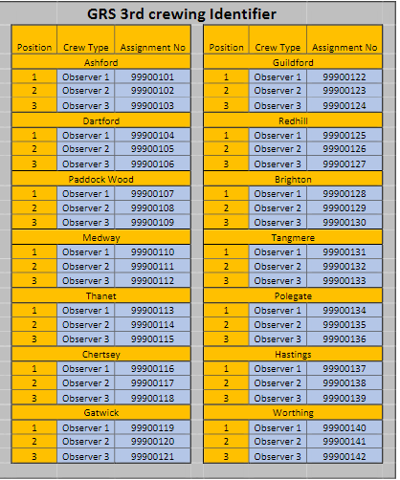

    - All Observers (including students) MUST be signed on to the vehicle and shown on GRS.
    - Non-student observers must have undertaken the discover training and complete an indemnity form and present both to the OU administrators who will keep a copy locally before being allowed to book onto observer shifts.
    - Anyone wanting to complete observer shifts MUST email observers@secamb.nhs.uk. There is no exception to this regardless of position held within the Trust, as it is a requirement of our liability insurance.
    - Local leadership teams are responsible for ensuring that all observers are signed onto the vehicle. There must be no delay to signing on if an observer doesn’t present with the indemnity form and a copy of the certificate, the observer shift must be rearranged.
    - Generic pins (as above) must be added to the MDT/MDVS when observers are not staff members or students without a payroll / pin number. All partner university students now have a pin for Electronic Patient Care Record (ePCR) and signing onto the MDT/MDVS.
    - Examples of potential observers is shown below, noting that this is not an exhaustive list:
- Non-Executive Directors
- Police /Fire (not assisting directly with a job but on an observational shift)
- Chaplains
- Hospital staff on placement with us
- Churchill Staff on induction
- Councillors or Member of parliament
- Potential future employees

    - For further information see the Observer Procedure.
  - GoodSAM Responders
    - GoodSAM allows suitably qualified individuals to offer their services to respond to patients suspected of being in cardiac arrest. Participation is entirely voluntary, and the only treatments sought from a responder are chest compressions with defibrillation only where a public access defibrillator is retrievable. No other interventions are expected of a GoodSAM responder.
    - When GoodSAM has been activated and when a responder accepts an incident, the Dispatch Function will be notified via a popup box. They will also see the responder’s details in the GoodSAM tab within the incident. There will also be relevant automatic entries in the call notes. No further action is required on the part of the RD at this point for the GoodSAM responder to mobilise.
    - The response desk is to have oversight of the dispatch of GoodSAM responders, supported by the RDs and DTLs. The RDC overseeing the GoodSAM operation is intended to serve the following aims:
- Ensuring GoodSAM responders are only dispatched to patients believed to be in cardiac arrest. This is currently set at a 600-metre radius.
- Stand-down of responders where it transpires that the patient is not in cardiac arrest, where it transpires a patient is obviously deceased, or a Do Not Attempt Cardio-Pulmonary Resuscitation (DNACPR) is in place for the patient.
- Consideration of the activation of GoodSAM where dispatch was initially rejected but the patient appears to be in cardiac arrest.
- Evaluating the safety of any said incident and standing down the GoodSAM response should any safety issues become apparent.
    - The RDC must ensure the GoodSAM portal is open on the “Incidents” tab and remains open on their computer for the duration of their shift. Upon a GoodSAM responder being alerted to an incident, there will be an audible siren alert to draw attention to the GoodSAM portal.
- Staff activated to an incident via GoodSAM must be backed up by a front-line A&E resource
- Staff activated through GoodSAM (both on or off duty) cannot stand down back-up
    - The standing down of GoodSAM volunteers is undertaken by RDC, RDs and DTLs and should only be done in the following circumstances:
- An obvious scene safety issue becomes apparent.
- It transpires that the incident is not a cardiac arrest.
- The patient is obviously deceased and beyond help.
- If the SECAmb resource is closer than the GoodSam
- If the call is re-categorised to anything lower than a C1 (if they have already arrived at scene Grade 2 back up must be arranged)
    - The procedure to stand down GoodSAM volunteer is as follows:
- Open the incident
- Click on the GoodSAM tab
- Click “Stand Down”
- Select “Send to All” from the popup screen
- This will send a message and a very loud audible alert to the volunteer. There is no need to make verbal contact.
    - If a GoodSAM responder attends a particularly distressing incident, the RDC should highlight this by e-mailing GoodSAM@secamb.nhs.uk and one of the team responsible for GoodSAM will reach out to them.
    - For further information on GoodSAM visit the GoodSAM website.
  - Community First Responders (CFRs)
    - CFRs are an integral part of the Trust’s response to emergency calls. In order to continually motivate CFRs and prevent skills-fade, it is imperative that they are utilised appropriately and allocated to a wide range of incidents.
    - CFRs do not count towards resource per incident (RPI) targets and should routinely be allocated to every suitable incident, according to their availability, where they are the closest available resource. Additionally, CFRs should be routinely assigned as an additional resource to cardiac arrests within their vicinity, as they can assist with clinical care and provide welfare support to relatives.
    - CFRs are volunteers and have the option to decline any call and choose the type of calls they are available to attend.
    - Consideration should be given to assigning CFRs to support single-crewed members of Trust staff (for example, when attending non-injury falls).
    - CFRs will be dispatched by the Resource Dispatcher. Where a CFR has not booked mobile within 30 seconds this will be followed up by a telephone call to confirm that the CFR is mobile. This can be routinely delegated to the (RDC).
    - CFRs will routinely be available for C1 and C2 incidents. They can also be deployed to C3 incidents, dependant of CSP level and with agreement of the CFR.
    - If a CFR is stood down from an incident, or if any safety concerns become apparent, the CFR must be contacted by telephone, by the RDC/Dispatcher, to ensure that they receive the message in a timely manner.
    - RDs must ensure the corresponding CFR desk/channel view is selected alongside the dispatch desk they are responsible for.
    - CFRs will appear in the suggestions box and on the map for all incidents. The RDC will have oversight of CFR’s utilising the channel view for all domestic dispatch desks.
    - CFRs will communicate with EOC via status messages. CFRs must telephone EOC in the following circumstances:
    - To advise EOC of a cardiac arrest
    - To provide a scene update (e.g., Back-up request and worsening)
    - To seek clinical advice
    - To advise they are withdrawing from scene due to safety concerns
    - CFRs are not routinely permitted to leave scene until the arrival of a SECAmb clinical resource. This excludes cases where:
    - The CFR makes a decision to leave scene in order to protect their own safety
    - The CFR is asked to leave by the patient (the patient withdraws their consent)
    - Where a SECAmb Clinician has liaised with the CFR on scene
    - Incidents can be closed where an Emergency Clinical Advice Line (ECAL) has been completed and approved by a clinician virtually
    - All the above must be clearly documented on the CAD and the Patient Clinical Record. CFRs are not permitted to discharge or refer patients.
    - CFRs primarily are lone-workers and do not have immediate access to welfare support in the same way as operational crews. The Dispatch Function is responsible for CFR welfare at all times and must ensure that welfare checks are undertaken after every significant incident. This action can be routinely delegated to the RDCs.
    - In certain circumstances RDCs, or DTLs, should notify the Community Resilience team of a CFRs attendance at a significant incident to ensure that welfare follow-up is undertaken. See examples below:
Cardiac Arrest | RTCs (involving a CFR)
Deceased Patients | Protracted delays on scene
Suicide or Attempted Suicide | Running Calls
Any incident involving Mental Health | Incidents where a CFR is injured/assaulted
Complex or Significant Incidents | Potentially contractible disease
Incidents where the patient has deteriorated considerably on scene in front of the CFR | Any incident where a CFR responds to a friend or family member
    - The Response Desk Co-Ordinator should make contact with the CFR post-incident and document contact has been successful in the incident notes.
    - A Welfare Notification should be completed on all applicable incidents. For immediate concerns the On Call Community Resilience Team can be contacted on 03303326204
    - When a RDC is on duty, they should complete the welfare notification. Where there is no RDC on duty, this must be completed by the DTL responsible for the RDC. It remains the DTLs responsibility for ensuring the process above is completed for all appropriate incidents.
    - CFRs are not permitted to respond to:
- Violent situations
- Incidents involving drink or drugs (except where cardiac arrest is confirmed and there are no scene safety concerns)
- Psychiatric/suicidal patients (except where cardiac arrest is confirmed and there are no scene safety concerns)
- Road Traffic Collision (except where cardiac arrest is confirmed and scene safety/access should not be an issue, e.g., in a cul-de-sac or minor closed road)
- Any incidents on the motorway network (excluding service stations)
- Incidents known to be on a live carriageway (excluding pavements and lay-bys where there is parking available, and the scene does not need protection)
- Any incidents involving hazardous materials (HAZMAT)
- Any gynaecological or maternity related incident unless cardiac arrest or where the chief complaint appears to be unrelated.
- Any incidents involving intrusive issues such as vaginal/rectal bleeding
- Any incidents involving fires
  - Community First Responder – Falls
    - Certain CFRs have been trained and are equipped to assist the patient off the floor (where appropriate) to prevent complications and improve patient outcomes. In collaboration with clinical support from the Unscheduled Care Navigation Hubs (UCNH) in the absence of any red-flag concerns, these CFRs can stand down from the incident, leaving the patient for a ‘secondary’ (clinical) response from a SECAmb resource or by telephone (APP) to undertake a full assessment.
    - Below are some pertinent points and updates regarding the CFR Fall initiative which will assist teams in the EOC:
- There are currently CFR Fall-trained responders across all dispatch desks
- At Gatwick MRC there is a Single Response Vehicle that has been converted for the use by CFR Fall-trained responders. The SRV does not have blue lights and responds routinely in the same way as CFRs, however it does have an MDT/MDVS (for booking on and changing status) and has an audio-enabled Airwave for verbal radio communication. All other CFR Fall-trained responders will book on, change status, and communicate following standard CFR methods (i.e.,NMA, SMS text and mobile telephone call)
- Relevant CFR Fall-trained responders are identified on the CAD with unit type of ‘CFR F’ and/or skill grade of ‘CFR Fall’
- CFR Fall-trained responders can now respond alone and can assist the patient with the aid of a bystander – e.g., another CFR, carer, relative of the patient or neighbour. There is no need for two responders to attend an incident, albeit some may wish to respond as a pair
- CFR Fall-trained responders can attend any category of call that relates to a patient who has fallen and is on the floor, unless they have indicated restricted availability (e.g., C1 or C2 only)
- Resource Dispatchers should seek to allocate a CFR Fall-trained responder (where available) to any incident for a fallen patient, particularly if there is an expected response delay >30-mins
- Allocation of CFR Fall is not sole responsibility of the Response Desk
- There is no longer a mandatory requirement for the CFR Fall responder to speak to a APP within an UCNH prior to assisting the patient off the floor. If they have concerns for the patient or need clinical advice, the CFR Fall will ask for a call-back via ECAL
- There is still a requirement for the CFR Fall to speak to an APP (via ECAL) before invoking “Interrupted Model of Care” and leaving the patient for a secondary (clinical) SECAmb response. The model of ‘interrupted care’ means that the CFR provides a primary attendance to get the patient off the floor, preventing deterioration whilst waiting for an ambulance response, then stands down and leaves the patient for an ambulance to attend for a full clinical assessment or if appropriate, for the APP to discharge and refer over the phone
- The CFR Fall does not replace an ambulance attendance and the CFR Fall will never discharge the patient, however by assisting the patient from the floor they may make the call more suitable for an SRV clinical response, or call back from an APP
- Following discussion with and agreement from an UCNH, the APP will show the responder’s unit status as ‘delayed available’ (Arrange Grade 4 or APP) so that the incident remains open on the CAD for a secondary response. (Unless the incident can be dealt with and discharged by the APP and refer over the phone)
- It’s the responsibility of the UCNH to ensure the responding resource has not cleared prior to the incident appearing back in the dispatch list
  - Volunteer Emergency Responders
    - Currently the Trust has three Emergency Responders vehicles, that are staffed by volunteers. The difference between a Community First Responder (CFR) and an ER is predominantly that they have an extended scope of practice and can respond to incidents under emergency driving conditions. All ERs have completed the Future Qual L3 CERAD qualification for livered cars only. ERs are not qualified to drive or volunteer as part of an ambulance crew.
    - ERs will be dispatched by the relevant dispatcher to all grades of call. At the current time all ERs will only be dispatched to incidents as per the CFR deployment list. ERs ideally will be double crewed, however can work alone if necessary.
    - ERs are resources in three teams of 12, supporting an effective response to our patients where we are currently challenged. They are currently based out of:
      - Ashford in Kent: Tethered to Romney Marsh area (Can be moved for CSP cover if necessary) Call sign R022
      - Horsham ACRP West Sussex: Tethered to the Horsham and Billingshurst areas. Call sign R011
      - Sheppey in Kent: Tethered to the Sheppey Area. Call sign R033
    - They will have ePCR and Airwave handsets with an MDT/MDVS in
their vehicle. For falls patients they will not be able to use ePCR and will complete a paper PCR especially designed for fallers managed by volunteers.
    - When the ERs book on duty they should be sent to the tethered area to provide cover. However, can be used on route for a C1 response if they are the closest resource. ERs should ideally not be used for other category of calls outside of their tethered area. Where possible once in the tethered area they can respond to all incidents within a 20-minute drive.
    - It is the responsibility of ER personnel to notify the EOC when they require a meal break or comfort break.
    - Although the ER vehicles are a tethered resource should a C1 call arise where they will be the nearest available resource but outside of the tethered area, the ER must be used. Once they have cleared, they must be returned to the area they are tethered to.
    - All ERs are falls trained and can also be used in the tethered areas for fallers.
  - Urgent Transport Vehicles
    - Urgent Transport Vehicles (UTV) are crewed predominantly by two Emergency Care Support Workers (ECSW) who are not clinicians. UTVs can also be crewed by any combination of non-registered clinicians if pre-agreed or authorised.
    - Further details are available in the Urgent Transport Vehicle (UTV) Policy and Scope of Practice and Clinical Standards Policy.
    - ECSW/AAP/Technicians undertaking transfers for patients who have had opioids or benzodiazepines are authorised to escort these patients.
    - UTVs are excluded from the LCDM.
  - Zoned Resource Deployment – Tethered
    - Zoned Resources (ZR) are designed to support response time standards in areas of high demand.
    - Each ZR will have an allocated stand-by location, either at an ACRP or Roadside Standby Post (RSP).
    - The ZR will be available for Category 1, 2 & 3 incidents. For other categories of incident, they should only be deployed where the clinicians deem the incident as a clinical risk.
    - The ZR can be sent to the nearest Category 1 & 2 out of the zoned catchment area if no other resources are available but must return to the zoned area after call as a priority.
    - Category 3 calls out of area can also be covered by zonal cars where the where clinical need is identified by Clinical Supervisor (CS)/Clinical Safety Navigator (CSN).
    - Zoned Resources may be untethered during periods of CSP escalation.
    - Any zonal resources across the Trust must operate to the above guidelines.
  - Operational Commanders
    - Operational Team Leaders (OTLs) who are on duty as the Operational Commander should book on as detailed in Section 10 however must be shown as status C1 Cardiac Arrest Only.
    - RDs should, manually allocate the duty OTL where they are the nearest response to a confirmed Cardiac Arrest, as the auto allocate function has been disabled.
    - OTLs must be informed of all Cardiac Arrests and significant incidents on their dispatch desk for review and attendance for scene management purposes or to ensure staff welfare is carried out where appropriate.
    - All other OTLs who are booked onto an SRV and not performing the Operational Command function should continue to remain available for C1 incidents.
    - OTLs can self-task to incidents and act as the Operational Commander for the incident or attend incidents for immediate staff welfare.

Specialist Resources

  - Advanced Paramedic Practitioners

    - All APPs not working on a DCA should operate as per the Advanced Paramedic (Urgent & Emergency Care) Deployment Procedure. Deployment for APPs should be as follows:
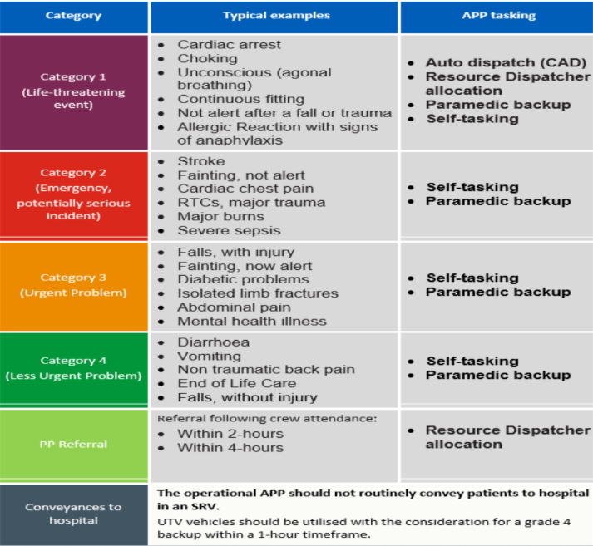

    - APPs with access to the CAD should proactively self-task, however, EOC can liaise with APPs to discuss potential suitability for attendance.
    - Where an APP referral is outstanding and an appropriate call comes in that could be dealt with by an APP (Appendix 3), consideration will be given to sending the APP to the emergency call. EOC staff must liaise with Dispatch Inline Support & APP to see if an appropriate delay can be applied to the referral. EOC can take the appropriate actions based on the advice of these.
    - Staff practicing as APPs are often at different stages of their pathway and may not be able to undertake all interventions. This will be denoted on the CAD as a SPP, and the RD should liaise with the SPP regarding their scope.
    - Further details are available in the Advanced Paramedic Practitioner (Urgent & Emergency Care) Deployment Procedure.
  - Critical Care Paramedic Deployment

    - Please refer to the Critical Care Desk Policy and Procedure for all relevant information.
  - Specialist Operational Response Team (SORT)

    - All NHS Ambulance Services, are required to have a minimum of 35 SORT Operatives on shift at any one time. As a result of these changes, SORT Operatives will no longer be deployed on Single Response Vehicles.
    - SORT Operatives will only be deployed to the following incidents:
- Marauding Terrorist Attacks
- Incidents where a Police Force have declared “Operation Plato”
- CBRNe/HAZMAT incidents where there is a requirement to carry out clinical and mass de-contamination
    - Other than normal DCA duties, SORT Operatives should not be routinely deployed to any other incidents outside of the above identifiers as SORT. This list is not definitive, and where it is believed a SORT deployment may be required, this should be discussed with the Duty Tactical Commander and On-Call Tactical Advisor in the first instance.
    - SORT resources are not tethered to their home dispatch desk and can be utilised on any dispatch desk. The resource is a normal DCA unless requested to attend an MTA, OP Plato or CBRN/Hazmat incident that requires mass de-contamination.
    - Deployment of Specialist Assets within SECAmb is the responsibility of the Duty Tactical Commander with specialist advice from the On-Call Tactical Advisor. Where an incident is identified that is likely to require SORT deployment, the EOC Manager should contact the Duty Tactical Commander for initial agreement and action. Any activation should be agreed following a discussion between the Duty Tactical Commander and the On-Call Tactical Advisor. Where an incident specifically requires the deployment of a SORT vehicle this should be done immediately. If the vehicle is already committed to an incident another resource must be assigned to release the SORT resource from scene as soon as possible. For further details please refer to the Emergency Breakaway Procedure.
    - EOC can identify SORT Operatives that are currently logged on to vehicles on Cleric by going to Enquiries > Crew Logged On/Off Enquiries and then searching by SORT. SORT Deployment to one of the incidents stated above, should be the nearest 35 Operatives as identified by EOC.
    - SORT operatives now form part of a normal Double Crewed Ambulance and will be met on scene by the Incident Support Vehicle which will deliver Ballistic PPE for 40 SORT Operatives. The trust’s SORT MTA Equipment Vehicle will be deployed to:
An actual or suspected MTA incident within SECAmb’s area, as soon as is reasonably practical. This could be to:
- The ‘Cold Zone’ of an incident
- An agreed rendezvous point
- An agreed Strategic Holding Area
- An incident where a Police Force has declared “Operation Plato”
- Pre-positioning in response to a pre-planned intelligence led event

    - The trust has 4 SORT Equipment Vehicles strategically placed to ensure we can promptly deliver sufficient equipment to scene. These vehicles can be driven by any member of staff with a C1 entitlement and Emergency Driver Training (for a blue light response). The trust’s de-contamination and equipment vehicle capabilities remain unchanged. Dispatch Team Leaders should routinely ensure they are familiar with utilising the “Enquiries” tool and aware of what SORT operatives are on shift on their dispatch pod.
  - Incident Support Vehicles
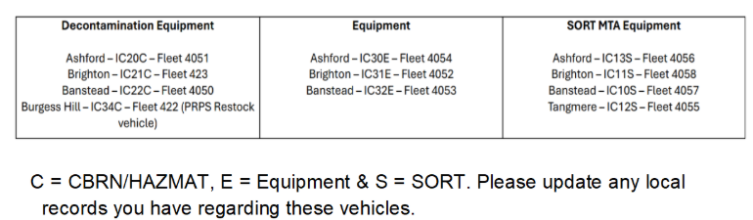

  - Hazardous Area Response Team (HART)

    - SECAmb HART resources will be tasked to incidents primarily by the HART Tasking Desk, supported by the CCD, however HART can be dispatched by any dispatcher if a HART appropriate incident is identified following liaison with the HART TL. Incident types are described in Appendix 6.
    - In support of A&E operations, when available (booked on with EOC), HART Response Vehicle (HRV) x 1 will be available to respond to Category 1 calls.
    - Further details are available in the HART Deployment Procedure.
  - Gatwick Airport Solo (GATSO)

    - The Gatso responder will be strategically positioned at a pre-determined location within the airport to facilitate rapid response across all areas.
    - Sign-on time is at 05:45, with deployment from Gatwick Make Ready Centre (MRC). Shift times will be 0545-1415 and 1400-0015 on weekdays. At weekends 0545-1615 and 1600-0015 and will be deployed every day of the year.
    - Once vehicle checks and controlled drug collection are complete. The vehicle is expected to pass through security by 06:00 but will be capable of responding as needed during this period.
    - Shift handovers include an overlap to maintain continuous response capability.
    - The Gatso responder will be deployed normally by the Gatwick Resource Dispatcher (RD) following Dispatch Standard Operating Procedures (SOP) and Ambulance Response Programme (ARP) guidelines. If Gatso is occupied, standard frontline 999 crews will be dispatched to incidents at the airport.
    - Dispatchers may coordinate with Gatso regarding ongoing incidents and potential availability.
    - Gatso will not be backed up unless the incident is categorised as a Category 1 call. Gatso will assess the patient on all other category calls and request back up (Grade 2) via CROPS and inform GCC to prepare for transporting resource if required.
    - All meals breaks for Gatso responders are fully disturbable for all categories of call.
    - Refer to the Gatwick Solo briefing for further information GATSO Briefing.
  - Adult Critical Care Transfer (ACCT)

    - The Trust is commissioned to undertake Adult Critical Care Transfers (ACCT). This is an interim arrangement with NHSE to support movement of critical care patients within our region (Kent, Surrey and Sussex) and transfers to specialist units outside our region. It is a separately commissioned service from normal 999 provision.
    - Two vehicles have been allocated for ACCTS specifically between the hours of 1000-2200 daily and should not be utilised for normal 999 operational deployment, unless authorised by the Duty Strategic Commander. The calls signs are 628 (Medway) and 614 (Gatwick).
    - The deployment of ACCTS resources will be overseen by the EOC dispatch function and primarily the RDCs.
    - The transfer will be booked by the Single Point of Contact (SPOC). When the SPOC is not covered, the Adult Regional Critical Care Kent Surrey Sussex (ARCCKSS) clinical teams will book the transfer directly.

Area Cover (System Status Plan)

  - The Trust operates using System Status Plan (SSP). One of the philosophies of this methodology is geographical distribution of resources to provide maximum coverage for all service users.
  - This is achieved via a network of deployment points which have been selected for their strategic location. These points can be broken down into two types:
- Ambulance Community Response Posts (ACRPs) which are posts with full facilities for crews
- Roadside Stand-by Posts (RSP) which are posts with no facilities
  - ACRPs are available for use on a 24-hour basis. RSPs are available between 6am and 1am. Crews can cover a RSP for 1 hour before being offered a location with facilities. However, crews can request facilities sooner or choose to stay at the RSP.
  - The System Status Plan (SSP) is set out in priority order. Dispatchers are expected to place all core resources in the SSP in the order of priority and must make every effort to maintain a minimum of the top three points covered.
  - An element of judgement needs to be exercised when covering the SSP. Dispatchers are expected to make judgement decisions based on known resource availability, likely availability of resources due to sign on, clear at hospital etc., and geographic distance between response posts. Ultimately the Dispatcher is responsible for SSP compliance. Deviations from the plan, although acceptable, should be considered the exception to the rule, and will require justification in the event a call is missed in a higher priority response area.
  - The DTLs are accountable for ensuring dispatchers are compliant in all areas of dispatch and SSP compliance and should have an awareness of cross-border activity.
  - Resources must deploy to a cover point immediately; in the same urgency they would respond to an emergency call (60 seconds). Should this not be possible, the crew must contact the Dispatcher to explain the situation. Resources which have not deployed within an acceptable timeframe should be escalated to the OTL.
  - Once at post, crews will only be moved under the following circumstances:
- First deployment at start of shift
- Deployed to an emergency call
- Move to a higher priority post
- No facilities for 60 minutes
- To facilitate Meal Breaks & Refreshment breaks

Resource Optimisation

  - A twice daily call occurs to proactively balance resources across the Trust.
  - Crews who are moved because of this call will be informed of their new dispatch desk at the beginning of their shift.
  - Whilst travelling to their new dispatch desk crews will only be available for C1 calls and C2 calls which are outside of their allotted timeframe if they are the closest resource.
  - Every effort will be made to ensure that crews finish on time at their base dispatch desk. Dispatchers will work together where possible to ensure that crews are returned to their home base in a time for the end of their shift.

Local Community Dispatch Model (LCDM)

  - The LCDM ensures that vehicles are not routinely assigned to incidents outside of their dispatch desk to neighbouring dispatch desks and will only be deployed outside of their geographical boundary for high acuity Category 1 or Category 2 incidents where there are no resources available, that would meet the ARP response time targets. If the dispatch desk has 15 or more calls holding in the stack (excluding those in CSD), or if there are double breaches, the RD is to escalate through the chain of command (RD>DTL>EOCM) so the LCDM Model can be reviewed with the CSN or Duty Operational Tactical Commander. Urgent Transport Vehicles are exempt from the LCDM.
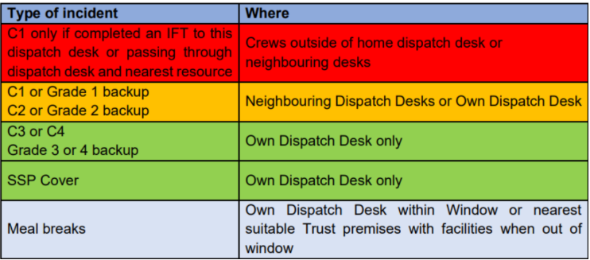

Incidents in Neighbouring Ambulance Trusts

  - All C1 incidents received within neighbouring Ambulance Trusts’ borders will follow the Cross Trust Border Memorandum of Understanding (MoU). It is the responsibility of all staff to be familiar with this MoU. On receipt of a C1 incident verbal confirmation from the neighbouring Trust is required before standing down.
  - The DTL must be made aware of all cross-border incidents. They are expected to actively monitor such incidents and liaise with neighbouring Trusts as appropriate regarding support.
  - When requesting support from a neighbouring Trust, the Dispatcher must first deploy the nearest Trust resource to the call, if available. Mutual aid will only be requested where the call is of at least Category 2.
  - The Dispatcher or DTL will liaise directly with the neighbouring Trust to determine if they have a nearer resource to an incident. The ETA, type and skillset of the Trust responding resource will be provided to the neighbouring Trust.
  - Comprehensive CAD notes will be maintained whether assistance is provided or not. Where assistance is provided the Dispatcher will assign the Trust callsign (SCAS, LAS, EEAS). The Dispatcher or DTL will then call back for times, and any further information, within 6 hours.
  - For further details please see the Managing Incidents Cross Borders Between Ambulance Trusts Memorandum of Understanding.

Passing Out of Area Incidents

  - The Dispatch Function is responsible for monitoring the default queue. The DTL is ultimately responsible for mapping, reviewing borders and access, and passing any out of area incidents to the appropriate Ambulance Service without delay. Passing of incidents should be considered the same priority as assigning to an incident.
  - All calls that have been passed via the ITK need to be checked to ensure there is a reference number and that it is showing as successful. If the ITK has failed or the call is being sent to an area without that functionality all details must be passed verbally to the correct service.

Incident Resourcing

  - For the purposes of reporting performance standards, the clock starts on an emergency call when one of the following occurs:
Category 1
- Disposition Reached
- 30 Seconds from Call Connect
- A resource is allocated to the call
- Auto allocation

Category 2-4
- Disposition Reached
- 240 Seconds from Call Connect
- A resource is allocated to the call
- Clock-start will not take place until one of the three bullet points occurs. The 240 second period is designed to be used for selection of the most appropriate resource for the call.
  - All allocations will occur as per the SECAmb Dispatch Model as shown in Appendix 1. Any allocation outside of these parameters must have gone through shared decision making with the DTL, Clinicians or EOCM as appropriate.
  - Dispatch should verbally contact the crew for all category of calls, if the crew have not mobilised (wheels turning) within 60 seconds. Any undue delays in mobilisation should be escalated to the OTL for further review.
  - Dispatch should also make voice contact if any scene safety related information has been received.
  - Where an SRV is dispatched to an incident the dispatcher must contact them via radio to pass the incident details as soon as possible and provide any further updates verbally.
  - To assist with decision making, the dispatcher must utilise the CAD’s suggestions in conjunction with the mapping system to identify the nearest and most appropriate resource.
  - It is the responsibility of the DTL to oversee and support the Dispatchers’ decisions and assist them to make adjustments where necessary, ensuring performance is met and the most appropriate resource is sent at all times.
  - The DTL is responsible for reviewing all incidents which have two or more resources assigned to ensure appropriate levels of resourcing have been deployed.
  - Deployment to Category 1 Incidents

    - The nearest available emergency resource regardless of resource type will be assigned to every Category 1 call. This includes all specialist resources: - Critical Care Paramedics (CCPs), Hazardous Area Response Teams (HART SRVs), Advanced Paramedic Practitioners (APPs), Operational Team Leaders (OTLs) and Response Capable Managers (RCMs); this list is not exhaustive and expands to other roles that could make a primary response.
    - If the nearest resource to a Category 1 call is not a Double Crewed Ambulance (DCA), a DCA must be assigned immediately as a second resource.
    - UTV resources can only attend confirmed or suspected C1 cardiac arrest, IFT level 1 and Grade 1 back up requests.
    - Duty OTLs can be deployed to confirmed cardiac arrests where they are the closest to the incident. Auto allocate function on the CAD is disabled for all duty OTLs.
    - If the DCA is the nearest resource to the incident, no further resources need be assigned, except for the following call types that will require further resources to attend the incident:
- Cardiac Arrest
- Obstetric Emergency
- Fitting now for non-paramedic resources

    - CCD may listen in on calls and deem one resource is appropriate for the calls listed above. They will document their rationale in the call notes.
    - For all other Category 1 incidents and to prevent over resourcing, only 1 DCA should initially be deployed. In all cases, an early update from the first resource on scene should be provided to EOC or the Critical Care Desk (CCD) with resourcing requirements.
    - Over resourcing incidents prevents other patients waiting in the community receiving a timely response.
    - See section 19 Specific Incidents for additional details around C1 deployment to obstetric emergencies, cardiac arrests and fitting patients.
  - Deployment to Category 2 Incidents

    - Where possible a DCA should be sent as the primary and only response to a Category 2 call.
    - When a DCA is unable to arrive on scene within 18 minutes, an SRV should be considered to attend if they are the nearest and most appropriate response. Category 2 calls with a NOC Chest pain/Stroke as an example or any incident you feel would benefit from a specialist resource, where there is not a response able to attend in ARP standards, please escalate to the DTL to review appropriateness for a specialist resource to attend i.e., CCP/OTL if an SRV is not closer. Do Not Delay deploying a resource to C2 Chest Pain incidents.
    - As per ARP, incidents should be assigned in time order (for C2s time incident received, upgrade time, G2s time back-up requested). The exception is any incident that has been “P1” by a clinician following a review. Dispatchers are encouraged to use the ‘Intelligent Dispatch Model’, and if utilised then robust and pertinent notes must be added to the ‘Call Notes’ to justify the decision-making process.
    - On request of all graded back-ups the Dispatcher must enter the time of request in the instruction field to match the timestamp of request. This is because currently the CAD does not change the elapsed time to match the back-up request time.
    - In all cases:
- A DCA must continue to scene and should not be diverted unless this is to a higher priority incident (Category 1/Grade 1). DCAs should not be diverted to unassigned C2 incidents
- Grade 3 Back-up can only be accepted in CSP level 1 or if the back-up resource can get to scene within 1 hour of the request
- This will ensure these cohort of patients, which can include stroke, myocardial infarctions, and sepsis, are not left waiting in the community with an SRV for extended periods waiting for a conveying resource, often arriving at hospital much later than other patients who called 999 later
- SRVs should be released from scene as quickly as possible to be available for further incidents in the community
- SRVs will routinely be stood down from scene post 15 minutes from when the conveying resource arrives on scene, unless an update is provided from the SRV advising additional time is required to support extrication/handover and support ongoing clinical care
  - Deployment to Category 3 Incidents

    - Where possible a DCA should be sent as the primary and only response to a Category 3 call.
    - An SRV should be sent to a Category 3 call if there is no DCA available to attend. No patient should be left waiting unnecessarily. The dispatch function should also consider the suitability of a falls trained CFR as the only resource to a faller with either suspected minor injury or non-Injury.
    - APPs should be monitoring the C3 waiting incidents to consider self-allocation to patients who are likely to be non-conveyed.
  - Deployment to Category 4 Incidents (Non-Emergency Calls)

    - The aim should be to task a DCA or UTV (if deemed appropriate and/or clinically reviewed by a clinician) as the primary and only response to a Category 4 incident.
    - C4 calls will be considered for allocation alongside C3 calls to avoid them going out of ARP standards. This should only be considered when the C4 call is older than outstanding C3s. For example, a C3 call has been unassigned for 30 minutes and a C4 call has been unassigned for 2 hours, the C4 should be considered for allocation first to reduce clinical risk.
    - It should not be routinely necessary to assign an SRV to a Category 4 incident.
    - Due to the low numbers of Category 4 incidents received in SECAmb, many of these patients are waiting excessively over the 3-hour ARP standard and often double breaching. This places a greater clinical risk to these cohort of patients when waiting unreasonable amounts of time for a response. Any concerns should be discussed with a clinician via the inline clinical support function.

Specific Incidents

  - Acute Behavioural Disturbance/Disorder (ABD) or Excited Delirium (ED)

    - The nearest DCA must be sent and the CCD informed.
    - The duty OTL should be informed for scene management and staff welfare.
    - Ensure Police are aware and attending for ABD.
  - Incidents on Public Transport

    - Any potential delay in responding to an incident on Public Transport could have a profound effect on the operations of the Transport Provider.
    - Any incident on a form of public transport (i.e. aeroplane, train, ferry, bus/coach) should be marked as such by the Emergency Medical Advisor taking the call. This is done by selecting ‘Public Transport’ from the drop-down list of instructions on the incident. A patient on a station, at a bus stop etc should be triaged as normal for a public place incident. The drop down is only relevant for those still on board the transport.
    - Where an incident requires a C3 or C4 response and the patient has been identified as on public transport the DTL & EOCM must be notified immediately.
    - The DTL will review the incident and where the expected response time is greater than a C2 (18-min) response a shared decision-making process should occur with the EOCM and Clinical Safety Navigator (CSN).
    - This shared decision-making process should consider whether upgrading the response time to a C2 or deploying specialist resources is appropriate.
    - Incidents at local airports received via the 999 system must be passed to local airport control by the Dispatch function. This is to ensure the airport can make arrangements in terms of access/egress and escorting crews to the location in a timely manner, preventing delays in physical attendance with the patient.
    - Gatwick Control Centre (GCC) is to be informed if an unmarked resource is attending. The responding unmarked resource is responsible for informing EOC so they can inform GCC.
  - Incidents Within an Event Footprint

    - If a 999 call is generated from within an event footprint, the call should be dispatched on following normal procedures.
    - If the EOCM has been made aware of an event medical provider in place at the event, they should ensure that the event medical provider is informed so that they can send appropriate resources to provide pre-arrival care.
    - The presence of an event medical provider should not influence or reduce the SECAmb resourcing to the incident.
    - If a registrant arrives on scene and confirms to SECAmb that backup is not required, EOC can close the call as “cancelled by caller”.
  - Bariatric Patients

    - The Trust’s response to bariatric incidents will be coordinated by specifically trained personnel Operational/Bariatric Commanders in liaison with EOC to ensure an effective clinical and logistical response as defined within the Bariatric Patient Treatment Policy and Procedure.
  - Calls for Patients Who Have Died

    - If there are any issues with Police demanding attendance or refusing to attend, escalate to the duty Tactical Commander.
    - If Police are on scene declaring the patient is obviously deceased SECAmb will not routinely attend - If the person is not breathing and obviously dead (i.e. beyond help) the coroner should not require a Health Care Professional (e.g. Paramedic) to verify death; Verification of death (VoD) can be done by Police in the following circumstances:
- Decapitation
- Massive cranial (skull) and cerebral (brain) deconstruction/injury
- Hemicorporectomy (body cut in half) or similar massive injury
- Decomposition/putrefaction
- Incineration (massive burn)
- Hypostasis (accumulation of fluid or blood in the lower parts of the body)
- Rigor mortis (rigidity/stiffening of limbs)

    - Please refer to the following for more information: End of Life Care Guidance and Procedures.
  - Death Under 18

    - All deaths under 18 must be notified to Safeguarding On Call as soon as possible after confirmation. This includes those confirmed deceased in the community or on arrival at hospital. The notification should be completed by the DTL or EOCM as soon as it is confirmed by the operational resource on scene.
    - If a child is successfully resuscitated and return of Spontaneous Circulation/Respiration (ROSC/ROSR) is obtained or a conveyed child is not reasonably expected to survive, then Safeguarding On Call should be informed.
    - For incidents involving patients under 18-years old (For neonates please review Appendix 7) confirmed or suspected cardiac arrests Police must be informed immediately, except where the death is expected and there are no suspicious circumstances.
    - Resource Dispatchers should ensure the duty OTL is deployed to scene and/or to hospital to support operational resources with decision making, scene management and welfare.
    - Tactical Commanders should be made aware of the incident and provide support and welfare for the duty OTL.
    - Chaplaincy should be considered for staff welfare.
    - Please refer to Appendix 7 for further information.
  - Attending a Family Member

    - Crews sometimes attend incidents which involve family members or friends that may have a direct impact on their cognitive ability to respond using emergency conditions and objectively triaging the patient.
    - Where a staff member is assigned to or becomes aware of any 999 call which relates to a member of their family or a friend, they should immediately inform EOC.
    - If assigned to the incident EOC should assign a second response (as if the incident was unassigned) as the primary response. The crew related to the incident should be stood down and marked as Out of Service (Not Available) for Staff Welfare.
    - Inform the duty OTL for staff welfare and to attend if they feel necessary.
    - The affected crew, whether initially assigned to the incident or not, may continue to the incident. The non-affected person must drive, if attending an incident requiring a blue light response.
    - If the affected crew are not aware of the incident the RD cannot knowingly assign the member of staff to the incident. General Data Protection Regulations (GDPR) must always be upheld. The RD should consider using an alternative resource, to that linked to the patient.
    - Under no circumstances can an on-duty staff member contact EOC and request a running call for a family member when they are not on scene with the patient. A 999 call must be made and an NHS Pathways Triage is completed.
  - Running Calls

    - All running calls will generate a Category 2 response.
    - Where a crew call up to notify of an incident they have come across or been flagged down for, a new incident must be created on the CAD at their current location unless there is already an active call for that patient.
    - Any appropriate incident details should be noted including whether any other services need to be informed and the appropriate actions taken.
    - If the resource is currently transporting a patient the running call should be backed up by another resource on Grade 2, so the initial resource can continue transporting.
    - This process should also apply for any instances where a member of staff or visitor to any Trust premises including EOCs needs the attendance of a clinician.
    - CFRs/ Non-operational staff that come across an incident or have been flagged down, should dial 999 and expect a full triage from an EMA. CFRs due to their scope of practise and being volunteers are unable to call EOC with a running call.
  - Ambulance Service Vehicle Involved in a Road Traffic Collision (RTC)

    - It is vital when any SECAmb resource, including CFRs, are involved in an RTC, the dispatcher takes the following actions:
- Immediately identify exact location of incident and generate new incident on the CAD as ‘RTC Service Vehicle’
- DO NOT assign the resource involved to the incident and book the resource OOS not available
- Identify number of vehicles involved
- Identify any injuries, crew and/or public
- Deploy required resource to deal with the incident
- Notify the relevant other emergency service I.E. Police, Fire (If required)
- Immediately inform OTL and DTL
- DTL to ensure EOCM, Tactical Commander and Driving Standards Manager (in hours via phone – oohs via email) are informed
- If the resource involved was en-route to a patient or to hospital with a patient immediately reallocate that case to another resource if appropriate

    - Following a crew update to EOC advising minimal damage/no injuries occurred (e.g., clipped wing mirror), and just an exchange of insurance details is required, standing the resource down isn’t necessary. Relevant delay notes should be added to the CAD.
  - HCP Mental Health Admissions

    - The Trust is locally commissioned, outside the Ambulance Response Programme, to respond to all Health Care Professional Mental Health Admissions within a 1-hour response.
    - Resource Dispatchers should be vigilant of any incident that has HCP MH as the ‘type’ and/or *MH* within the instructions and attempt to provide a resource on scene within 1-hour.
    - In some instances, the police may request a transfer for a patient under section 136 to an Accident and Emergency Unit (AEU), this can be booked as an 18-minute response. A C2 is only to convey the patient to a place of safety from the community. Should the police request transport to a MH facility from an AEU this must be declined, redirected and must be booked via HCP 1HR MH transfer. UTV resources are suitable for this transfer.
  - Obstetric Emergencies/Imminent Births

    - Every imminent birth and Born Before Arrival (BBA) must receive 2 DCAs (1 for mother and 1 for baby). If the nearest resource to an imminent birth/BBA is an SRV, the SRV and 2 DCAs must be tasked.
    - All resources must continue to scene unless the primary resource stands subsequent resources down.
  - Cardiac Arrest

    - Every Category 1 cardiac arrest should receive a minimum of four pairs of hands, one of which should have a minimum skillset of paramedic and one of which must be a DCA. For example, this could be 1 x DCA and 2 x SRV. Ideally a critical care paramedic should be deployed. A second example could be 1 x DCA, 1 x CCP and 1 x OTL.
    - CFRs count towards pairs of hands on scene.
    - CCD may listen in on calls and deem one resource is appropriate. They will document their rationale in the call notes.
  - Fitting

    - Every Category 1 fitting now incident must have a paramedic response deployed as a minimum clinical grade of resource.
    - If the primary response is not a paramedic resource, then a secondary response with a paramedic must be deployed immediately.
    - The primary response once attended, can stand down the ambulance if they are able to deal with the patient’s presenting complaint within their scope of practice.
    - The process is including those patients who have ‘stopped fitting’ but remain a Category 1 disposition.
  - Other Category 1 Incidents

    - For all other Category 1 incidents and to prevent over resourcing, only 1 x DCA should be initially deployed.
    - In all cases, an early update should be provided from the first resource on scene to either EOC or the critical care desk with resourcing requirements.
    - Over resourcing incidents prevents other patients waiting in the community to receive a timely response.

Inter-Facility Transfers

  - SECAmb are not commissioned to provide a clinical skill set for any IFT.
  - When undertaking an IFT, any interventions or therapies performed in transit must be in accordance with the scope of practice of the clinician performing the transfer. These can be found in the Scope of Practice and Clinical Standards Policy.
  - Where the patient needs an intervention/therapy that cannot be deactivated for the journey, it is the hospital’s responsibility to provide an appropriately trained escort.
  - Examples of interventions/therapies that will ALWAYS require an escort, regardless of grade of ambulance staff are:
- Chest drains
- Infusion pumps
- Syringe drivers (Note: this does not include McKinley T34 syringe drivers*** for Palliative and End of Life Care patients)
- Blood transfusion
  - Please be aware that ‘managing IV fluid infusion’ is within the scope of practice of Associate Ambulance Practitioner (AAP) and above.
  - Escorting a patient after opioid infusion is within scope of practice for all clinical grades.
  - Conveying a patient outside of your scope of practice represents a patient safety issue as the member of staff will not be in a position to troubleshoot any problems during the journey. A medical escort must be provided by the facility requesting the transfer.
  - Prior to undertaking any inter-facility transfer, the crew should ensure they have the following information:
- The exact destination for the patient
- The reason for the escalation of care and current NEWS2 score
- What current medications are running?
- Any medication not in clinician scope or JRCALC will require cessation or an escort (including Blood products)
- What devices or drains are currently running?
- Any device that may require trouble shooting during the journey must have a suitably trained escort e.g. external pacing/ intercostal(chest) drain/ arterial line/syringe driver
- What clinical interventions may be required enroute?
- Have patients with A B and D problems had an anaesthetic assessment
- Have patients with a C problem had adequate resuscitation and support for ongoing care?
- What monitoring is required enroute?
- Patients requiring invasive monitoring such as arterial lines must have an escort
- Any delays due to the patient not being ready must be relayed to EOC ASAP
  - If you have any questions/concerns prior to undertaking the transfer that the transferring unit cannot satisfactorily address, then please escalate to the local OTL or Critical Care Desk in the first instance.
  - Level 2 Inter-Facility Transfer Prioritisation
    - Level 2 Interfacility Transfer (IFT) requests will receive review (where capacity allows) from a clinician in EOC (including the Critical Care Desk) to support appropriate prioritisation and reduction in delays for patients with time-critical emergency care needs.
    - There have been cases where time-critical emergency Level 2 IFT patients have been severely disadvantaged by delays in dispatching an ambulance resource. Upon review, there are several apparent factors for delays, including operational pressures and over-use of Level 2 IFT requests for non-time-critical patients by some hospitals.
    - Within the national framework, there are nine specific examples of immediate life, limb or sight threatening situations that require immediate management in another healthcare facility that should receive an IFT Level 2 response:
- Mechanical (stroke) Thrombectomy
- Stroke Thrombolysis
- Primary Percutaneous Coronary Intervention (PPCI)
- Major Trauma
- Immediate Neurosurgery
- Ruptured Aortic Aneurism or other Vascular Emergency Surgery
- Emergency Laparotomy
- Surgery for Ectopic Pregnancy
- Possible Acute Behavioural Disturbance (mental health under active restraint)
    - Relevant hospitals will be provided with guidance to support requests for Level 2 inter-facility transfers, so that patients in the (specific) nine categories above can be easily documented in Call Notes by Emergency Medical Advisors (EMAs) and easily identified by clinicians in EOC.
    - Where capacity allows, the Critical Care Desk (CCD) will review these requests at the earliest opportunity to identify suitable cases for prioritisation.
    - Other clinicians within EOC are also encouraged (where capacity allows) to review and prioritise these requests at the earliest opportunity.
    - Where a request falling into any of the categories above is identified, consideration should be given by the reviewing clinician to add ‘P1’ into the instructions field of the incident, prioritising for dispatch.
    - This list is not exhaustive. There may be other time-critical Level 2 IFTs not listed, which should be considered on a case-by-case basis and advice sought via Dispatch Inline Support if necessary.
    - All cases within the above groups should be referred to the HEMS desk by the CCD or others for consideration of air ambulance deployment if a Double Crewed Ambulance (DCA) is not immediately available, or if the referring hospital is a substantial distance away from the destination hospital.

Incident Review

  - All incidents requiring a response must be continually reviewed by the dispatcher. Once an incident shows on the Dispatch List on CAD, the incident should be opened by the dispatcher. The incident should then be continually reviewed until triage has been completed and the EMA has exited the call. This is to ensure all pertinent notes have been read. It is the responsibility of the RD and DTL to ensure incidents are reviewed using the “take ACTION guidance for dispatch” (Appendix 9).
- Action Card? Is there an action card for this situation
- Ask for help or advice if needed
- Alert a Team Leader
- Call other agencies (e.g., police, fire, or specialist units)
- Commander deployed to the scene as required
- Communicate with responding resources and provide shared situational awareness through radio updates
- Tell your team leader and EOC manager for oversight
- Take time to review the incident clearly and consider all the relevant notes. Has anything been missed?
- Talk – request an update from the responding resources (Windscreen Report / METHANE)
  - Incidents Received via ITK
    - For incidents received via the ITK, the RD must open these incidents at the earliest opportunity to complete the address validation process. A resource should not be dispatched to an unvalidated address. Upon opening an incident requiring address validation, the user will immediately become the sole individual responsible for the validation process. Warning: If this process is ignored, it will not be presented to CAD users who later open the incident.
    - The CAD will present a window called ITK incident location. Within it, it will show two addresses. The first is the address that was sent by the original system and is the correct address. The second is the address that the CAD has matched.
    - It has been identified that some ITK links do not map correctly. Please ensure you review where the call is mapped and refer to OS Places Online Gazetteer.
    - Any incident received by ITK, the RD must ensure the pathways summary is sent manually to the crew as well as any pertinent notes as this is not automatically sent via the CAD to the MDT/MDVS.
  - All incidents should continue to be reviewed until the crew arrive on scene with the patient. The review should take consideration of any crews which have or may become clear, (e.g Clearing on scene, Clearing at hospital, New Sign-ons), resources from neighbouring dispatch desk, utilising more suitable resources and reviewing any additional notes which may need to be passed on for clinical review.
  - Notes should be entered by a DTL once every 2 hours dependent on demand on the service. The DTLs should use the below format, operational hours information is not required as this is available via BI reports:
- DTL Reviewed Outstanding Unassigned Incident at 00:00
- I have verified no available resources, having checked neighbouring dispatch desks and resource availability
- Not assigned due to fully uncovered SSP, no available resources with outstanding incidents. POD 1 CSP Level: 4
- 150 total calls unassigned
- Any additional pertinent notes i.e hospital delays/diverts
  - RDs are expected to open and review the call notes for any updates. RD notes should be entered for outstanding calls every 2 hours. RD reviews are expected to include the following:
- C – Check incident - incident must be opened and notes reviewed regularly, ensuring relevant information is copied to the crew notes tab.
- L – Log key observations - outstanding calls, hospital delays etc
- E – Evaluate response needs - what plan do you have e.g., Crew off Meal break in 5-minutes
- A – Add relevant updates - every 2 hours
- R – Review for accuracy and escalation
  - Any incidents where there is a clinical concern should be escalated to the EOC clinical function at the earliest opportunity for clinical review, via inline clinical support.
  - Inline Clinical Support
    - To maximise the benefits of this resource, below are a few examples of when you might need clinical support and how to utilise the resource.
- Highlighting Long Lies: Whenever you encounter situations involving prolonged patient immobilisation or "Long Lies," please contact In-Line Clinical Support to flag and discuss your concerns. (A long lie is a patient that has been on the floor over 1-2 hours)
- Incidents of Concern: If you come across incidents that raise concerns or doubts regarding patient welfare, immediate clinical review is required
- Resource Allocation: In cases where you find yourself confronted with more incidents than available resources and you require assistance in prioritising which incident to attend first, our clinicians are here to provide guidance based on clinical urgency rather than chronological order
    - The primary goal is to ensure the safety and well-being of patients in all situations. By proactively engaging with In-Line Clinical Support, we can optimise our response and decision-making processes.
    - For direct access to In-Line Clinical Support, select via phone book or dial ext. 60014. Following the SBAR format as below:
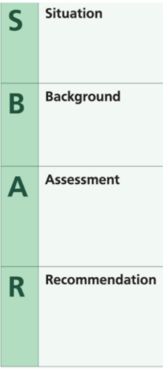
  - Out of Time Incidents
    - Any incident which has breached its standard response time is considered ‘Out of Time’.
    - Any incidents which are out of time must still be reviewed as normal, however, the following additional actions must also be taken:
- Discuss with appropriate clinical support the use of alternate resources (e.g. UTV, admin OTL, RCM etc.)
- Confirm that resources from neighbouring dispatch desks are not running on newer Category 2 incidents. For lower acuity incidents discuss concerns with Clinical Inline Support/EOCM to determine if LCDM override is appropriate
  - Double Breached Incidents
    - Any incident which has breached its standard response time twice over is considered a ‘double breach incident’.
- C3 target 2 hours (120 mins) = breach
- C3 time elapsed 4 hours (240 mins) = double breach
    - Any incidents which have double breached should still be reviewed as normal, however require further escalation to the DTL for discussion with appropriate clinical support via inline clinical support line to consider operating outside of LCDM and ARP guidelines to minimise the risk of patient harm. This should be done utilising the Intelligent Dispatch Model.

Incidents to Escalate

  - To ensure the DTL, EOCM, duty OTL and Tactical Commander on duty are fully informed of any significant incident, the following list is a guide to incident types that the DTL, EOCM, duty OTL and Tactical Commander should be informed of:
- Incidents involving a response of two or more resources outside of the C1 list that requires more than one resource. CAD should generate an automated message for incidents that have 3 or more resources assigned, however best practice is to verbally ensure that this has been seen by relevant parties
- Protracted serious traumatic incidents where the patient’s condition is life threatening
- Incidents that are deemed to warrant escalation to the Tactical and/or Strategic Commander
- Fire persons reported
- Large Fires involving building evacuation. E.g., Hospitals, blocks of flats, public buildings such as shopping centres
- Confirmed HART/HEMS cases where once on scene they have confirmed that their presence is required. To be fed to appropriate desks
- Suspect packages/devices
- Police/ Security Services/ Anti-terrorist Operations within our area
- Incidents that may significantly affect Service Delivery, such as public disorder, major road closures e.g., Operation BROCK, Police red routes
- Any incident where escalation to the press is necessary because of immediate media interest
- Any incident where a Trust vehicle has been involved in an RTC
- Any incident where a member of staff has been assaulted
- Paediatric Arrests or death of under 18
- Full emergency at Airports
- Significant incidents at a port. e.g., Dover
- MTA/CBRN incidents
- Protracted on scene delays
- Bariatric incidents requiring specialist vehicles
- High profile incidents including Royalty, Celebrities etc.

  - This list is not exhaustive so if there is any incident where you feel the DTL/EOCM should be aware this also needs to be actioned. For an extensive EOCM alerting criteria, please see Appendix 8.
  - Any Hospital Handover Delays over 30 minutes should be escalated to the Duty OTL.

On Scene Reports (STEPS)

  - Operational resources at scene should provide a timely update which contains a situation report and what their plans are for the management of the patient. This should be completed routinely no later than 30 minutes after arrival.
    - The update provided should follow the following STEPS acronym:
- S – Staff welfare at scene, including if any additional support is required
- T – Transporting to a further care facility - Yes/No
- E – Expected time on scene including if awaiting a GP Call Back etc.
- P – Patients current condition
- S – Support needed for shared decision making regarding appropriate ongoing patient care
    - RDs should contact operational resources on scene, no later than 45 minutes from initial attendance, request a “situation report” and a proposed plan for the patient, if this has not been provided by the crew previously. This update should be taken utilising the STEPS acronym.
    - RDs are responsible for ensuring updates are received no later than 45-minutes after a crew have arrived at scene. DTLs are accountable for monitoring compliance, escalating to the duty OTL where appropriate.
    - At 75-Minutes from initial attendance time, the duty OTL is responsible for contacting the crew should they remain at scene. If the duty OTL is committed to another tasking, the DTL should contact the duty OTL if appropriate in order to escalate the delay. If there is no response or they are unavailable, then this should be escalated to the Tactical Commander.
    - The following slash codes should be utilised on the CAD to support Dispatch and Operational Teams with reporting of Scene Updates:
- /STEPS 30 min update from Crew
- /STEPS 45 min EOC follow up as no STEPS report received
- /STEPS 75 min DOTL to contact crew for update and support
  - Process for Requesting Support at Scene
    - Should a crew wish to receive a clinical call back for a discussion on their patient, non-conveyance or shared decision making, this should be done via an Emergency Call Advice Line (ECAL) request from the crew directly either as part of a STEPS update or as soon as possible after a care decision has been made at scene.
    - The crew are to provide a call back number at scene which should be accurately recorded and logged by the RD.
    - If a crew are referring via an Out of Hours General Practitioner (OOH GP) and there is any concern regarding length of time for contact, then the below process should be utilised.
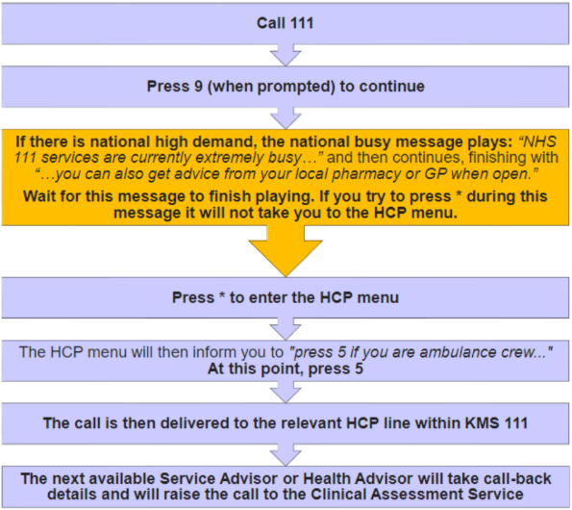

Duplicate Incidents

  - High numbers of 999 calls to EOC are duplicate calls, to either report worsening symptoms, cancel the ambulance or ask for an estimated time of arrival (ETA). Locations such as nursing homes and care homes may call for more than one patient at a time, and there is the potential for assumptions that subsequent calls from the same address may all be for a single patient.
  - As a Trust there is a requirement to reduce the risk to patient harm and as such the current process has been reviewed nationally with other Ambulance Trusts and updated to minimise error.
  - Process for Resource Dispatchers
    - Identify potential duplicate calls including ETA, worsening and multiple calls for the same patient.
    - It is the dispatcher’s responsibility to ensure that they are running on the primary call or a subsequent call with a higher disposition. Any concerns such as, a higher priority call from a remote observer verses a first party triage, raise to Dispatch Inline Support.
    - Confirm the patient’s demographics are the same on both incidents. The full name – first name and surname must match (do not presume a first name match is the same patient), Date of Birth (DOB)/Age must match on both incidents, The Address location must also match. (Please consider patients movements e.g in a public place) Check history tab on CAD and confirm if a reattendance is required.
    - If all the above criteria match on both incidents, then the Resource Dispatcher can cancel the incident as “Duplicate”.
    - RDs must escalate to a DTL/EOCM for all potential duplicate calls that do not meet the criteria and information is not clear or missing in terms of matching the full name, DOB/age and address, for a further review and clearly document in the call notes the name of the person you have escalated to and their role.
    - RDs must have passed their probation period (or 6-month period as an RD) prior to being permitted to close duplicate calls.
    - Rendezvous point for a backup resource to meet at a different location to the scene, e.g. CCP to meet crew en route to hospital or crew broken down with patient on board. An information only call to be created for new location and back up resource to be assigned. On arrival, back up resource should be reassigned to the original incident with the on-scene time removed from the info call and then closed as “Information Only”.
    - On arrival at scene, if a crew are presented with more than one patient with similar or linked conditions, these should be dealt with via separate ePCRs linked to one incident number.
    - More than one patient at a location without a linked cause will continue to be managed under the pre-existing call management process.
  - Process for Dispatch Team Leaders
    - All potential duplicate incidents that do not match the minimum criteria for both incidents will be escalated by the RD for a more in-depth review by a DTL/EOCM to reduce the risk of incidents being cancelled in error.
    - Cancellation of duplicate calls is a two-step process and RDs can safely cancel duplicate incidents that match.
    - Potential incidents that cannot be confirmed as a duplicate, due to not matching address/name and DOB must also be reviewed by a DTL/EOCM. Further investigation is necessary, and a resource deployed to the incident where possible, until confirmed otherwise.
    - DTLs must oversee/delegate or complete the following actions, they may not all need to be completed as ringing back etc. may provide the assurances required:
- Ringing back the original number
- Listening back to the call
- Review history of previous potential incidents, consider telephone number, name of patient and DOB
- Contact other agencies (e.g. Police, Fire, BT, Careline)
  - Accuracy of At Scene Times
    - Should a crew show as at scene but be stood down prior to making contact, the “At Scene” time must be removed.
    - If a crew inadvertently book at scene prematurely, the “At Scene” time must be removed however if the crew are now in the presence of the patient, the correct time should be inputted by the dispatcher.
    - RDs are responsible and DTLs are accountable to ensure that the EOC At Scene Time Checks is completed for the duration of their shift. This report should be frequently reviewed throughout the shift.

No Trace Incidents

  - Where a crew arrive at a given location and no patient can be found, the first action should be to contact the EOC. Patient Demographic Search (PDS) details should be checked to confirm the address is correct. The RD will escalate the issue to the DTL as such issues may be time consuming to resolve.
  - If the location of incident is correct, the DTL will call back the patient/caller to see if verbal contact can be made and verify location. This will then be passed to the attending resource by the RD/DTL.
  - In the event the call is answered the DTL must ensure the patient/caller is aware of an ambulance dispatch and be able to verify the location of the patient. The DTL must give due consideration to the patient/caller’s cognitive awareness to identify this successfully.
  - In the event a call back is not answered, the DTL will then listen back to the call to ensure the address/location has been entered into the CAD correctly. If the call originated from a third-party agency, liaise with the agency, and request the call recording is listened to confirming the correct location details have been passed.
  - DTL will check the location history for incidents that have a physical address and search the origin phone number on the CAD to verify any previous access details have previously been passed, such as key safe details or next of kin. Previous calls may have been received from a careline who may have additional information.
  - When calling any third party, make sure you provide a full explanation, as they may be caught unawares and allow time for the person to process and respond fully.
  - DTL to contact the nearest hospital to confirm if the patient has self-presented.
  - Consider contacting the Police to see if they have any information relating to the patient.
  - Once all checks have been completed and EOCM has verified this, the decision to gain entry into a private property lies with the crew on scene. See Forcing Entry Procedure for further information.
  - If the decision has been made to force entry and the crew are unable to gain access the DTL will contact Fire and Rescue Service to assist with gaining access. Staff should consider forcing entry themselves where safe and appropriate to do so.
  - In the event the incident is in a public place, action 25.1, 2, 3, 4, 5, 6, 7, 8 & 9 need to be undertaken.
  - Where the location is a public place and the location is confirmed as correct, the crew must complete an area search to satisfy themselves a patient is no longer in the vicinity. Where no patient is found the crew will advise EOC and clear from scene.
  - Crews should be supported to complete a DCIQ in a timely manner.

Staff Safety and Welfare

  - DTLs and RDs have an indirect responsibility for crew safety and welfare. This includes:
- Ensuring meal breaks are provided in accordance with the meal break policy
- Ensuring at risk marking information is provided to crews
- Ensuring scene safety information is provided to crews
- Ensuring health & wellbeing checks are carried out
  - Crews will use all the information available to them to make a dynamic risk assessment (Appendix 3) and take steps to ensure their own safety. Risk assessments are a continuous and ever-changing process. It must be noted that this risk assessment must seek to balance the risk to the crew against the risk to the patient.
  - Where a crew are required to move a significant distance from their vehicle, or to enter a dwelling that was not the address given in the original emergency call, they should update the EOC accordingly with their location details to ensure assistance can be provided should the need arise.
  - RDs supported by DTLs will continually review incidents for apparent scene safety issues and at-risk markers on the CAD. Where there is concern for a resource’s safety, a welfare check must be undertaken at the earliest opportunity and no later than 15-minutes of attendance of the incident. The conversation will be recorded in the incident notes and any welfare concerns should be escalated as appropriate to the duty OTL, EOCM and Duty Tactical.
  - Resources will routinely receive a welfare check when they have attended an incident which is deemed particularly distressing. Please note OTLs and RCMs who attend distressing incidents will also need a welfare check and this should be escalated to the on duty tactical for actioning. RDs must use /WC (welfare check) in the call notes of the incident once all welfare checks have been completed.
  - For operational staff that need additional welfare support, it is the DTLs responsibility to inform the duty OTL or the person’s line manager if more appropriate. Please also consider other resources that are available, for example the Chaplain team.
  - Where a crew choose to stand off from scene, they must inform the EOC via the most appropriate communication means with the rationale they are relying upon in determining that there is too great a risk to continue. This will form part of the CAD notes and may be used to justify the decision.
  - Some incidents present a very clear risk to crews. In these cases, the RD will notify the DTL to agree with the crew a Rendezvous Point (RVP) at a given location so they may wait for another agency’s attendance. For reporting purposes, arriving at a dedicated RVP counts as an ‘at scene’ status and RDs should manually update the CAD to reflect this.
  - Where a RD/DTL fails to provide information which is present in the call log to aid the crew in their dynamic risk assessment, such as at-risk marker or notes entered by the EMA, this must be reported via a DCIQ by the person who identifies this for further investigation.

Trauma Risk Management (TRiM)

  - The TRiM welfare process is in place for staff where there are specific incidents that may require staff members to receive welfare calls which are found in the below table. The below list is not exhaustive and any incidents that a Dispatcher feels may have been traumatic then escalate appropriately to the DTL and Duty OTL.
  - Any incidents that require welfare should be notified to the OTL & DTL and noted on the CAD. Further guidance on (TRiM) can be accessed via Trauma Risk Management (TRiM) Policy.
Serious Events | Notable Events
Paediatric arrest | All workable cardiac arrest
Traumatic cardiac arrest | RTC patients trapped
Building collapse | Suicide or attempted suicide
RTC – multiple vehicles and patients | Fire – No persons reports
Aircraft emergency landing | Bariatric patients
Incident or injury to an on-duty staff member | Incident or injury that involves an off-duty staff member
Firearms incident | RTC involving SECAmb vehicle
Potential CBRN incident | Out of protocol/deployment area
Fire – Persons reports | Protracted on scene times
Serious allegation against member of staff | Potential contractible diseases e.g. meningitis, TB, SARS, MERS
Any incident where weapons are mentioned/involved | Concern raised my member of public
Unexpected patient in cardiac arrest whilst being assessed on the phone or at scene
Incidents of crews responding to family, friends or colleagues

Requests for Police

  - Crews will often ask RDs for police attendance, either verbally or by way of a crew down status. Such requests will be considered as Routine or Urgent.
  - All urgent requests for police can be dealt with by the RD or DTL responsible for the dispatch desk area concerned.
  - Where the resource is obviously still at scene, police will be deployed to the scene or the last known location of the crew if an update has been received. Where the vehicle has moved from the scene, police will be sent to the location of the resource unless information exists to suggest the crew are elsewhere.
  - Where a routine request for the police is made, requests may be delegated to another team member, but the RD must note in the CAD who they have passed the request to, and all information associated with the nature of this request.
  - Where Police have been requested and declined to attend, the operational resource should contact the duty OTL for additional support and guidance. Consideration should be given to deploying an OTL to scene at the earliest opportunity in order to support the crew.

Requests for Back-Up

  - Where an SRV or a DCA are on scene and identify the need for a conveying resource or an additional ambulance, following the grading system as per Appendix 2.
  - The crew must advise the reason for back-up and what type of resource is required alongside skillset so this can be entered into the notes by the Dispatcher.
  - The DTL must be informed of all Grade 1 requests at the time of the request and is expected to assist the Dispatcher with resourcing if required. CCD should also be informed.
  - Resources may request a Grade 1 back-up when en route to hospital and the following process must be adhered to:
- Create Info call to location of crew requesting Grade 1
- Assign resource to incident, advising this is for a Grade 1 crew en route to hospital and the info call is the RVP
- Once crew have arrived on scene, stand down from info call, assign to original call and add times
  - Clinicians on scene are no longer able to request Grade 3 back-up to ensure a conveying resource arrives on scene as quickly as possible as required by ARP and Ambulance Quality Indicators (AQI) standards on C2 calls unless a resource can arrive with them within 1 hour of their request.
  - On C3 incidents Grade 3 back-up can only be accepted in CSP level 1 or if the back-up resource can get to scene within 1 hour of the request.
  - When requesting a Grade 4 back-up the clinician must provide a full clinical update to the RD at the time of the request. Grade 4 back-up (or Delayed Conveyance) can only be accepted in CSP level 1 or if the back-up resource can get to scene within 2 hours of the request.

Re-Tasking Resources

  - It may be necessary to stand down or divert a resource before it reaches scene. This will be routinely completed via MDT/MDVS message which should be automatically generated following the action being completed on the CAD.
  - For resources without an MDT/MDVS, radio or phone contact must be established to confirm receipt of the stand down or diversion.

Manual MDT/MDVS/Incident Changes

  - RDs will on occasion have to manually update the MDT/MDVS to perform status changes for crews.
  - In addition, where a crew must divert to a different hospital, specific actions are required as listed below:
- Upon leaving the scene of an incident, crews update their MDT/MDVS or advise EOC of the hospital they are headed to. The CAD records the hospital and the at hospital time. If the crew need to divert to another hospital whilst en-route or divert shortly after arrival due to being refused at the hospital, the crew must update the EOC manually via radio
- The RD responsible for the crew must manually remove the at hospital time from the incident and update the resource to show as leaving scene to the correct destination. This will ensure reporting is accurate for hospital delays and will remove any delays associated with the original destination
- To do this, the RD should open the incident affected, go to the resources tab and double click the allocated resource. This will open the allocation screen, where the Hosp time should be removed
- Following this, the status of the affected resource must be manually updated to Leaving Scene (even if this is already set) with the correct destination inputted. Note that crews changing the destination hospital on their MDT/MDVS will not correct the reporting issue

Clearing At Scene

  - Crews are requested not to book clear when on scene at an incident in the following circumstances:
- No contact has been made with the patient and crew has geofenced on scene and crew subsequently diverted to another incident.
    - Crews must contact EOC for them to remove the crew from the incident, which will ensure the incident goes back into the waiting dispatch list and not cancelled and cleared from CAD. Dispatchers must remove the “at scene” time from the diverted incident to ensure accurate time recording.
  - When a unit becomes clear at scene following completion of the patient care record, the crew will press the “No Transfer” button on the MDT/MDVS which will give a list of reasons. The crew will select the most appropriate reason which will book the unit clear. It is not necessary for the crew to place a request to speak on the radio system. It is not a requirement for the crew to update the EOC beyond the use of the pick list on the MDT/MDVS. Where appropriate crews can place additional notes into the CAD incident notes via the MDT/MDVS.
  - Dispatchers are to use “EOC At Scene times check” report on Power BI to ensure that incident times are correct.
  - Clinical staff are reminded of their professional duty to complete all aspects of the patient care record related to a patient care episode (ePCR, safeguarding, history marker, etc) when discharging or referring a patient. This patient care record forms part of the care episode and should be undertaken at the incident address and wherever possible at the patient’s side.
  - All records should be completed at the scene to allow any discharge paperwork to be left with the patient at that time. In certain cases, an EPCR and associated referrals may be completed in the vehicle, but crews should remain at the incident location, the patient and/or carers should be aware of the crew’s whereabouts and how to seek help should the patient’s condition change.
  - Following five minutes of being clear, if the crew have not received further instructions, they should place a request to speak via the radio system.

Crews Clearing at Hospital/Clearing at Hospital

  - Once at hospital, crews are allocated up to 30 minutes broken down into two halves.
  - Within the first 15 minutes, the hospital should accept the patient and have the patient transferred onto a hospital bed/chair or placed in the waiting area.
  - Where a resource has arrived at hospital and are unable to immediately unload their patient, they must contact their RD. Where a patient is being held on a vehicle, the RD will update the CAD incident by enter the keyword “Held On Amb At Hosp”.
  - The DTL must immediately escalate each occurrence to the Tactical Commander and the duty OTL must contact the hospital. Deployment to the hospital can be made in conjunction with the Tactical Commander.
  - A DCIQ must be completed by the crew when there is evidence of harm or there is potential for harm to have occurred, as a result of a patient being held in an ambulance and prevented from entering a hospital.
  - Up to an additional 15 minutes are reserved for crews completing paperwork and re-commissioning their vehicle. This time commences from the moment the hospital handover screen has been completed. To clarify, not all incidents require a further 15 minutes and as such crews should clear from hospital as quickly as possible.
  - If more than 15 minutes is needed due to exceptional circumstances, crews need to inform their OTL to provide an explanation for delay before the 15 minutes window has passed. The OTL will notify the DTL and update local records. If the OTL is unavailable, contact should be made through the dispatcher for a call back from the EOCM who can also authorise Out of Service.
  - Crews will be automatically cleared from their assigned incident 15 minutes post-handover at hospital or if they move away from hospital.
  - If dispatchers have been notified of a delay post-handover, they must book the crews Out of Service (Not Available) with the appropriate reason selected. The crew must then inform the dispatcher when they are ready to be booked into service.
  - If no delays post-handover has been communicated, crews will automatically be cleared from hospital and allocated a new tasking.
  - Once ready to clear, should the crew require any additional notes to be added to the CAD Log, they should send these via the MDT/MDVS “Message” button prior to clearing, which automatically stamps the notes into the CAD prior to sending a clear status through.
  - Vehicles should not move from the hospital until a further instruction from EOC has been received. If a crew is within the last 30 minutes or have completed their shift they should start to return to base.
  - Following five minutes of being clear, if the crew have not received further instructions, they should place a request to speak via the radio system.

Returning Medical Escorts

  - The practice of returning medical escorts back to their respective Acute Trust as a result of Hospital transfers is no longer permitted.
  - This will enable the Trust to maximise the availability of operational resource for patients and ensures that the medical escorts return directly to their respective hospital, rather than being diverted due to crews having to respond to other emergency calls. It is now the hospital’s responsibility to arrange return transportation for their staff, along with any small items of equipment.
  - The exception to this rule is where any equipment is too large to be transported by another method e.g, ITU Trolleys, Intra Balloon Pumps. In these circumstances the crew will return the medical escorts to the Acute Trust but must remain C1 available during this period, available to make a 1st response and must be backed up immediately. The crew must make the medical escorts aware they are highly likely to be diverted.

Information Broadcasts

  - It will be necessary during a shift to share information with the crews in the field. There are two methods of achieving this:
- Transmitting a message via MDT/MDVS
- Airwave Radio General Broadcast
  - Information will always be sent via CAD in the first instance to ensure a documented record of the message is maintained. All units will receive the message via MDT/MDVS, as they must acknowledge it to continue to use the system.
  - General Broadcasts via the Radio system may be used to reiterate the CAD message but are not a substitute for the message unless CAD/MDT/MDVS are down.

Out of Service (OOS)

  - All resources should remain in service and be available for category 1 and category 2 incidents where possible. Out of service times must be reviewed regularly and kept to a minimum to reduce down time and maximise resource availability.
  - All out of service requests must be authorised and recorded by the OTL. There may be alternatives to out of service depending on the reason for the out of service.
  - Out of service for pre-planned meetings or events should be scheduled for the start or end of a shift where possible to minimise operational impact.
The OTL will contact the Dispatch Team Leader and update local records.
  - If the OTL is unavailable, contact should be made through the Resource Dispatcher for a call back from the EOC Manager who can also authorise out of service. There may be multiple reasons as to why a crew needs to be Out of Service such as Drugs Restocking, Equipment Restocking (Including PPE), broken headlight etc, with the reason noted in the comment as mentioned above. The crew should complete their tasking at the closest available suitable facility.
  - All resources should remain available to attend patients who are in Cardiac Arrest therefore should only be booked “Unavailable” due to vehicle breakdowns or staff welfare concerns.
  - Consideration should be given to deploying an OTL or RCM to the resources location in order to resolve an Out of Service reason such as “restocking”.
  - If completion of a DCIQ/Safeguarding Referral/referral form will exceed a further 15 minutes (at hospital or on scene), the staff member completing it should contact the duty OTL for the area they are working in to discuss.
  - The duty OTL is responsible for monitoring all Out of Service status resources regularly, ensuring they are returned to service as soon as practicable.
  - The DTL is responsible for ensuring that all OOS statuses are escalated to the duty OTL in a timely manner, this can be via Teams chat, however, if there is no response on the team chat, the DTL should make contact via phone or Airwave. Alternatively, the DTL should consider escalation to the Tactical Commander or EOCM should the OTL be committed on an incident.
  - The duty EOCM has overall primacy for overriding any out of service decisions they feel is unwarranted and could be detrimental to patient care and alternative solutions should be sort to resolve the issue without excessive downtime.

Meal Breaks, Refreshment Breaks and Facility Usage

  - All crew meal breaks will be managed as per the Meal Break Policy and the documentation that supersedes the Policy in regards to length of window.
  - Facility Usage Arrangements
    - Crews requesting to use facilities must be sent to the nearest SECAmb Site or Hospital with adequate facilities. If agreed with EOC and the crew, other facilities can be used at alternative locations i.e., petrol station, supermarkets etc.
    - The crew should be shown as OOS available Facilities.

Crew End of Shift Arrangements

  - During the last two hours of a shift, a range of protective measures are gradually applied to operational resources to increase the likelihood of ending a shift on time. These are contained in the table below:

Timeframe | Action | Can be used for:
Last 2 hours | Dispatcher to aim for resource to be within own dispatch desk area | - C1, C2, Grade 1 or Grade 2 back-up  - C3, C4, Grade 3 or Grade 4 back-up in own dispatch desk  - 1-4 hour HCP calls if likely to complete before shift end  - Standy in own dispatch desk area
Last hour | Dispatcher to return resource to home station if not allocated to an incident | - C1 and Grade 1 back-up if nearest resource and should be backed up where possible  - C2 and Grade 2 back-up in own dispatch desk
Last 30 minutes | Crew time for admin tasks, OTL engagement and readying vehicle | - C1 and Grade 1 back-up if nearest resource and should be backed up where possible
Last 5 minutes | Crew sign off MDT/MDVS and return equipment and vehicle | - No calls
End of shift | Crew finish | - No calls

  - Dispatch teams will be proactive in continuously reviewing incidents and available resourcing to ensure that crews finish on time, subject to emergency 999 calls in conjunction with End of Shift arrangements.
  - ‘Home station’ refers to the SECAmb base that crew are designated to be working from. For voluntary crews, this may be a Trust site rather than that of their company.
  - In cases where crews are nearing their EOS times, should a crew be delayed handing over at hospital, they must communicate with the OTL to discuss the potential implementation of the End of Shift – Transfer of Care Procedure.
    - Please see the "Transfer of Care flow chart" below:
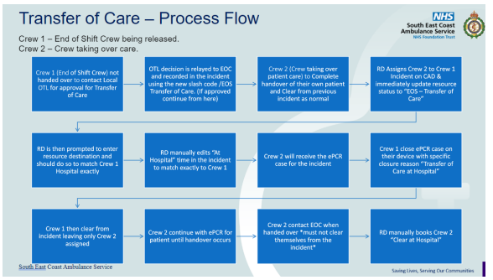

Dispatcher End of Shift Arrangements

  - A comprehensive verbal handover should be completed by each Dispatcher and DTL for the oncoming team.
  - A handover checklist (Appendix 4) has been compiled as a tool to support this process if Dispatchers wish to use it.
  - This process is to be repeated any time the dispatcher or DTL leaves their desk. This to ensure oversight of incidents, patient and crew safety.

Responsibilities

  - The Chief Executive Officer is the overarching Executive Lead for the Trust.
  - The Executive Director of Operations is responsible for implementation of the procedure.
  - The Associate Director for Integrated Care (999 & 111) and Operating Unit Managers for the EOC & Field Ops are responsible for the day-to-day implementation of the procedure.
  - The Executive Director of Nursing and Quality and Medical Director are responsible for Clinical Governance within the Trust.
  - All EOC staff are responsible for compliance with the procedure with daily monitoring provided by the Emergency Operations Centre Manager (EOCM).
  - The Clinical Safety Navigators are responsible for ensuring implementation and adherence to relevant standards and overseeing clinical safety, through devolved responsibilities to the Clinical Supervisors, across the Trust.
  - The Head of EOC Development is responsible for auditing and quality assurance, as well as provision of training systems to support the safe use of all mission critical systems used by the EOC. This includes any training required following new version release of NHSP, and documentation of training delivered to all staff.

Glossary
- A&E – Accident and Emergency
- AAP – Associate Ambulance Practitioner
- ACCT – Adult Critical Care Transfer
- APP – Advanced Paramedic Practitioner
- ABD - Acute Behavioural Disturbance/Disorder
- ACRP – Ambulance Community Response Post
- AQI – Ambulance Quality Indicators
- ARP – Ambulance Response Programme
- BBA – Born Before Arrival
- BLS – Basic Life Support
- CAD – Computer Aided Dispatch System operated by the Trust
- CBRN- Chemical, Biological, Radiation or Nuclear
- CCD – Critical Care Desk
- CCP – Critical Care Paramedic
- CFR – Community First Responder
- CS – Clinical Supervisor (Paramedic/Nurse or Greater)
- CSN – Clinical Safety Navigator
- CSP – Clinical Safety Plan
- DCA – Double Crewed Ambulance
- DD – Dispatch Desk
- DOB – Date of Birth
- DTL – Dispatch Team Leader
- ECAL – Emergency Call Advice Line
- ECSW – Emergency Care Support Worker
- ED – Excited Delirium
- EEAS – East of England Ambulance Service
- EOC – Emergency Operations Centre
- EOCM – Emergency Operations Centre Manager
- EPCR - Electronic Patient Clinical Record
- GATSO – Gatwick Airport Solo Response
- GCC – Gatwick Control Centre
- GDPR - General Data Protection Regulations
- GRS- Global Rostering System
- HART – Hazardous Area Response Team
- HCP – Health Care Professional
- HEMS – Helicopter Emergency Medical Services
- IFT – Interfacility Transfer
- ITK – Inter-operability Toolkit
- ITU – Intensive Care Unit
- JPF – Joint Partnership Forum
- KPI – Key Performance Indicator
- LAS – London Ambulance Service
- LSO – Late Sign Off
- MDT – Mobile Data Terminal
- MDVS – Mobile Data Vehicle Solution
- MH – Mental Health
- MTA- Marauding Terrorist Attacks
- NEWS2 – National Earlier Warning Score
- OOP PP – Out of Plan PP
- OOS – Out of Service
- OTL – Operational Team Leader
- OU – Operating Unit
- OUM – Operating Unit Manager
- PACCS – Pathways Clinical Consultation Support
- PDS – Patient Demographic Search
- PPCI - Primary Percutaneous Coronary Intervention
- PPE- Personal Protective Equipment
- PRV - Primary Response Vehicle
- PSI – Patient Safety Incident
- PSIR – Patient Safety Incident Review
- RCM – Response Capable Manager
- RD – Resource Dispatcher
- RDC – Response Desk Co-ordinator
- ROLE – Recognition of life extinct
- ROSC – Return of Spontaneous Circulation
- ROSR – Return of Spontaneous Respiration
- RPI – Response Per incident
- RSP – Road-Side Standby Post
- SCAS – South Central Ambulance Service
- SCG - Specialist Commissioning Group
- SECAmb – South East Coast Ambulance Service
- SLT – Senior Leadership Team
- SORT - Specialist Operational Response Team
- SPP - Student Paramedic Practitioner
- SRV – Single Response Vehicle
- SSP – System Status Plan
- TRIM – Traumatic Incident Response Management
- UCNH - Unscheduled Care Navigation Hub
- UTV – Urgent Transport Vehicle
- VDI – Vehicle Daily inspection
- ZR – Zoned Resource

Audit and Review

  - All procedures have their effectiveness audited by the responsible Management Group at regular intervals, and initially six months after a new policy is approved and disseminated.
  - Effectiveness will be reviewed using the tools set out in the Trust’s Policy and Procedure for the Development and Management of Trust Policies and Procedures (also known as the Policy on Policies).
  - This document will be reviewed in its entirety every three years or sooner if new legislation, codes of practice or national standards are introduced, or if feedback from employees indicates that the policy is not working effectively.
  - All changes made to this procedure will go through the governance route for development and approval as set out in the Policy on Policies.

Associated Trust Documents
- Adult Critical Care Transfer 2024 Process v9
- Automatic Clear at Hospital/Scene Geofencing Operational Bulletin 580 v1
- Bariatric Patient Treatment Procedure
- Capability Policy & Procedure
- CFR Deployment Procedure
- Conveyance, Handover & Transfer of Care Procedure
- Critical Care Desk Policy and Procedure
- Cross Trust Border Memorandum of Understanding
- Discharge Procedure
- Disciplinary Policy & Procedure
- Emergency Breakaway Procedure
- End of Shift – Transfer of Care Procedure
- EOC Call Handling Procedure
- History Marking Policy
- History Marking Procedure
- Improving Resource Availability Ops 582 v1
- Incident Reporting Policy (DCIQ) & Procedure
- Interrupted Care/Delayed Conveyance Procedure
- Local Community Dispatch Model v1.2
- Meal Break Policy
- Patient Clinical Records & Leaving Scene or Hospital - Op561 V1
- Radio Communication Procedure
- Referral, Discharge & Conveyance Policy
- Single Responder Policy
- Specialist & Advanced Paramedic Practitioner Deployment Procedure

Financial Checkpoint

  - This document has been confirmed by Finance to have no unbudgeted financial implications.

Equality Analysis

  - The Trust believes in fairness and equality, and values diversity in its role as both a provider of services and as an employer. The Trust aims to provide accessible services that respect the needs of each individual and exclude no-one. It is committed to comply with the Human Rights Act and to meeting the Equality Act 2010, which identifies the following nine protected characteristics: Age, Disability, Race, Religion and Belief, Gender Reassignment, Sexual Orientation, Sex, Marriage and Civil Partnership and Pregnancy and Maternity.
  - Compliance with the Public Sector Equality Duty: If a contractor carries out functions of a public nature then for the duration of the contract, the contractor or supplier would itself be considered a public authority and have the duty to comply with the equalities duties when carrying out those functions.

Appendix 1 – SECAmb Dispatch Model
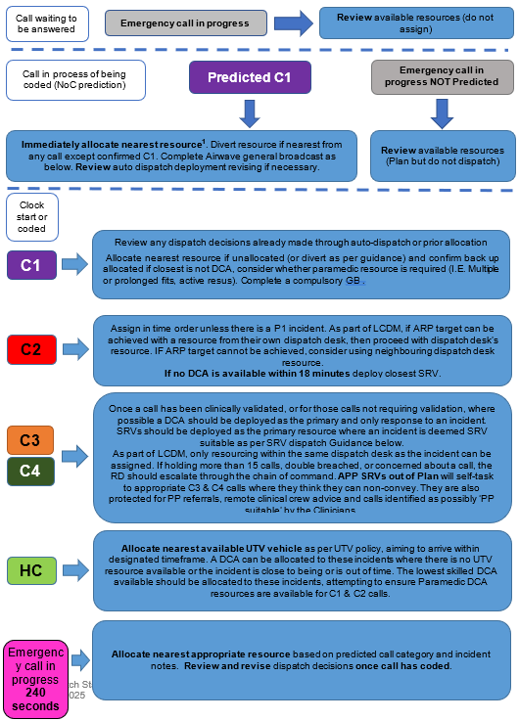
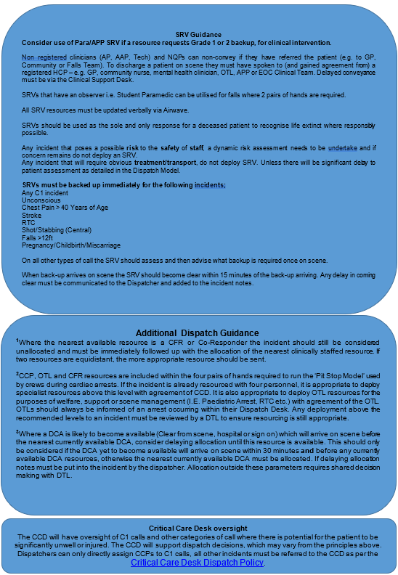

Appendix 2 – Back-Up Request Model
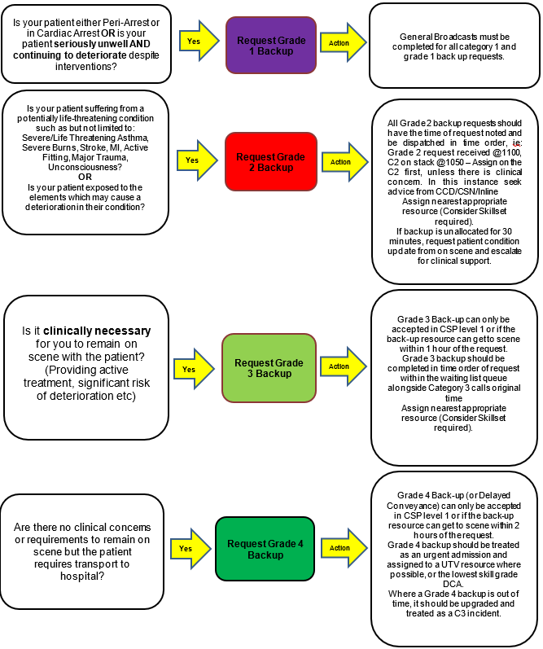

Appendix 3 – Dynamic Risk Assessment
We are obliged to attend all calls for clinical assistance and if we do not, both the individual and the organisation could be liable for negligence if the patient’s health is adversely affected, by non or delayed attendance, where an assessment of the risks has not been carried out. However, it is important that all staff are mindful of their own safety and should not expose themselves to circumstances where they have realistically assessed they are in danger.
We complete dynamic risk assessments throughout our everyday lives. e.g. on a simple basis – crossing the road; a risk assessment is not written down for this, however we assess the risks and cross when it is safe to do so. In the environment of ambulance work we carry out such assessments when attending RTCs: no one puts themselves in unnecessary danger and protects the scene by using the vehicle, blue lights, wearing high visibility clothing and working safely.
A dynamic risk assessment process helps an individual to effectively assess a situation from a personal safety perspective, as it is unfolding. The person can continuously assess the circumstances and adjust his or her response to meet the risk presented moment by moment. The difference between this and a formal risk assessment is that it is unpredictable and is changing according to the circumstances and the environment.
One of the greatest threats to an individual is complacency. This is something that anyone can fall prey to and often happens because the individual concerned has performed a task hundreds of times before. Being approached by a member of the public, finding someone asleep in as waiting area or visiting premises – all are part of the routine of a job, and it is easy to miss if there are signs of danger.
Work-related violence can be difficult to predict and control because it is hard to anticipate the range of responses that someone might use in the situation involving conflict.
In this respect, when attending any incident clinicians must complete a dynamic risk assessment of the hazards which they face. This should start with the information which they receive relating to the call. As they approach, if possible, they should be gathering more information and when approaching the scene should be assessing the threats toward their safety. It is realistic to expect staff to listen and watch for any dangers, e.g., shouting, aggressive or threatening behaviour. It is correct to raise awareness when in certain areas however, previous calls cannot dictate non-attendance to an address or area unless they are history marked as red, meaning police attendance is necessary. The vehicle is a safe haven and when approaching a patient incident, the employee should be listening and watching for any behaviour which raises their alertness and should withdraw to the safety of the vehicle if they are under threat. If they have made an assessment that there is a real and current threat to their safety then they should call for further assistance, either additional ambulance support or, if appropriate, the police.

Appendix 4 – Dispatch Handover Checklist
Item | X | Requirement/Rationale
Outstanding Emergency Calls and plans for resourcing |  | To ensure that awareness is maintained and efforts to resource are fully maintained.
SRVs Requiring Back-Up & Grade |  | To ensure the awareness is maintained and constant efforts are made to provide back-up.
Units Running a Distance to an Emergency Call |  | Aids the receiving dispatcher with awareness and the need to constantly consider closer crews who may come clear.
Units En route to Stand-By |  | Overview of all units transiting the area, assists receiving dispatcher where calls come in that the transiting resource may be passing.
REAP / CSP Level |  | Advise What CSP Level the EOC / Trust is working to.
Significant Incidents |  | Aids the receiving dispatcher in assuring adequate resourcing and crew welfare.
Hospital Issues |  | Aids the receiving dispatcher in managing the situation,
Crews Out of Break Window |  | Ensures the meal-break remains top priority.
Incident times |  | Ensures accurate reporting of calls during shift.
Staffing Issues in ODA |  | Ensures accurate reporting of the crew sheet and awareness of potential shortages/issues.

This check list is for shift handover where a dispatcher passes responsibility for their area to another party. Both the dispatcher handing over AND the dispatcher receiving are equally responsible for ensuring this checklist is carried out. “It’s as you see it” is not an acceptable handover and should be considered an outdated practice. From an Information Governance perspective, it is not acceptable to allow another user to use your login. Best practise is for another RD/DTL to take your channel, log out and the oncoming RD then logs in and take the channel over.

Appendix 5 – METHANE Template
Incident Initiation Form
Major Incident | Is this a Major Incident  Yes/No ?
Exact Location | Exact location / geographic area of incident
Type of Incident | Flooding / Fire / Utility Failure / HazMat/ Disease outbreak etc.
Hazards | Present or suspected
Access | Routes that are safe to use, any inaccessible routes and RVP’s
Number of casualties | Numbers, type and severity
Emergency Services | Present and those required

Appendix 6 – HART Deployment Parameters
HART Incidents (whilst not exhaustive this list indicates the type of incidents HART should be tasked to)
Incident Type | Description | Rationale
CARDIAC ARREST | Difficult or dangerous location | HART are a team and train as such when responding to cardiac arrests. Teams are staffed with paramedics at all times and can deliver required clinical interventions and can support core assets at any incident.
INCIDENTS INVOLVING WATER (inshore) | Inland water incidents – rivers, lakes, ponds, rising water, mud, ice. - Incidents involving Coastguard, RNLI or Fire TRU/USAR Teams on land at the coast or inland | HART can participate in the search phase of an operation. Whilst deployments are made on clinical need HART also provide a Search and Rescue capability and should be deployed to support multi agency operations.
INCIDENTS INVOLVING WATER (offshore) | Maritime incidents – Sea, Incidents involving Coastguard, RNLI or Fire TRU/USAR Teams | HART have undergone Ambulance Maritime Incident Response Team (AMIRT) training, whilst not offering a full at sea response HART will respond to alongside incidents. HART will be deployed as part of a multiagency response and this will be coordinated by the on duty Tac Ad / Tactical commander.
CBRN / HAZMAT INCIDENTS | Including Gas or Chemical leaks, white powder & chemical suicides or suspected CBRN involvement. | HART are able to work in contaminated environments. In addition, they can negate the need for or reduce the number of DCAs / SRVs at an incident. They are able to deliver patient care and if a DCA resource is required then HART can request one in line with the NEWS process.
FIRES & EXPLOSIONS | Persons Reported  Requests for Ambulance cover  Large protracted incidents with Fire-fighters in Breathing Apparatus | HART work in conjunction with FRS. HART can negate the need for or reduce the number of DCAs / SRVs at an incident. They are able to deliver patient care and if a resource is required then HART can request one in line with the NEWS process.
SUSPECT PACKAGES / EXPLOSIVE DEVICES | WWII UXB/grenades  Rrequests for Ambulance cover by EOD (bomb disposal) | HART staff train with EOD teams, can work in the hazardous areas around a device and can negate the need for or reduce the number of DCAs / SRVs at an incident. They are able to deliver patient care and if a resource is required then HART can request one in line with the NEWS process.
RTCs | Difficult access, HGVs, unusual entrapments, unstable vehicles/terrain | Should be tasked to RTCs etc. involving complex / time-consuming extrications particularly with low casualty numbers as this may negate the need for DCAs / SRVs to be sent to scene. At larger scale incidents they can further reduce the need for additional core assets but can also provide scene management and logistical / clinical support.
BUILDING COLLAPSE / DIFFICULT ACCESS.  CONFINED SPACES | Unsafe structures, scaffolding collapse, silos, demolition sites, entrapment under machinery, confined space incidents, mines. | HART are trained and practiced in working in these environments and HART Team Leaders are qualified Confined Space Supervisors. HART work in conjunction with FRS and can negate the need for or reduce the number of DCAs / SRVs at an incident. They are able to deliver patient care and if a resource is required then HART can request one in line with the NEWS process.
AIRCRAFT INCIDENTS | Aircraft Accident  Aircraft Accident Imminent Aircraft Ground Incident  Full Emergency  Fuel Farm Fire  Hi-jack / Unlawful Act  Bomb Warning  Act of Aggression | HART are familiar with smaller incidents involving private / light aircraft that are fitted with ballistic recovery systems. HART are trained and equipped to deal with complex, hazardous or mass casualties, which are likely to occur during an aircraft incident.
RAIL INCIDENTS | Includes incidents on the railway, including train derailment or for a patient struck by / trapped under a train. | Casualty packaging / extrication. Particularly if casualties are in remote (away from station) locations. Team Leaders have specific Rail Incident Management training. HART also have limited access to Res-q rails that facilitate transport over long distances.
CHANNEL TUNNEL INCIDENTS | Incidents in the Channel Tunnel, including broken down trains. | HART are on the Pre-determined attendance for Level 2 and 3 Channel Tunnel Incidents, and able to support protracted or complex incidents
INCIDENTS AT HEIGHT | Any incident involving height, such as scaffolding, cranes, tree tops. | HART are trained to work at height and are developing this capability to include rescue from height (line access) autonomously. They are able to deliver patient care and if a DCA or other resource is required then HART can request one in line with the NEWS process.
DIFFICULT LOCATIONS / ROUGH TERRAIN | POLARIS | Vehicle is available for use 24/7 and able to transport patients over distance and operate in areas inaccessible to aircraft / 4x4 vehicles.
CLIFF RESCUE INCIDENTS | Incidents that are on or under cliffs, foreshore, beach, rocks | HART are trained to work at, over or under cliffs as well as the foreshore and are developing this capability to include rescue from height (line access) autonomously. HART can negate the need for or reduce the number of DCAs / SRVs at an incident. They are able to deliver patient care and if a resource is required then HART can request one in line with the NEWS process.
MASS CASULTY INCIDENTS | HART specialises in mass casualty triage | At any large scale, multiple casualty incident HART can provide clinical care, logistical support and additional staff to assist in the management and treatment of casualties.
FIREARMS INCIDENTS | Marauding Terrorist Attack (MTA) | HART should be tasked to any spontaneous firearms incidents, such as active shooter / MTFA. Their attendance at hostage / siege incidents may also may negate the need for DCAs / SRVs to be sent to scene.
SUPPORT TO SPECIALIST OPERATIONS (SSO) | Pre-planned support to partner agencies for specific operations | HART will provide medical cover and support to partner agencies for pre-planned operations. Primarily managed by the TacAd/NILO and Tactical Commander.
INCIDENTS AT KEY SITES THROUGHOUT SECAMB | Channel Tunnel  Dover Docks  Airports  Bluewater  Ebbsfleet  Dungeness Power Station  Gatwick Airport  COMAH Sites  Ports / Harbours | HART train / exercise at these sites regularly. The attendance of HART can reduce the number of DCAs / SRVs required at these locations. There may be a need to provide support as per mass casualty incidents. They are also able to deliver patient care and if a resource is required then HART can request one in line with the NEWS process.
DIFFICULT ACCESS / EXTRICATION | Lofts, upper / lower levels of properties particularly if patients require immobilisation | As per confined space. They can also be tasked to provide crews ‘assistance with lifting’ patients in difficult or awkward locations. HART are not bariatric trained and do not have any bariatric specific equipment. The only capacity is a larger version of an extrication stretcher to facilitate movement in awkward or difficult locations.

Appendix 7 – Child Death Procedure
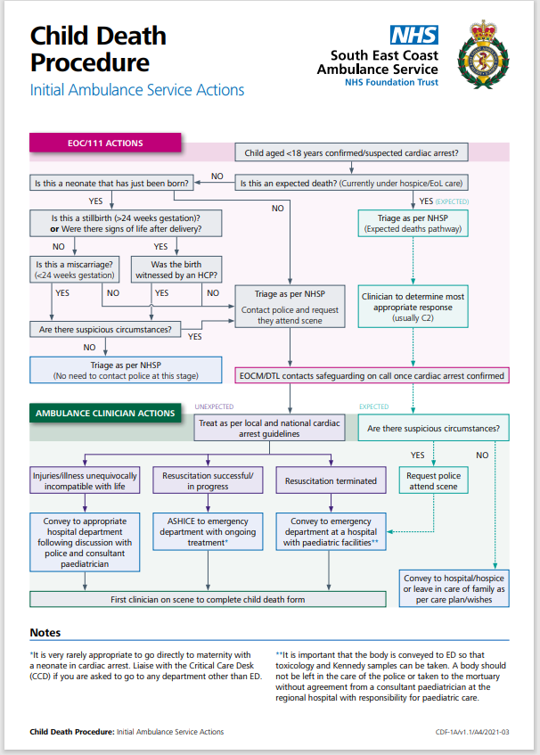

Appendix 8 – EOCM Alerting Criteria
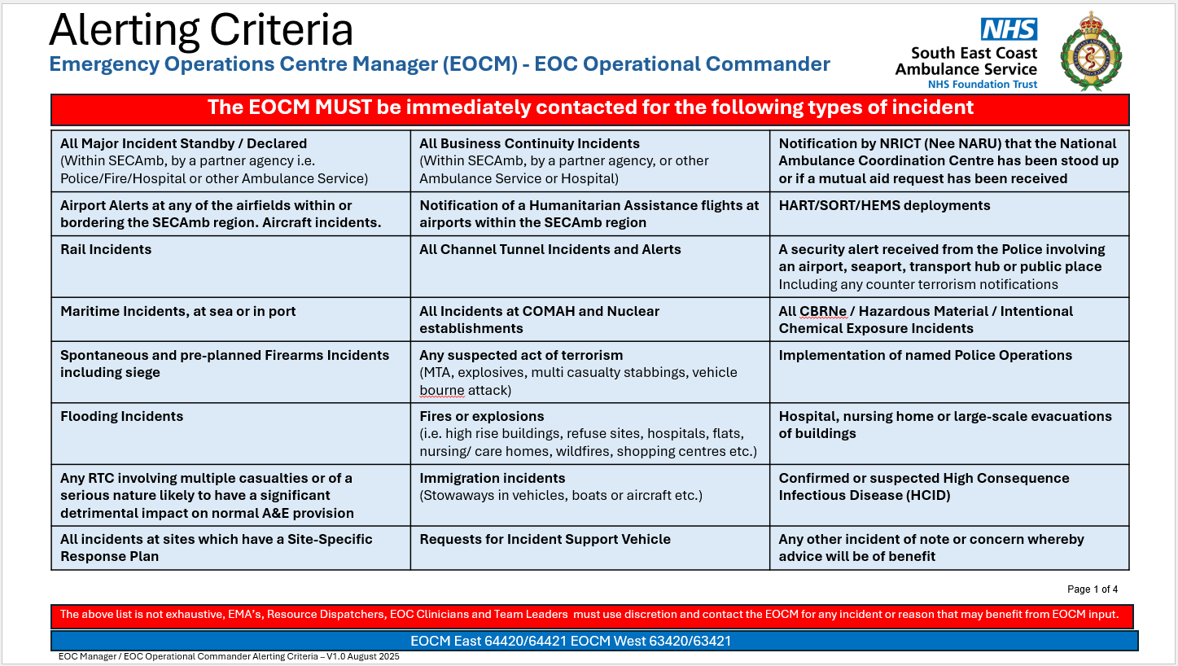
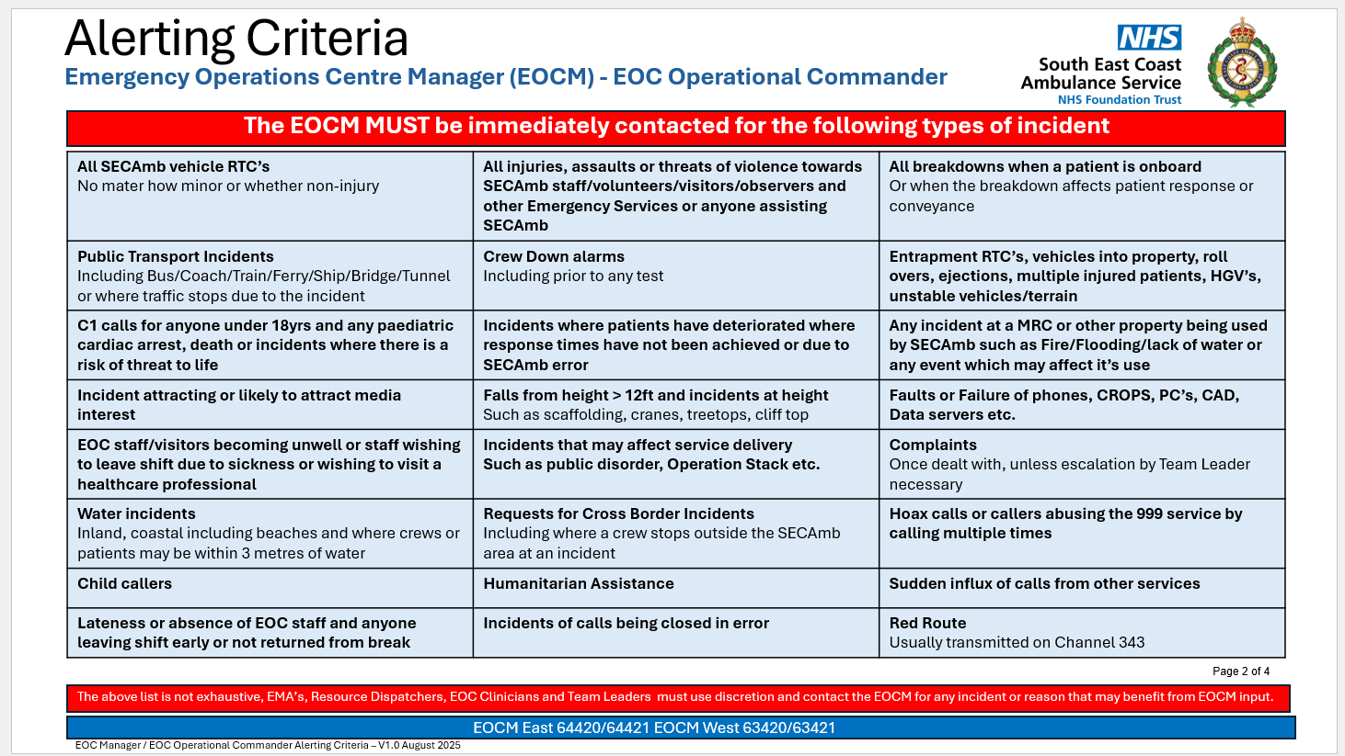
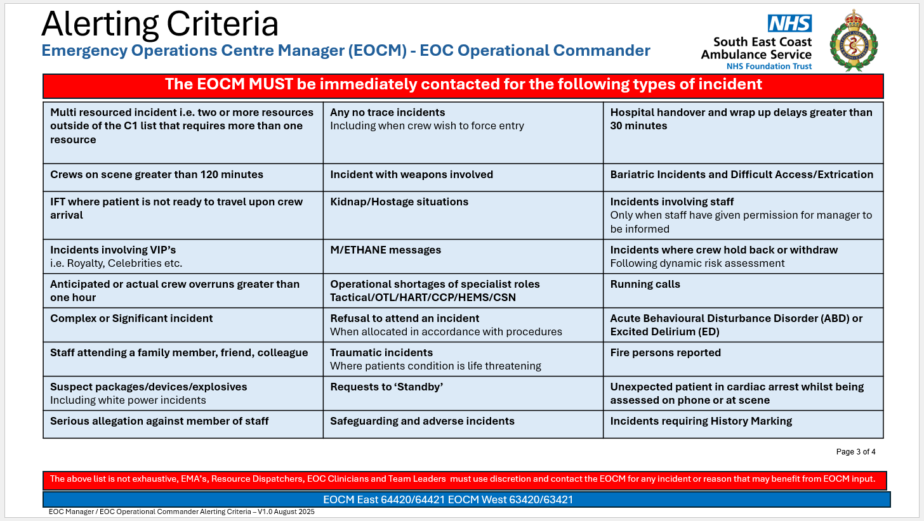
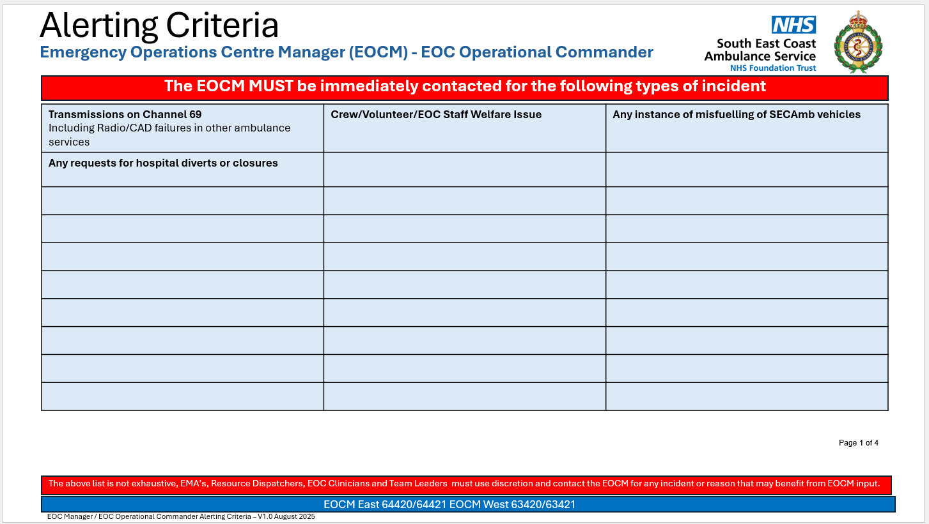

Appendix 9 – Take ACTION Guidance for Dispatch
