Category A Waste Procedure

1. Scope
1.1 South East Coast Ambulance Service NHS Foundation Trust (the Trust) requires a procedure in the event of patient's creating or staff members handling Category A Waste.
1.2 Category A Waste refers to clinical waste that poses a high risk of infection due to contamination with pathogens that can cause life-threatening diseases, examples include diseases classed as High Consequence Infectious Disease (HCID).
1.3 Within the Trust’s Hazardous Area Response Team (HART), Category A Waste is defined as any waste produced from an incident in which there is a patient with a confirmed HCID disease. This includes all waste relating to the decontamination of the vehicle and the personal protective equipment (PPE) worn by personnel.
1.4 This waste requires different packaging, labelling and processing that other types of waste, and therefore requires special consideration and planning.
1.5 The destination hospital of the patient does not have an obligation to accept the clinical waste. However, it is recognised as best practice to accept Category A Waste in the ‘Health Technical Memorandum 07-01: Safe and sustainable management of healthcare waste’.
1.6 When leaving waste with the receiving hospital, the Trust must comply to the key legislation detailed in the memorandum.
1.7 The Trust is developing a Joint Standard Operating Procedure (SOP) based on an understanding with hospitals within its area that it will take the clinical waste created from a HCID transfer. Due to the lack of High-Level Isolation Unit’s (HLIU) in the Trust’s patch, this is most likely to take place using an EpiShuttle transfer and HART. If, in the unlikely event that the hospital does not accept the Category A Waste, then guidance must be sort from Tactical level. Consideration must be made as to how the waste will be safely and securely transported back to a Trust base in a HART vehicle.
1.8 Only suitably trained staff with the correct HCID PPE should be handling Category A Waste. All staff handling these bins must have documented training on Category A Waste handling and should have a documented history of training and regular competency assessments.

2. Storage
2.1 Category A Waste must be stored in UN certified 60 litre yellow clinical waste bins (hereon referred to as ‘bins’) that are double lined with UN certified heavy duty (50 micron) yellow clinical waste sacks (hereon referred to as ‘bags’). The bins must be closed in the specified way, detailed below in the bin sealing process.
2.2 The bin must display the correct UN 3549 Hazardous Waste, Infectious Clinical Waste label which must be completed in full.
2.3 If the HCID is suspected and not confirmed then the waste must be packaged following the Category A Waste procedure – with the exception of the UN label sticker. These Category B waste bins must be kept identifiably separate from any other bin. If the status of the HCID is later confirmed as positive, only then is the UN label sticker applied to make it Category A Waste.

3. Transporting Clinical Waste
3.1 In the unlikely event that the HLIU does not accept the Category A Waste then it must be returned to a HART base. The vehicle containing clinical waste must remain locked and/or supervised the whole time the infectious waste is on board. Where possible avoid stopping on the journey.
3.2 The bins must be stored inside a locked area; it is vital that this area cannot be accessed by members of the public at any time. It should not be stored in an area that is open to the elements.
3.3 When placing the bins in the store ensure that the Cat A bins are stored separately from other clinical waste. This is to avoid confusion between types. It is acceptable to store them in an isolated area of the HART garage.
3.4 Contact the Estates Team as soon as possible to arrange the bins collection by specialist contractors, who will remove the items and transport it directly to a high-temperature incinerator. These bins are not permitted to be removed via the standard clinical bin collection. Ensure Estates are informed that the bins are Category A Waste from a patient transfer with known / suspected HCID EstatesTeam@secamb.nhs.uk
3.5 The Operational Support Lead/Officers, Make Ready Contractor Team and Infection Prevention & Control must also be informed. It should be made clear that these bins, whilst containing contaminated materials, have been decontaminated on the outside.
4. Spills
4.1 Any spills emanating from Category A Waste bins present a risk to all persons in the working environment and must be dealt with by HART using full HCID PPE and Standard Undressing Procedure detail in the HCID Standard Operating Procedure NH SOP 05. Trust Spill Kits may be used to aid in the cleaning but must be treated as Category A Waste and destroyed as such. Leaks or spills from bins must be recorded using the Datix reporting system.
4.2 The cause of the spill should be found without putting the HART Operative at undue risk from contamination. Equipment such as Vernagel and Trust issue Spill Kits should be used at preventing further spills.
4.3 Once the spill has been cleaned the area should then be decontaminated using the HART HCID vehicle decontamination procedure.

5. Bin Sealing Process
5.1 For the safe transfer of Category A Waste to the High-Level Isolation Unit’s from HART, the bins must be sealed using the following process:
5.2 Preparation:
5.3 Place two yellow clinical waste bags inside each other and then place these bags inside the 60-litre polypropylene container. Ensure the bags drape over the bin lip while reaching the inside base of the bin.
5.4 Filling:
5.5 Ensure the bin is not overfilled and when placing items inside the bag that care is taken not to make contact with the outside of the bin. There is a fill line approximately two thirds up, the bin should not be filled above this point.
5.6 If fluids have been added, add sufficient amount of Vernacare Vernagel to the inner yellow waste sack to ensure the complete solidification of any liquid waste. A 7g sachet of Vernagel can absorb up to 1.2 litres of fluid.
5.7 For sharps bins: ensure that contents do not go past the indicated fill line, to reduce the risk of inadvertent sharps risk. When closed place sealed sharps bin into inner sack.
5.8 Sealing:
5.9 Once the waste bag is two thirds full, wipe the outside of inner bag with Peracetic Acid wipes and place wipes inside the inner bag. Lift the inner bag off the waste bin.
5.10 Wipe the outside of the intermediate bag with wipes and place the wipe inside the inner bag.
5.11 Tie the inner bag using the swan-neck technique and secure with a cable tie (Appendix II).
5.12 Peel the intermediate bag off the waste bin and tie in a swan-neck, then secure with a cable tie (Appendix II).
5.13 Seal the bin lid ensuring every corner is pushed down. Finally wipe around the outside of the bin, especially any areas that have been contaminated. These wipes can be disposed of into lower categories of waste.
5.14 Directions on how to seal the clinical waste bins are available in the References.
5.15 Labelling:
5.16 Each polypropylene 60-litre container must have a clearly completed label stating the ambulance service and the date (Appendix I). A label must be affixed to each container to facilitate the identification of Category A Waste by waste contractors and ensure appropriate handling and disposal procedures.

6. Appendix: Appendix I
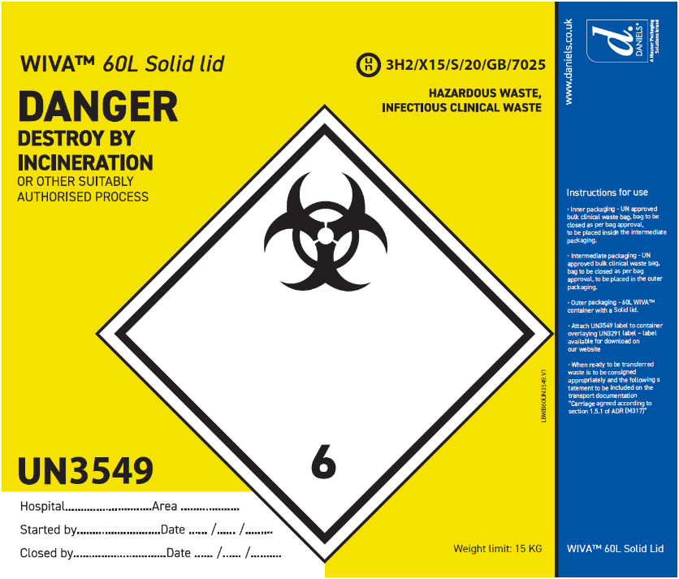
Appendix II
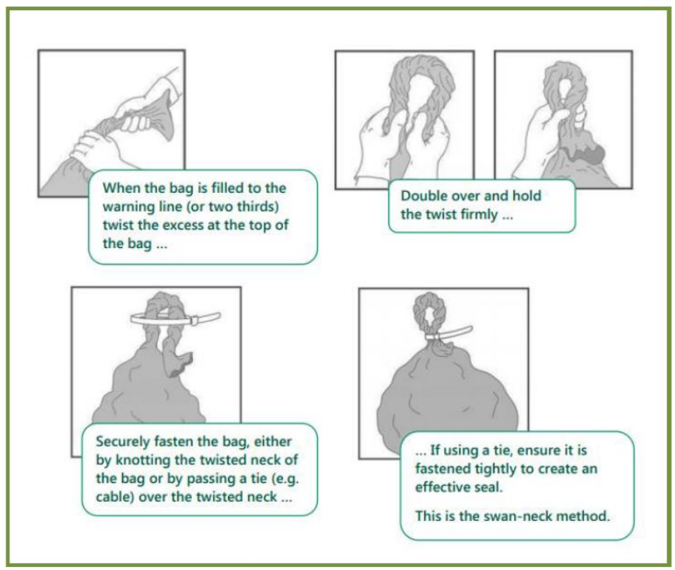

7. References:
7.1 ‘Health Technical Memorandum 07-01: Safe and sustainable management of healthcare waste’ – NHS England, 2022 (Available at: Health Technical Memorandum 07-01: Safe and sustainable management of healthcare waste, Hyperlink)
7.2 ‘High Consequence Infectious Disease waste management and EpiShuttle decontamination SOP’ Version 0.5, NHS Emergency Capabilities Unit, October 2024.
7.3 ‘WIVA Training and Education, Daniels Healthcare, 2023 (Available at: WIVA™ Training and Education, YouTube Hyperlink).

