Clinical Handover and Transfer of Care
Procedure

Contents

Document Control………………………………………………………………………4

1 Scope……………………………………………………………………………….5

2 Procedure………………………………………………………………………….6

2.12 Standards of care in transit ……………………………………………………7

2.12 Patient Notes and other documentation……………………………………..8

2.13 Special handover conditions…………………………………………………..8

2.14 Handover & Transfer of Care…………………………………………………..8

2.15 Types of Handovers….………………………………………………………….9

3 Definitions………………………………………………………………………...16

4 Responsibilities………………………………………………………………….16

5 Audit and Review (evaluating effectiveness) ……..……………………….17

6 Associated Trust Documentation……………………………………………..17

7 References………………………………………………………………………...18

8 Financial Checkpoint……………………………………………………………18

9 Equality Analysis………………………………………………………………...18

Appendix A: Delayed Handover Flowchart………………………………………...20

Appendix B: SECAmb handover process ………………………………………….21

Appendix C: Patient safety risks in Health care…………………………………..22

Appendix D: Transfer of care ePCR process………………………………………23

Scope
  - This document describes the requirements and processes for South East Coast Ambulance Service NHS Foundation Trust (the Trust) clinicians conveying patients to hospitals and other healthcare facilities and how to safely transfer care of the patient to another healthcare professional once arrived.
  - This procedure applies to all grades of staff that need to convey a patient to any receiving healthcare destination.
  - This procedure does not apply to transporting patients to their home address following discharge on scene by a clinician (please refer to the Discharge Procedure).
  - This procedure does not apply to patients being transported to their home address from a public place for the purposes of being treated there. In these instances, please refer to the Discharge Procedure.
  - This document will outline the process for managing handover delays, actions to be taken, and points of escalation.
  - This document divides the handover process into 3 distinct areas for ease of understanding (see appendix A):
    - Standard handover
    - Delayed handover
    - Emergency Handover
  - The aims of this procedure are:
    - To reduce the risks to patients associated with handover of care to a healthcare facility.
    - To reduce the risk to patients waiting for a 999 response in the community due to hours lost at hospitals and improve patient safety and experience.
    - To standardise clinical processes and promote clinical standards.
    - To ensure appropriate care is given to patients when under the care of Trust clinicians when en-route to a care facility or prior to the transfer of care due to hospital delays.
    - To facilitate effective joint working with other providers by ensuring there is a clear process to follow should delays occur when transferring patients at the point of handover, and to promote effective streaming and use of appropriate pathways of care.
    - To ensure that clinicians can confidently hand patients over in a timely way, following clear Trust approved processes which are supported by Commissioners and partner providers, and which supports safe and effective patient care.
- Procedure
  - The decision to convey a patient will be made as a result of a clinical assessment in line with Trust clinical guidelines, Joint Royal Colleges Ambulance Liaison Committee (JRCALC) and discussion with an advanced paramedic, where appropriate, for joint decision making. All grades of staff are required to work within their scope of practice as per the Scope of Practice and Clinical Standards policy.
  - Joint Decision-making is the most effective way to reduce clinical risk. It is an essential tool when a clinician is deciding on the appropriate pathway for their patient, supporting care outside the hospital environment, ensuring appropriate conveyances and promoting appropriate referrals.
  - Conveyance to hospital does create some risk, especially for frail patients. All decisions to convey must be made in the best interests of the patient. This includes conveying to the most appropriate destination, to ensure the patient receives the most suitable care and to avoid a subsequent secondary transfer to the definitive facility.
  - The most senior attending clinician is responsible for making the decision on the most appropriate destination. Local pathways may include alternative destination arrangements for specialities. For example, if it is known that the local hospital has no out-of-hours specialists to deal with the patient’s condition (e.g. urology); it may be more suitable to convey the patient to the next closest hospital that does have these facilities.
  - Advice may be sought via Emergency Operations Centre (EOC), Critical care desk or urgent care hubs, on the potential receiving facility e.g. confirming which hospital is on call for PPCI or for discussing the Major Trauma decision tree.
  - Decisions to not convey must follow the Referral, Discharge and Conveyance Policy, and/or the Referral Procedure, Discharge Procedure or Urgent Transport Vehicle (UTV) Policy.
  - If a clinician has requested a Double Crewed Ambulance (DCA) to convey the patient immediately, either under routine or emergency conditions (Grade 1, Grade 2 or Grade 3 back up,) they must await the arrival of the vehicle and complete a handover to crew.
  - If a clinician is standing down from an incident after booking a delayed conveyance, the electronic Patient Clinical Record (ePCR) should be completed in full and closed under Incident-Close Case On Device -Passed to another Vehicle. If ePCR is unavailable the carbon copy of the PCR is to be left with the patient for the conveying resource to refer to. Please refer to the Interrupted Care/Delayed Conveyance Procedure. (This is dependent upon clinical grade).
  - Patients who may be ‘red carded’ or ‘banned’ from a hospital site does not affect your clinical decision making. Where conveyance is indicated, the patient should be conveyed to the nearest receiving emergency department (unless there is a speciality need e.g. Major Trauma, PPCI, HASU). Hospitals cannot require you to convey a patient to another acute site on the basis of a ‘red card/ban’. Patients should be handed over in line with normal procedures, any issues should be escalated to EOC and your Operational Commander in the first instance.
  - Where patients are unable to care for themselves, and may need help with basic needs such as eating, drinking, using the toilet and communicating, crews should seek to bring an escort with them wherever possible to enhance patient dignity and safety.
  - Standards of care in transit
    - The patient and any passengers must be safe at all times. The correct seatbelt or restraints must always be used. If seated the patient or passengers should be facing forwards to travel.
    - Clinicians travelling in the saloon of the vehicle, caring for the patient, must be seated and wearing a seatbelt. The only exception to this is when carrying out immediately lifesaving interventions or treatment. If this occurs the clinician must make the driver aware, to enable them to adapt their driving style, if necessary.
https://aace.org.uk/safeintheback/
    - Any property or belongings must be properly secured at all times.
    - It is the responsibility of the crew to ensure that the vehicle is adequately equipped for a response, however this occurs in the context of a make ready service and stock management which is out with their control.
    - The most appropriate clinical grade of staff for the patient’s needs must become the attendant and travel in the rear with them.
    - Travelling in an ambulance can cause worry and stress for many patients. Every consideration should be given to reduce a patient’s anxiety wherever possible.
    - The patient should be made as comfortable as possible. This includes finding the most appropriate position for sitting/laying, and the use of blankets/pillows.
    - The patient’s dignity and modesty must be considered at all times.
    - Many patients, particularly the elderly, may have poor skin health which could cause them pain or discomfort during transfer. Care must be taken in both the handling of the patient whilst transferring to a seat or stretcher and in arranging their positioning. The moving and transporting of a patient should not cause or exacerbate any injury or illness.
    - All patient medicines should be placed in a labelled green medicines bag. If the location has specific processes i.e. a care home using the red bag scheme, this can be followed.
  - Patient Notes and other documentation
    - Where a patient is being transferred from a care facility or other similar location, any documentation relating to that patient must be checked by the crew prior to leaving scene to ensure that the documents supplied relate to the correct patient and includes all relevant information.
    - SECAmb staff must satisfy themselves that any accompanying documents are accurate and appropriate, and it is considered best practice to confirm with the patient their name, comparing this information provided by the care facility.
    - Where the patient lacks capacity, SECAmb staff should, where possible, independently confirm the patient’s identity with a staff member or patient’s family member.
    - Errors made by the use of incorrect data may cause the patient harm. Staff must be diligent to the risk of this occurring and satisfy themselves of the identity of their patient.
  - Special handover conditions
    - Multi-casualty incidents may require handovers at scene between clinicians due to dynamic changes including available staff, patient condition, the environment etc. These situations are often challenging but should not prevent a handover of all relevant information. Practicalities may mean that these are verbal handovers only, but every effort should be made to start an ePCR as early as possible, and in every case an ePCR must be completed.
    - Handover to the Helicopter Emergency Medical Service (HEMS) may be required either at scene or at a rendezvous point (RVP) to transfer a patient. A full handover must be given by the senior Trust clinician attending the patient, to the HEMS doctor or paramedic.
    - Where the staff attending a patient and are backed up, joined or supported by a resource with a higher clinical grade, the most senior clinician assumes overall patient responsibility and clinical authority. A full handover must be given to the senior clinician (see Scope of practice and clinical standards policy, appendix c).
  - Handover & Transfer of Care
    - On arrival at the conveyance destination, the patient clinical record (ePCR/PCR) should be submitted according to Trust health records policies. Please refer to the Trust PCR policy documents.
    - If the hospitals inbound screen isn’t available or the receiving department does not have access, a Case Summary Access Card should be left. This will provide details on how to access a patient’s electronic clinical record.
    - Handover of the patients’ care should be made to a designated member of receiving staff in each receiving department. This would usually be a registered healthcare professional (HCP), such as a doctor or nurse. In some instances, for example a safe haven, this may be a non-registrant.
    - Clinicians must ensure that they hand-over to the correct member of staff and minimise duplication of handover.
    - For hospitals with full Emergency Department (ED) A&E (type 1 or 2) - patients with minor injuries or minor illness may be seated in the ED waiting room if clinically appropriate without undertaking a clinical handover to hospital staff, i.e.
      - Those patients who are clinically stable with minor injuries or illness who would normally be expected to self-present to the department. (Must be safe to self-care while waiting to be called through to triage area.)
    - Patients left in the waiting room without a clinical handover must be given worsening care advice and informed as to the actions should their condition worsen. The most senior clinician in attendance retains responsibility for this decision.
    - It is best practice to inform a hospital HCP of the intention to place the patient in the waiting room.
    - Where the patient is placed in the waiting room, the crew MUST confirm with hospital staff the receipt of ePCR or provide a paper copy together with the four-digit pin to reception for the hospital to input.
    - Wherever possible, patients should be streamed into the most appropriate part of the Emergency Department/Hospital.
  - Types of Handover
    - Standard Handover
      - In line with national policy, on arrival at hospital, the target turnaround time is 30 minutes. This procedure will be updated in line with any revised national handover standards, that are published. This is broken up into two sections:
      - Up to 15 minutes for the hospital to book in their patient, receive the patient handover AND have the patient transferred onto hospital furniture AND release the SECAmb crew.
      - Up to 15 Minutes for the SECAmb crew to complete any outstanding documentation, re-commission their vehicle and press clear on their Mobile Data Terminal (MDT) (see appendix A).
      - The patient remains the responsibility of the ambulance clinician until 15 minutes after arrival, or until the handover has taken place (whichever is first).
      - Whilst awaiting transfer of care, patients must be appropriately monitored by a SECAmb clinician and documentation updated to reflect care during this period where necessary.
      - Any deterioration in the patient’s condition during this time will be notified to the Nurse in charge immediately. The ambulance Clinician should clearly highlight their concerns and seek a timely solution to the matter.
      - The arrival at hospital time is captured by the SECAmb Computer aided dispatch (CAD) System via the Mobile Data Terminal (MDT) system is the point at which the hospitals 15 minutes to handover commences.
      - The hospital handover screen will capture the time when the physical and verbal handover has taken place, the patient has been transferred physically to a hospital chair/trolley or cubicle. The four-digit code must be passed to hospital staff to enter on the handover screen, releasing SECAmb staff.
    - Delayed Handover process
      - The delayed handover process allows crews to handover clinically stable patients at 45 minutes without the attendance of an onsite Operational Commander.
      - Any deterioration in a patient’s condition during this time must be communicated to the nurse in charge.
      - In all cases of delayed handover, consider the patients’ needs which might include hydration, nutrition, patients own medication, risk of pressure sores, support and reassurance.
      - Where a hospital clinician undertakes any investigation or treatment of a patient still under a SECAmb crews care, this should be documented on the ePCR.
      - Should a handover not have been achieved within a total of 45 minutes, the following actions should be taken;
- Where the patient is evidentially clinically stable, and is safe to be left, the crew should ensure that the patient is on a hospital trolley, wheelchair/chair and then approach the Nurse in Charge to advise them they will be leaving and submit the ePCR.

- Where the patient is evidentially clinically unstable (i.e. evidenced by National Early Warning Score (NEWS2 Score) and/or is unsafe to be left, one last attempt should be made to handover to the Nurse in Charge. If this fails, the clinician should seek to communicate their concerns to the Nurse in charge and failing this a member of the medical team. A Datix should be logged in this instance, and the Operational Commander should be contacted.
      - If the above action fails to resolve the concern for patient safety, the Operational Commander will contact Hospital Clinical Site Manager (CSM) and escalate their concerns to them. In the interim all reasonable steps must be taken to ensure patient safety.
      - Any inappropriately delayed handover of a clinically unstable patient warrants a datix incident report (DIF-1) and quality alert to the acute trust.
      - Patients remaining in the care of SECAmb staff during delayed handover MUST receive the same level of care, regardless of whether they are inside or outside the hospital. This includes observations, monitoring and medicines, where necessary. All monitoring and treatments must be documented and follow the same standards as if in the pre-hospital setting. Delayed handover does not preclude the ongoing care of the patient by SECAmb staff.
    - Emergency Handover (release to rescue)
      - The emergency handover process should be considered when queues are forming and there is no immediate plan in place to address the delays quickly. The emergency handover process will ensure patients can be safely left at 30 minutes with the onsite support of an Operational Commander. The following steps should be taken when considering implementation of emergency handover:
      - 15-minute Breach
      - When two ambulances breach 15 minutes at a designated ED the Resource Dispatcher (RD) will contact the operational crew to identify if a problem exists. The Operational Commander will be made aware as appropriate.
      - 30-minute Breach
      - When one ambulance breaches 30 minutes at a designated ED the Tactical Commander must contact the ED Clinical Site Manager (CSM) and ask what plans are in place to address (see below).
  - The Tactical Commander must discus with the CSM the following:
    - What is their current capacity?
    - What are the factors causing the delay?
    - What plans the Acute Trust/Accident & Emergency department has to resolve the delay?
    - When is/are our Trust vehicle(s) going to be clear?
    - Are future breaches likely within one to two hours?
      - The Tactical Commander will advise the CSM that if the ambulance delay breaches 45 minutes and resolution is unlikely, then a decision will be made by the Tactical Commander Manager, based on a risk assessment of SECAmb’s Clinical Safety Plan (CSP) level, as to whether the emergency handover process will be implemented for this breach, and all subsequent breaches over 30 minutes.
      - The Tactical Commander will then immediately alert the nearest available Operational Commander to advise them of the current and anticipated position, as well as tasking them to attend the ED.
      - The Operational Commander will update the Tactical Commander once on site and continue to provide updates to monitor progress.
      - The Operational Commander will also make a note of the time of this contact in their incident log and telephone the Emergency Operations Centre Manager (EOCM) to record the information in the dispatch notes on CAD.
      - The Operational Commander will ensure that there are spare trolleys (either belonging to the ED department or the Trust) which are already available and consider mobilising further trolleys to the site.
      - If no spare hospital trollies can be identified, then the Operational Commander will authorise the crew to leave the stretcher that the patient is on from their vehicle. The crew will immediately be deployed when clear to the nearest Ambulance Station/Make Ready Centre to collect a spare stretcher to replace.
      - The Operational Commander will manage the return of the stretchers once they become spare by recycling onto other ambulances (without an existing SECAmb trolley in situ) or by returning them to the nearest Ambulance Station.
    - End of shift transfer of care – (see appendix D, for flow chart)
      - When awaiting handover of care of a patient at a hospital, past the end of the planned shift time, it is possible to transfer the care of that patient to another SECAmb clinician, following this process: Transfer of Care can only occur if a crew is past their shift end time or in another dispatch desk which would cause a considerable overrun while awaiting handover

      - Transfers are limited to situations where the crew taking over care of the patient must have already handed over any patients from their previous incident
      - Transfers of Care must be requested by the crew to the Duty Operational Team Leader (OTL) of the Hospital effected (i.e. Gatwick crew at Royal Sussex County would have to seek approval from the Brighton OTL) who will communicate to the Emergency Operations Centre (EOC) if approved to ensure accurate CAD updates and Trust data capture
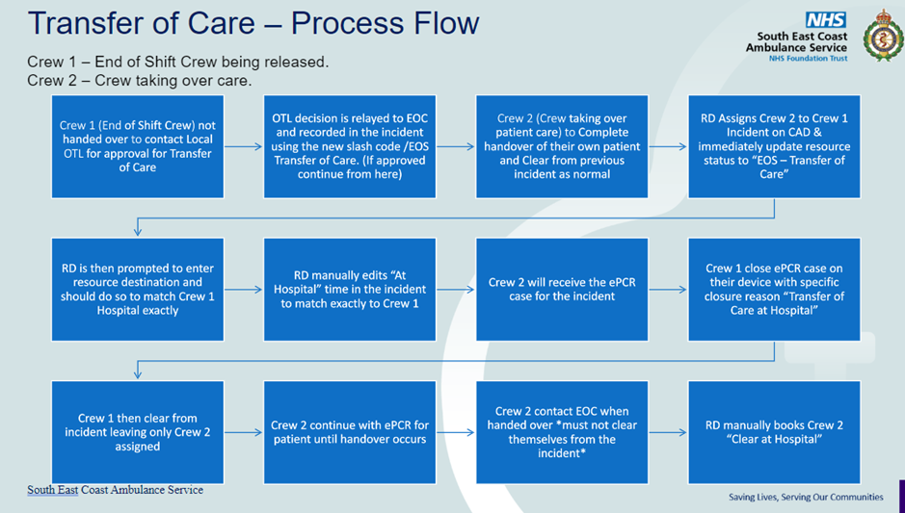
      - It is important that the steps laid out in the attached EOC guide are followed in order and actioned as stated to avoid issues with statuses on CAD and reporting anomalies

- Definitions
  - Worsening care advice: information given to patient relating to signs and symptoms to be aware of
  - Transfer of Care – This is the point in which another healthcare professional has taken over clinical responsibility for the patient
  - Standard handover is where handover of patient care, from the trust to the hospital, is completed within 30 minutes
  - Delayed handover is where the standard handover is not completed within the allocated 30-minute window.
  - Emergency Handover is the process of instigating handover at 30 minutes, with the support of the operational commander, where demand is high and patients in the community are waiting.
  - DIF-1 (Datix) is the Trust’s incident management system.
- Responsibilities
  - This procedure is aligned to Scope of Practice and Clinical Standards Policy which identifies the lines of accountability at policy level.
  - The Chief Executive Officer has ultimate responsibility for conveyance, handover and transfers of care.
  - The Medical Director is responsible for all aspects of clinical governance under this procedure.
  - The Regional Operations Managers together with the Consultant Paramedics are responsible for providing oversight of this procedure, including monitoring and audit.
  - The Operating Unit Managers are responsible for implementing the procedure, and for the obtaining of local Memorandums of Understanding relating to conveyance without clinician handover at MIUs.
  - Staff operating at Operational Commander level when assigned to a hospital are responsible for ensuring compliance with this procedure.
  - All Staff are responsible for ensuring they have knowledge of and comply with this procedure.
  - Describe here the level of education and training required by employees to fulfil the requirements of this procedure. If there are no education or training implications to enable employees to fulfil the policy’s requirements, simply delete this section.
- Audit and Review (evaluating effectiveness)
  - Adverse incidents occurring as a result of delays in transfer of care will be investigated via the DIF 1 system by the local operating unit management team in partnership with the hospital concerned.

  - These DIF 1s will be reviewed by the Clinical Risk Managers and escalated to the Clinical Risk Panel where appropriate.

  - The procedure will be reviewed every three years or sooner if new legislation, codes of practice or national standards are introduced.

  - All policies have their effectiveness audited by the responsible Management Group at regular intervals, and initially six months after a new policy is approved and disseminated.

  - Effectiveness will be reviewed using the tools set out in the Trust’s Policy and Procedure for the Development and Management of Trust Policies and Procedures (also known as the Policy on Policies).

  - This document will be reviewed in its entirety every three years or sooner if new legislation, codes of practice or national standards are introduced, or if feedback from employees indicates that the policy is not working effectively.

  - All changes made to this policy will go through the governance route for development and approval as set out in the Policy on Policies.
- Associated Trust Documentation
  - PCR document set (including continuation forms and ROLE documents etc.)
  - Referral, Discharge and Conveyance Policy
  - Referral Procedure
  - Discharge Procedure
  - Scope of Practice and Clinical Standards Policy
  - Driving and Vehicle Standards Policy
  - Information Governance Policy
  - JRCALC+ (2024) Guidelines
  - Health Records Management Policy
  - Interrupted care/delayed conveyance Procedure
  - Ambulance Service Basic Training Manual
  - Urgent Transport Vehicle (UTV) policy
  - ePCR and PCR completion guide
  - ePCR Case Summary Access
- References
  - Flory, D. (2012). Ambulance Handover Delays.
  - NHS Confederation. (2012). Zero Tolerance; Making ambulance handover delays a thing of the past. London: The NHS Confederation.
  - https://improvement.nhs.uk/resources/addressing-ambulance-handover-delays-actions-for-local-ae-delivery-boards/
  - NHS England » Urgent and emergency care plan 2025/26
- Financial Checkpoint
  - To ensure that any financial implications of changes in policy or procedure are considered in advance of document approval, document authors are required to seek approval from the Finance Team before submitting their document for final approval.
  - This document has been confirmed by Finance to have no unbudgeted financial implications.
- Equality Analysis
  - The Trust believes in fairness and equality, and values diversity in its role as both a provider of services and as an employer. The Trust aims to provide accessible services that respect the needs of each individual and exclude no-one. It is committed to comply with the Human Rights Act and to meeting the Equality Act 2010, which identifies the following nine protected characteristics: Age, Disability, Race, Religion and Belief, Gender Reassignment, Sexual Orientation, Sex, Marriage and Civil Partnership and Pregnancy and Maternity.
  - Compliance with the Public Sector Equality Duty: If a contractor carries out functions of a public nature, then for the duration of the contract, the contractor or supplier would itself be considered a public authority and have the duty to comply with the equalities duties when carrying out those functions.
Name of author and role | Julie Ormrod Consultant Paramedic
Directorate | Paramedic | Date of analysis: | 4th February 2025
Name of policy being analysed | Clinical Handover and Transfer of Care Procedure
Names of those involved in this EA | Carolanne L’Etedrine, Julie Ormrod and Dave Hawkins

Appendix A: Delayed Handover Flowchart

Any ambulance breaches 15 minutes: Delayed Handover Record to commence

Two ambulances breach 15 minutes: Crews will be contacted by EOC to see if a problem exists

One ambulance breaches 30 minutes: Operational Commander tasked to attend site. EOC to escalate to Tactical Commander and seek permission to implement emergency handover.

Emergency Handover in operation: All subsequent ambulances breaching 30 minutes to immediately handover

Emergency Handover Stand-down: To be agreed with Tactical Commander and revert to standard/delayed handover process

Appendix C: Patient safety risks in Healthcare

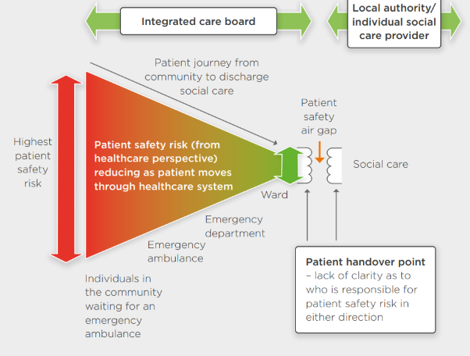

Appendix D: Transfer of Care ePCR process

*cases ‘closed case on device’ remain in an active state, which allows other resources to acquire them. Any resource assigned to an incident can either create or acquire cases. Active cases already created from a CAD PUSH do not disappear when a resource is cleared from an incident only at the point of ‘submission’

Figure 1
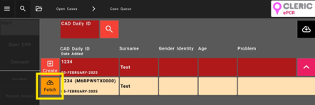

Figure 2

