**WRES and WDES 2024 – Review and Summary of reports**

**1. Executive Summary**

The Workforce Race Equality Standard (WRES) and Workforce Disability Equality Standard (WDES) reports for the Trust reveal critical disparities affecting Black and Minority Ethnic (BME) and Disabled staff. These include underrepresentation, unequal career progression, and experiences of harassment. Furthermore, organisation-wide cultural and systemic issues impact all staff, necessitating urgent action.

This paper summarises key findings, identifies challenges, and outlines a roadmap to embed equity, diversity, and inclusion into the organisational culture. The proposed strategies align with the Combined EDI Action Plan (CEAP) for 2024 - 2027 and focus on achieving measurable progress in the next three years.

**2. Summary of Findings: WRES and WDES Reports for South East Coast Ambulance Service NHS Foundation Trust (SECAmb)**

**Workforce Race Equality Standard (WRES) Findings**

1. **Representation**
   * **BME Representation**: 8.4% of the overall workforce identifies as Black and Minority Ethnic (BME).
   * **Leadership Gaps**: No BME representation at senior leadership levels (Bands 8C and above for clinical staff). There are two BME staff at 8c and above in non-clinical roles.
   * **Recruitment Inequity**: White candidates are more than twice as likely to be appointed from shortlisting compared to BME candidates (likelihood ratio: 2.10).
2. **Harassment and Bullying**
   * **From Patients/Public**: 40.3% of BME staff experienced harassment or bullying from patients or the public, compared to 29.2% regionally. 46.4% of White staff experienced harassment or bullying from patients or the public. This suggests that there is a Trust wide issue with bullying and harassment from patients or the public.
   * **From Staff**: 24.6% of BME staff reported harassment or bullying from colleagues compared to 26.1% of White staff.
3. **Career Progression**
   * **Perceptions of Equality**: Only 39.8% of BME staff believe they have equal opportunities for career progression or promotion compared to 43.4% of White staff.
4. **Workplace Culture**
   * **Board Representation**: No BME executive board members, indicating a lack of diversity at the highest organisational level. There are three BME non-executive board members, out of nine.

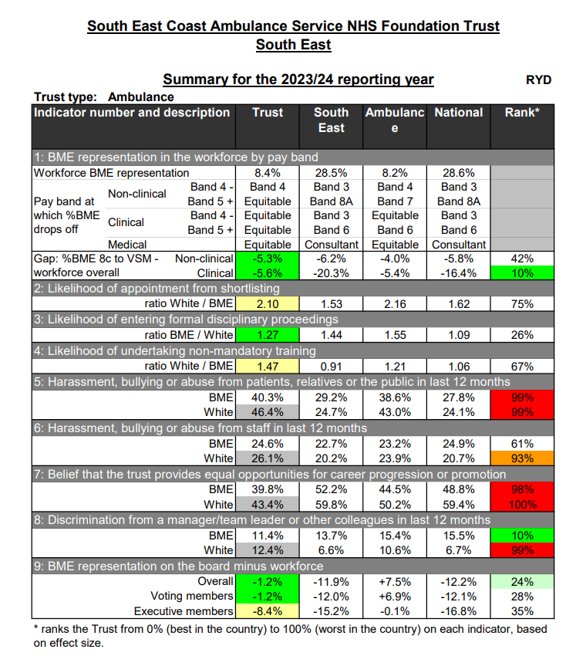

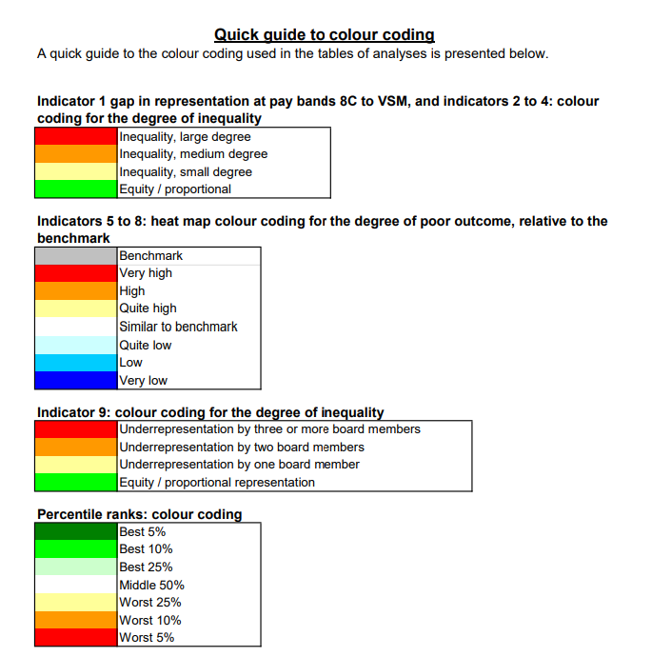

**Workforce Disability Equality Standard (WDES) Findings**

1. **Representation**
   * **Disabled Staff**: 9.0% of staff identify as Disabled, although the non-declaration rate is 5.2%, suggesting potential underreporting.
   * **Senior Roles**: Disabled staff are not represented in senior clinical leadership roles (Bands 8C and above). There are 5 members of staff with disabilities in non-clinical Band 8C and above roles.
2. **Harassment and Discrimination**
   * **From Patients/Public**: 52.6% of Disabled staff experienced harassment or bullying from patients, relatives, or the public, significantly higher than non-disabled staff (42.2%).
   * **From Colleagues**: 24.1% of Disabled staff reported harassment or bullying from colleagues, compared to 15.9% of non-disabled staff.
   * **From Managers**: 22.5% of Disabled staff reported harassment, bullying or abuse from managers which is significantly higher than 11.6% non-disabled staff.
3. **Health and Wellbeing**
   * **Pressure to Work**: 32.0% of Disabled staff felt pressured to work despite not feeling well enough, compared to 20.0% of non-disabled staff.
4. **Workplace Satisfaction**
   * **Work Valuation**: Only 20.8% of Disabled staff feel their work is valued, compared to 31.0% of non-disabled staff.
   * **Career Progression**: 37.5% of Disabled staff believe in equal opportunities for career progression, compared to 46.0% of non-disabled staff.
5. **Board Representation**
   * **Disability Gap**: No Disabilities have been reported at Board level, leading to a disparity with the overall workforce percentage.

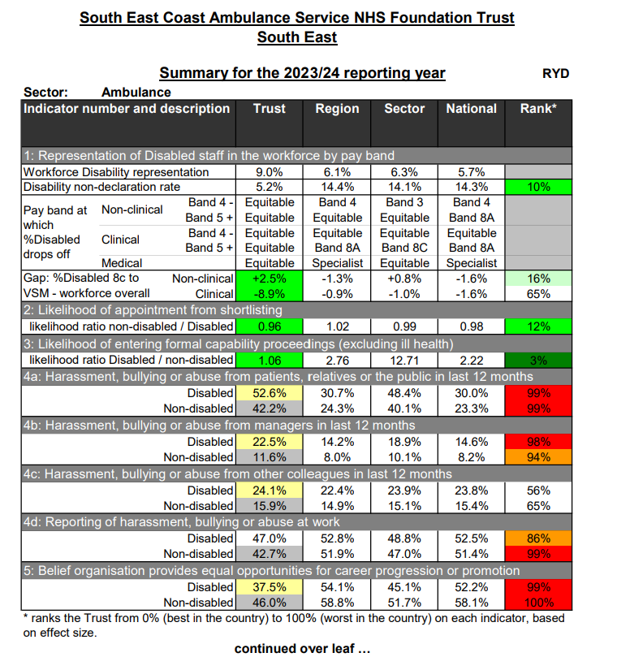

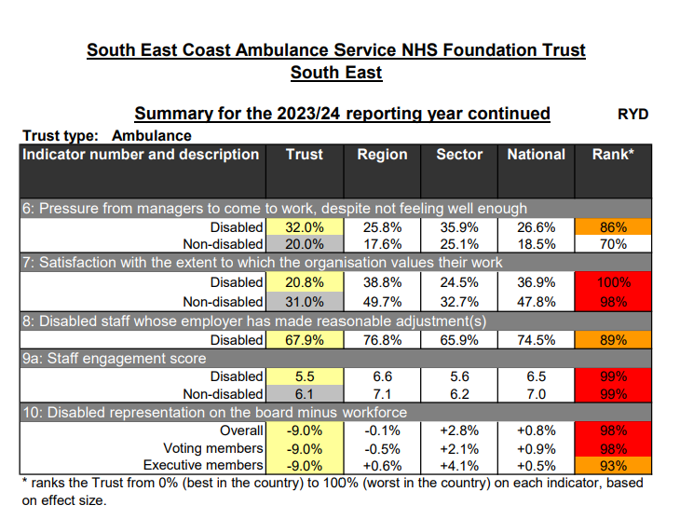

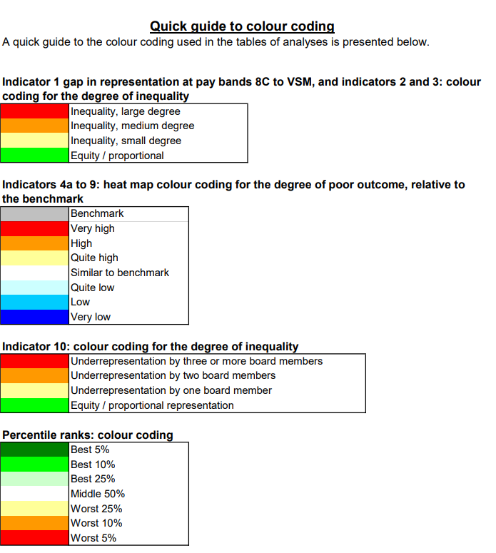

**Organisation-Wide Issues**

1. **Harassment Across Groups**:
   * High levels of harassment from patients or the public affect all staff groups, though Disabled staff seem to be disproportionately affected.
2. **Non-Declaration Rates**:
   * A high percentage of staff do not declare their disability (5.2%) or ethnicity, which hampers accurate data collection and targeted action.
3. **Bullying Culture**:
   * Reports of bullying and harassment from colleagues and managers are consistent issues for all staff groups.
4. **Equal Opportunities for Progression**:
   * Both BME and Disabled staff report lower confidence in fair access to career progression compared to their white and non-disabled peers.
5. **Data and Transparency**:
   * Lack of consistent EDI data tracking across directorates hampers targeted interventions.

**3. Risks and mitigations**

**Staff Morale and Retention:**

* Risk: High levels of harassment, perceived inequities, and lack of support for Disabled and BME staff may lead to disengagement, low morale, and increased turnover.
* Mitigation: Strengthen reporting mechanisms, create supportive networks, and implement targeted education and well-being initiatives.

**Operational Disruption:**

* Risk: HR already supports with high levels of grievances and formal complaints and an increase in grievances and formal complaints related to harassment or discrimination may further burden HR processes and disrupt operations.
* Mitigation: Streamline grievance procedures and provide training for managers to address concerns informally and effectively.

**Patient Care Quality:**

* Risk: Ongoing harassment from patients/public and inadequate support for staff facing these challenges could lead to reduced staff performance and quality of care.
* Mitigation: Train staff in de-escalation techniques, establish a clear zero-tolerance policy, and provide mental health support for affected employees.

**Data Gaps and Accuracy Issues:**

* Risk: High non-declaration rates for disability and ethnicity hinder the ability to track progress and implement targeted actions.
* Mitigation: Encourage self-reporting through awareness campaigns and assurances of data confidentiality.

**4. Proposed Initiatives**

**A. Organisational EDI Strategies (3-Year Plan); included within the CEAP**

1. **Improve Representation in Leadership**
   * **Action**: Increase BME and Disabled staff representation in leadership roles by 10% by 2027.
2. **Tackle Harassment and Discrimination**
   * **Action**: Reduce staff complaints of harassment and bullying by 20% annually over three years.
   * **Approach**: Launch anti-bullying campaigns, provide conflict resolution training, and enhance reporting mechanisms.
3. **Enhance Career Progression Opportunities**
   * **Action**: Ensure 50% of BME and Disabled staff believe in equal opportunities by 2027.
   * **Approach**: Provide mentoring schemes, developmental feedback following internal interviews, and inclusive career progression frameworks.

**B. Patient-Focused Initiatives**

1. **Address Patient Harassment Towards Staff**
   * **Action**: Reduce harassment incidents reported by frontline staff.
   * **Approach**: Train staff to handle patient aggression and communicate zero-tolerance policies clearly to the public.
2. **Improve Patient Interactions**
   * **Action**: Increase cultural competence among patient-facing staff.
   * **Approach**: Provide workshops on cultural awareness and improve diversity in patient-facing roles.

**5. Metrics and Expected Outcomes**

|  |  |  |
| --- | --- | --- |
| Objective | Metric | Target |
| Leadership Diversity | % of BME and Disabled leaders in Bands 8C+ | 10% increase by 2027 |
| Discrimination Complaints | % reduction in complaints | 20% annual reduction |
| Equal Career Opportunities | % of staff reporting equal opportunities | 50% by 2027 |
| Workplace Satisfaction | Staff satisfaction with work valuation | 30% increase by 2027 |
| Harassment Reduction | % of staff reporting harassment from patients | 20% reduction by 2027 |

**6. Conclusion**

The Trust has a unique opportunity to lead the way in embedding equity, diversity, and inclusion into its culture. This proposal, supported by findings from the WRES and WDES reports and the EDI Improvement Plan, provides a comprehensive roadmap to address systemic inequities. The Board’s leadership and accountability will be critical to the success of these initiatives.