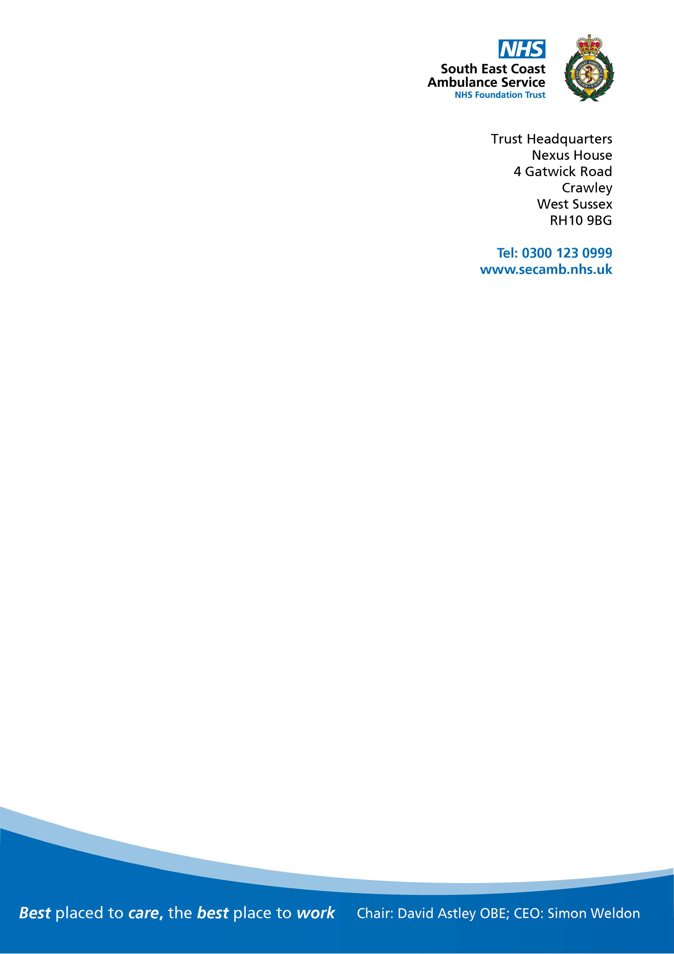

Date:.

Email:

Dear

I am writing in response to your enquiry under the Freedom of Information Act 2000 (FOIA) reference FOI 231224.

You requested the following information, please see our response below:

Dear South East Coast Ambulance Service NHS Foundation Trust,

I wish to make an FOI request. Please provide me with the following information for the financial years 2020/21, 2021/22, 2022/23.

All expenditure made by your organisation, in every facet of its operations and purview, on translation, interpretation, and language services.

Please provide the aggregated total spent by your organisation and then, if possible, please provide this broken down by particular function for which the service was carried out.

|  |  |  |  |
| --- | --- | --- | --- |
| **Financial Year:** | **2020/21** | **2021/22** | **2022/23** |
| Spend on translation, interpretation, and language services: | £60,096 | £85,084 | £99,299 |

I hope you find this information of some assistance.

If for any reason you are dissatisfied with our response, kindly in the first instance contact Caroline Smart, Head of Information Governance via the following email address:

[FOI@secamb.nhs.uk](mailto:FOI@secamb.nhs.uk)

Yours sincerely

Freedom of Information Coordinator

South East Coast Ambulance Service NHS Foundation Trust



