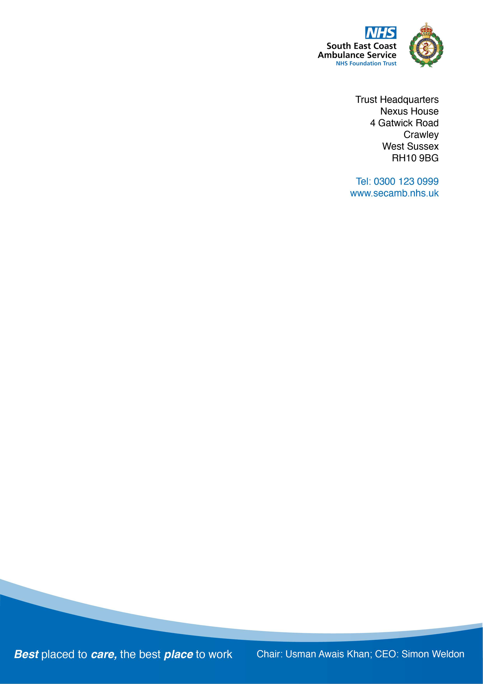

Date:

Email:

Dear,

I am writing in response to your enquiry under the Freedom of Information Act 2000 (FOIA) reference FOI 231130. Please accept my sincere apologies for the delay and inconvenience you have experienced regarding this request. In this instance, the Trust has not responded to your request within the required 20 days, and for this I apologise.

You requested the following information, please also see our response below:

# Since 1st January 2022 how many staff have been given permission to work remotely outside of the UK?

Not recorded centrally. This practice was disbanded January 2023.

# Please provide a list of each unique approval detailing; country, job title of the individual concerned and length of time spent working outside of the UK.

Not recorded centrally

# Are there any additional associated costs created by staff working outside of the UK. Please provide a breakdown of these costs and the total spent since 1st January 2022.

There are no additional associated costs created by staff working outside the UK, remote staff are given the same support package (laptop etc) as those working remotely within the UK.

Agile working outside of the UK is no longer supported.

I hope you find this information of some assistance.

If for any reason you are dissatisfied with our response, kindly in the first instance contact Caroline Smart, Head of Information Governance via the following email address:

[FOI@secamb.nhs.uk](mailto:FOI@secamb.nhs.uk)

Yours sincerely

**Freedom of Information Coordinator**

**South East Coast Ambulance Service NHS Foundation Trust**