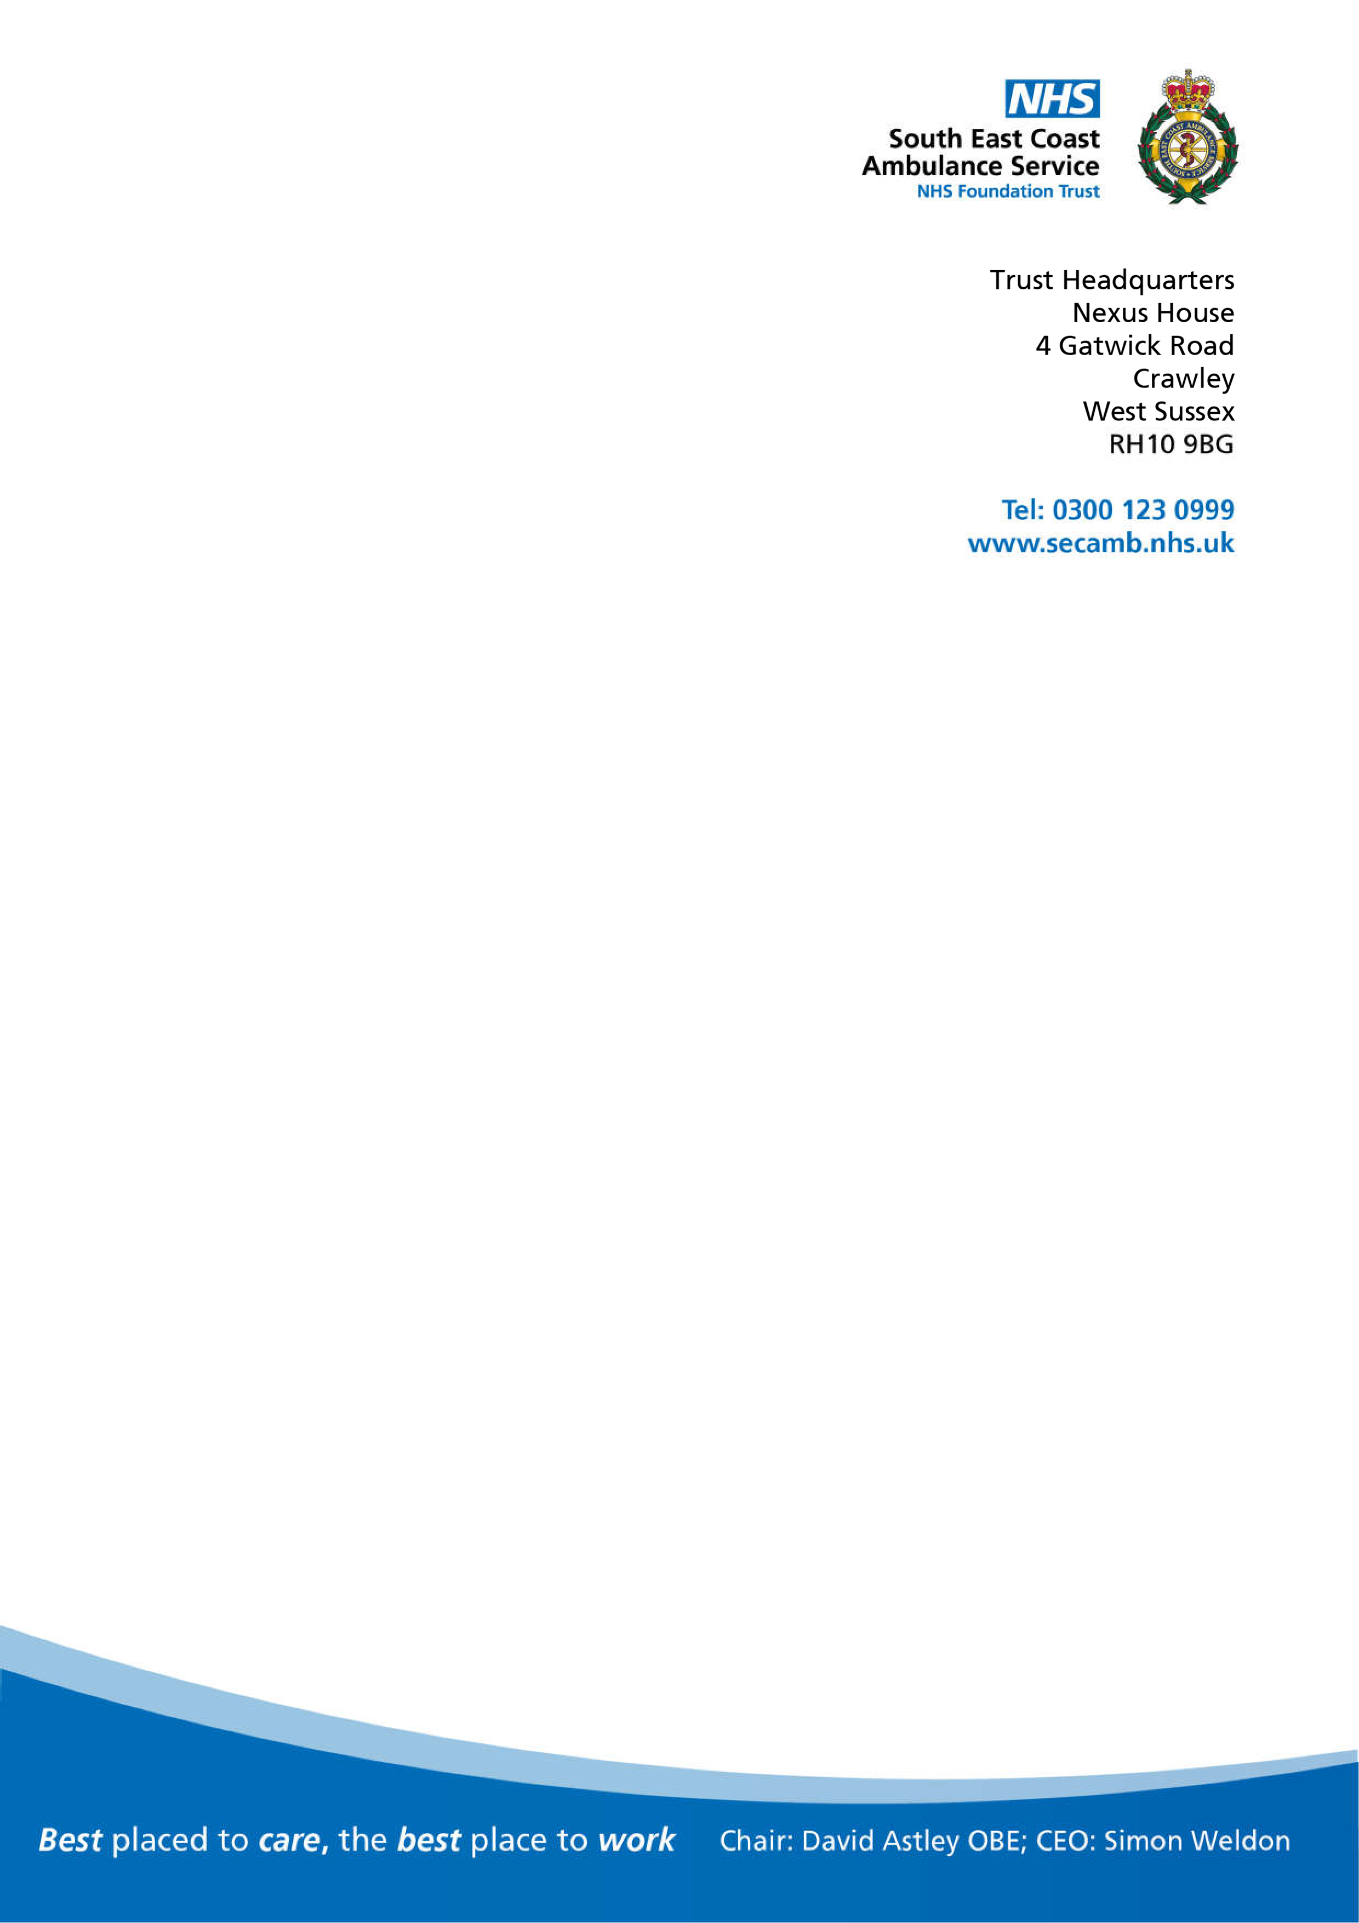

Date:

Email:

Dear,

I am writing in response to your enquiry under the Freedom of Information Act 2000 (FOIA) reference FOI 230626.

You requested the following information, please see our response below:

**Please may I request the following data for research purposes:**

1. **The number of Drug Overdoses / Suspected Drug Overdoses attended by SECAmb Brighton MRO cluster per year for the latest five years of available data.**

**1a) During the same period and geographical area, how many Drug Overdoses**

**/ Suspected Drug Overdoses were in patients under the age of 18?**

1. **During the same period and geographical area, what were the outcome codes recorded for these patients, and in what quantity, again separated by year, ranging for the latest five years?**
2. **During the same period and geographical area, how many amps of Naloxone HCI have been administered per year for the latest five years?**

|  |  |  |  |  |  |  |
| --- | --- | --- | --- | --- | --- | --- |
| Year | Number of Overdoses attended to by Brighton OU | Number of Overdoses (patient  <18)  attended to by Brighton OU | Number of Overdoses attended to by Brighton OU where the final outcome was Hear and Treat | Number of Overdoses attended to by Brighton OU where the final outcome was See and Treat | Number of Overdoses attended to by Brighton OU where the final outcome was See and Convey | Number of Incidents attended to by Brighton OU  where a Naloxone dose was given to the patient |
| 2018 | 142 | 15 | 11 | 65 | 50 | 133 |
| 2019 | 229 | 24 | Less than  10 | 102 | 95 | 134 |

|  |  |  |  |  |  |  |
| --- | --- | --- | --- | --- | --- | --- |
| 2020 | 212 | 25 | Less than  10 | 103 | 86 | 188 |
| 2021 | 171 | 20 | Less than  10 | 76 | 75 | 190 |
| 2022 | 189 | 15 | Less than  10 | 91 | 74 | 213 |



Less than 10 - we are unable to provide the exact number as it may be identifiable to individuals.

Note: the request covered incidents attended to by the Brighton OU team so the incidents recorded above are those attended to by said team. Some incidents in Brighton OUs area will have been attended by non-Brighton crews and some Brighton crews will have attended incidents outside of their area.

Overdoses are identified via Symptom Group = 'Toxic Ingestion/Inhalation/Overdose' I hope you find this information of some assistance.

If for any reason you are dissatisfied with our response, kindly in the first instance contact Caroline Smart, Head of Information Governance via the following email address:

[FOI@secamb.nhs.uk](mailto:FOI@secamb.nhs.uk)

Yours sincerely

**Freedom of Information Coordinator**

**South East Coast Ambulance Service NHS Foundation Trust**

