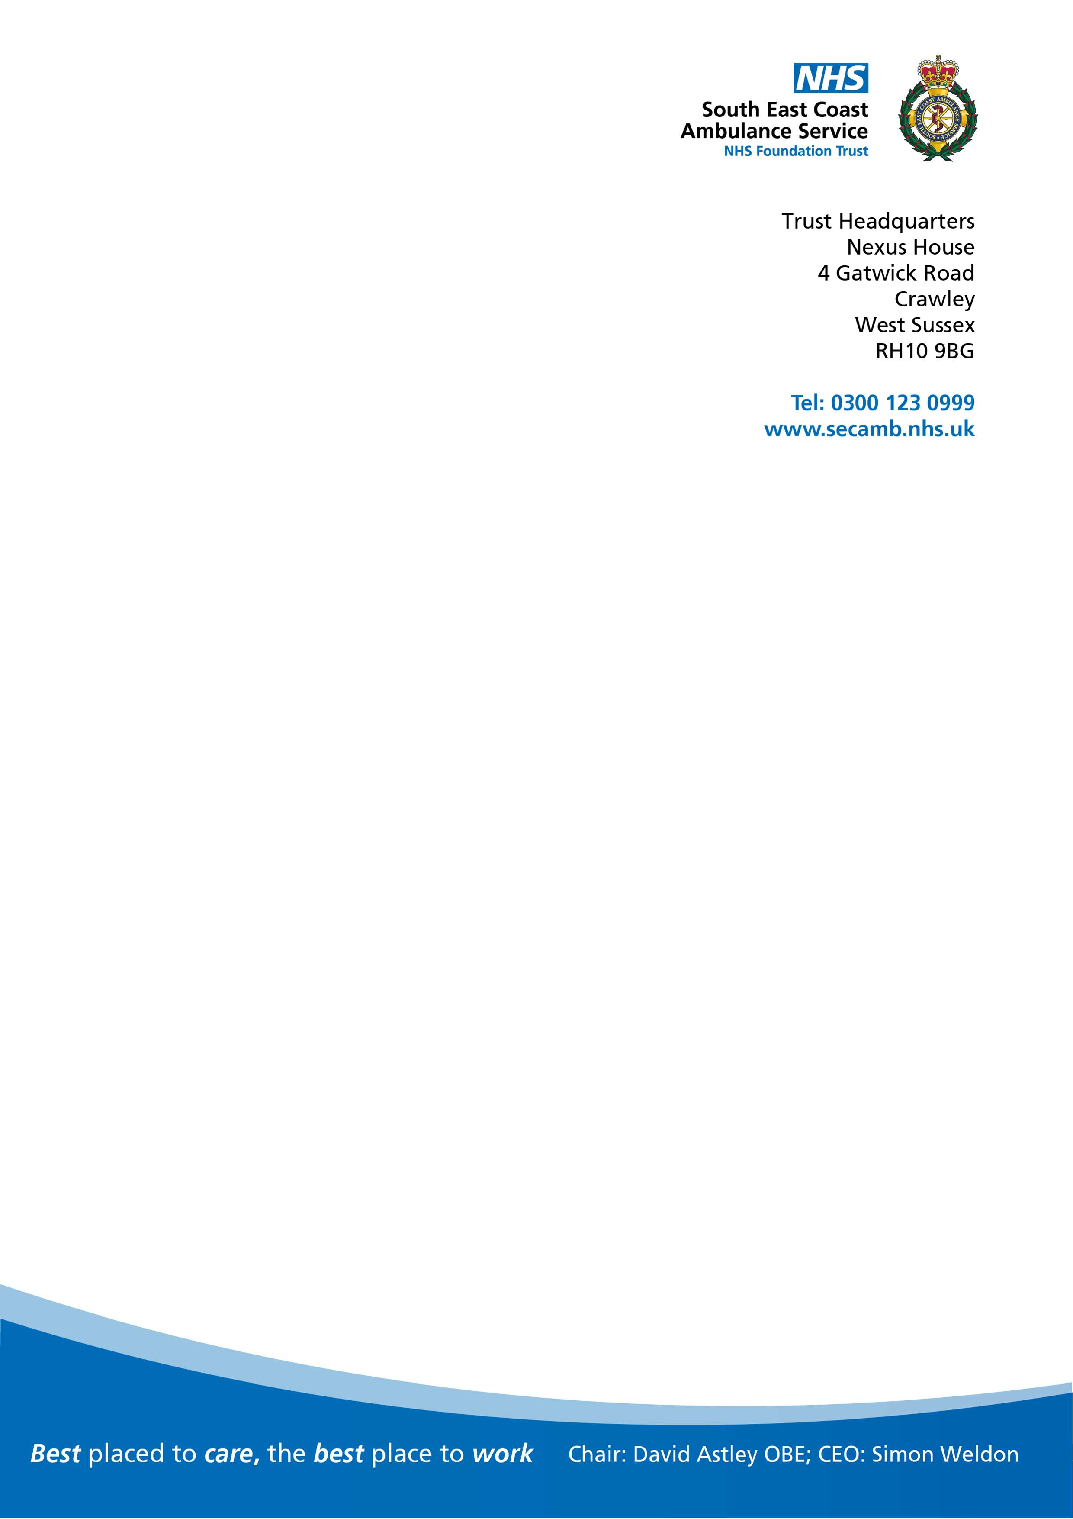

Date:

Email:

Dear

I am writing in response to your enquiry under the Freedom of Information Act 2000 (FOIA) reference FOI 230608.

You requested the following information, please see our response on the attached spreadsheet:

**I am looking for some assistance with your organisation’s Spend/Transparency data, available on the following weblink:** [**http://www.secamb.nhs.uk/about_us/document_library.aspx?cat=228&pageNu**](http://www.secamb.nhs.uk/about_us/document_library.aspx?cat=228&pageNu) **m=1**

**There appears to be no file available for the month of April 2023 . Could you advise when the file will be made available to view online? Would it be possible for you to email me a copy of the April 2023 file please & Thank you. This file is now available to view on the following link:** https://[www.secamb.nhs.uk/how-we-do-it/our-budget/single-spends-over-25000/](http://www.secamb.nhs.uk/how-we-do-it/our-budget/single-spends-over-25000/)

Please see attached spreadsheet.

I hope you find this information of some assistance.

If for any reason you are dissatisfied with our response, kindly in the first instance contact Caroline Smart, Head of Information Governance via the following email address:

[FOI@secamb.nhs.uk](mailto:FOI@secamb.nhs.uk)

Yours sincerely

**Freedom of Information Coordinator**

**South East Coast Ambulance Service NHS Foundation Trust**



